Project: Chesterfield
Xbox

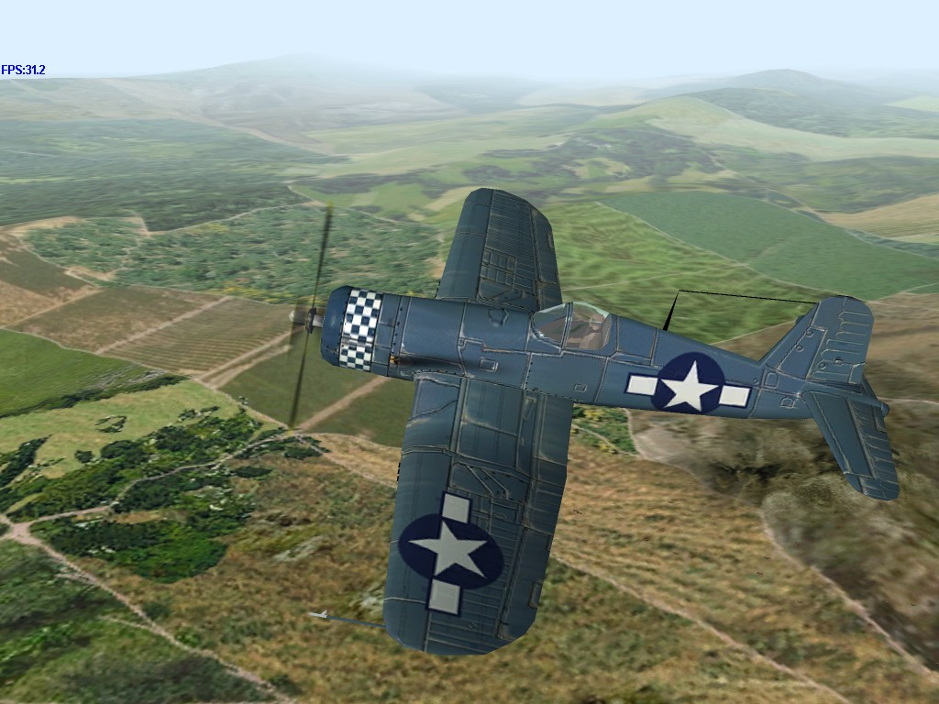

About This Document

This document describes the basic content and gameplay of Project: Chesterfield, which is based heavily on the Fighter Ace III game. This document will refer to gameplay or features in Fighter Ace III and a basic knowledge of that game will be assumed on the part of the reader.

Document Version Control

This is a new version of the document. Each major revision will be saved to a new filename denoting the date of the revision.

Changes in this Version
In future versions, changes in the body of the document will be highlighted in yellow.

Open Issues
In the body of the document, open issues are highlighted in green

1 Introduction 9
1.1 Full Story Mode Summary 9
1.2 Training Mission Mode Summary 10
1.3 Multiplayer Mode Summary 10
2 The Campaigns 11
3 Missions 11
3.1.1 Battle of Britain 13
3.1.1.1 Mission 1: The Straggler 13
3.1.1.2 Mission 2: Scramble! 15
3.1.1.3 Mission 3: Dogfight Above the Clouds 18
3.1.1.4 Mission 4: Target London 20
3.1.2 Western Desert 23
3.1.2.1 Mission 5: Scramble at Sunset 23
3.1.2.2 Mission 6: Looking For Trouble 26
3.1.2.3 Mission 7: Armored Shield 28
3.1.2.4 Mission 8: Save Cairo 31
3.1.3 Guadalcanal 33
3.1.3.1 Mission 9: Aerial Umbrella 33
3.1.3.2 Mission 10: The Avengers 36
3.1.3.3 Mission 11: Reach For The Sky 38
3.1.3.4 Mission 12: Sink That Flattop! 41
3.1.4 Kursk 44
3.1.4.1 Mission 13: Strike at Dawn 44
3.1.4.2 Mission 14: Guarding the Lines 46
3.1.4.3 Mission 15: Tank Buster Deluxe 49
3.1.4.4 Mission 16: Storm Watch 51
3.1.5 Battle Of Germany 53
3.1.5.1 Mission 17: Wrecking Crew 54
3.1.5.2 Mission 18: The Big B 56
3.1.5.3 Mission 19: Wacht Am Rhine 58
3.1.5.4 Mission 20: Taming The Jet 61
4 The User Interface 64
5 Main Menu 64
6 Full story mode 65
6.1 Chesterfield Back Story 65
6.2 Full Story Mode Overview 66
6.3 Full Story Mode Flowchart 67
6.4 Full Story Mode Welcome Screen 68
6.4.1 New Pilot Screen 68
6.4.2 Campaign Story Screen 68
6.4.3 Pilot Profile Screen 68
6.4.3.1 Mission History Screen 69
6.4.3.2 Mission Details Screen 69
6.4.3.2.1 Campaign Medals Screen 70
6.4.4 Briefing Screen 71
6.4.5 Pause Menu (within the Game) 71
6.4.5.1 Game Maps 72
6.4.5.2 Options Menu 72
6.4.5.3 Configure Controller Screen 72
6.4.5.4 Sound Options Screen 74
6.4.5.5 End Of Mission Screen 74
7 Training Missions 75
7.1 Training Mode Flowchart 75
7.2 Training Missions 76
7.3 Mission 1: Fighter vs Fighter Combat 76
7.4 Mission 1: Fighter vs Fighter Combat 76
7.5 Mission 2: Bomber Intercept Combat 77
7.6 Mission 3: Dive Bombing 77
7.7 Mission 4: Torpedo Bombing 78
7.8 Mission 5: Rocket & Strafing Attacks 78
7.8.1 Training Mission Screen 78
7.8.2 Training Mission Briefing Screen 79
8 Multiplayer Mode 80
8.1.1 Gameplay 80
8.1.2 Arenas 80
8.1.3 Aircraft 80
8.1.4 Player Progression 80
8.1.5 Rank 80
8.1.6 Plane Tags 80
8.1.7 Chat 81
8.2 Online Mode Flowchart 81
8.3 Nose 82
8.4 Cockpit 82
8.5 External 83
8.6 Cockpit Instrumentation/Information 84
9 Weather 85
9.1 Sun Glare 85
9.2 Clouds 85
10 Weapons 86
10.1 Bombs 86
10.2 Rockets 86
10.3 Guns 87
10.4 Torpedoes 89
11 Damage System 90
11.1 Aircraft Damage 90
11.2 Building Damage 94
11.3 Vehicle Damage 94
11.4 Ship Damage 94
12 Game Statistics 97
12.1 Game Statistics 97
12.2 Guns 97
12.3 Stall 97
12.4 Speed 97
12.5 Acceleration 97
12.6 Pull-Out 97
12.7 Armor 97
12.8 Maneuverability 97
12.9 Researched Statistics 97
12.9.1 Guns 97
12.9.2 Speed 98
12.9.3 HP 98
12.9.4 Wing Area 98
12.9.5 Weight 98
12.9.6 Wingspan 98
12.9.7 Length 98
12.10 Derived Statistics 98
12.10.1 Stall 98
12.10.2 Acceleration 98
12.10.3 Pull-Out and Maneuverability 98
13 Scoring 99
13.1 Scoring Appendix 99
14 Game Objects 103
14.1 British Planes 103
14.1.1 Hawker Hurricane Mk.Ia 103
14.1.2 Hurricane Mk.IIc 104
14.1.3 Supermarine Spitfire Mk.Ia 105
14.1.4 Supermarine Spitfire MkVb (Trop) 106
14.1.5 British Mosquito Bomber 107
14.1.6 Supermarine Seafire Mk.IIIb 108
14.1.7 Hawker Typhoon Mk.Ib 109
14.1.8 Supermarine Spitfire Mk.IXc 110
14.1.9 Hawker Tempest Mk.V 111
14.1.10 Supermarine Spitfire Mk.XIVe 112
14.2 German Planes 113
14.2.1 Messerschmitt Bf-109E-4 113
14.2.2 Messerschmitt Bf-109K-4 115
14.2.3 Messerschmitt Bf-109F-4 116
14.2.4 Messerschmitt Bf-109G-6 118
14.2.5 Messerschmitt Me-262 Schwalbe 120
14.2.6 Junkers Ju-88A-4 121
14.2.7 Junkers Ju-87G-1 Stuka 123
14.2.8 Ju-87D-3 Stuka 124
14.2.9 Focke-Wulf FW-190A-4 126
14.2.10 Focke-Wulf FW-190A-8 127
14.2.11 Focke-Wulf FW-190D-9 128
14.2.12 Dornier Do-217e 129
14.3 Japanese Planes 130
14.3.1 Aichi D3A1 Val 130
14.3.2 Mitsubishi B5N2 Kate 131
14.3.3 Mitsubishi A6M2 Zero 132
14.3.4 Mitsubishi G4M2 Betty 134
14.3.5 Nakajima Ki-43-II Oscar 135
14.3.6 Kawasaki Ki-61-II Tony 136
14.3.7 Kawasaki Ki-100 Tony 137
14.3.8 Mitsubishi J2M3 Jack 138
14.3.9 Kawanishi N1K2 George 139
14.4 Russian Planes 140
14.4.1 Ilyushin IL-2 Stormovik 140
14.4.2 Lavochkin La-5FN 141
14.4.3 Tupolev Tu-2 142
14.4.4 Hawker Hurricane Mk.IIb 143
14.4.5 Lavochkin LaGG-3 144
14.4.6 Polikarpov I-16 Ratta 145
14.4.7 Yakovlev Yak-1b 146
14.4.8 Yakovlev Yak-3 147
14.4.9 Bell P-39Q Airacobra 148
14.4.10 Lavochkin La-7 149
14.5 American Planes 150
14.5.1 Chance-Vought F4U-1a Corsair 150
14.5.2 Grumman TBF-1C Avenger 151
14.5.3 Douglas SBD-2 Dauntless 152
14.5.4 Lockheed P-38L Lightning 153
14.5.5 P-51D Mustang 154
14.5.6 Boeing B-17G Flying Fortress 155
14.5.7 Curtiss P-40C Tomahawk 156
14.5.8 Grumman F4F-3 Wildcat 157
14.5.9 Curtiss P-40E-1 Warhawk 158
14.5.10 Grumman F4F-4 Wildcat 159
14.5.11 Lockheed P-38G Lightning 160
14.5.12 Grumman F6F-3 Hellcat 161
14.5.13 Republic P-47D Thunderbolt 162
15 Game Objects 163
15.1 Tanks 163
15.1.1 Tiger Tank - German 163
15.1.2 Panther Tank - German 163
15.1.3 Cromwell - British Tank 164
15.1.4 T-34 - British Tank 164
15.1.5 US Marine Tank 164
15.2 Ships 164
15.2.1 British Cargo Ship 164
15.2.2 American Carrier 165
15.2.3 American Cruiser 165
15.2.4 Japanese Cruiser # 1 165
15.2.5 Japanese Battleship 165
15.2.6 Japanese Carrier 166
15.2.7 Japanese Submarine 166
15.2.8 Japanese Torpedo Boat 166
15.2.9 German Torpedo Boat 166
15.3 Other Vehicles 167
15.3.1 German Train 167
15.3.2 German Scout Car 167
15.3.3 German Truck (column) 167
15.3.4 German Truck Column: 167
15.4 Guns 167
15.4.1 British Airfield AA Guns 167
15.4.2 American Airfield AA Guns 168
15.4.3 German AA Guns 168
15.4.4 London AA Guns 168
15.4.5 Japanese Airfield AA Guns 168
15.5 Buildings 169
15.5.1 British Airfield Strip 169
15.5.2 American Airfield Strip 169
15.5.3 Russian Airfield Strip 169
15.5.4 German Airfield Strip 169
15.5.5 German Artillery Site 169
15.5.6 German Jet Base 169
15.5.7 German Rocket Site 169
15.5.8 Westminster 169
15.5.9 London Bridge 169
15.5.10 St. James Cathedral 170
15.5.11 British House of Parliament 170
15.5.12 British Airfield Building #1 170
15.5.13 British Airfield Building #2 170
15.5.14 German Supply Depot 170
15.5.15 Japanese Supply Dump 170
15.5.16 German Enemy Building #1 170
15.5.17 German Enemy Building #2 170
15.5.18 German Train Tunnel 171
15.5.19 German Train Station 171
15.5.20 Allied Bridge 171
15.5.21 Enemy Bridge 171
15.5.22 Japanese Observation Post 171
15.6 Other Objects 171
15.6.1 Gas tanks and Ammo 171
15.7 Other Available FA3.0 Objects 172
16 Medals 174
16.1 RAF (British) 174
16.1.1 Africa Star 175
16.1.2 Atlantic Star 175
16.1.3 Air Crew Europe Star 176
16.1.4 Pacific Star 177
16.1.5 France and Germany Star 178
16.2 RAAF (Australian) 178
16.2.1 1939-45 Star 181
16.2.2 Atlantic Star 181
16.2.3 Air Crew Europe Star 181
16.2.4 Africa Star 182
16.2.5 Pacific Star 182
16.2.6 Burma Star 182
16.2.7 Italy Star 182
16.2.8 France And Germany Star 183
16.2.9 Defence Medal 183
16.2.10 War Medal 1939-45 183
16.2.11 Australian Service Medal 1939-45 184
16.3 RUSSIAN 184
16.3.1 Bravery Medal (Medal "Za otvagu") 184
16.3.2 Ushakov Medal (Medal Ushakova) 184
16.3.3 Nyestyerov Medal (Medal Nyestyerova) 185
16.4 USAF 185
16.4.1 Presidential Unit Citation (Air Force and Army) 185
16.4.2 The Silver Star 186
16.4.3 Distinguished Flying Cross 187
16.4.4 Air Medal 188
16.4.5 Presidential Unit Citation 189
16.5 US NAVY AIR FORCE 189
17 Sounds 190
17.1 Audio Strategy 190
17.2 Music 190
17.3 GUI audio 191
17.4 In-flight 3D audio 191
17.4.1 Environment Sounds 203
17.4.1.1 Other planes 203
17.4.1.2 Ground Objects 203
17.5 Campaign/Mission Briefing Screens audio 204
18 Technology Detail 205
18.1 Xbox Optimizations 205
18.2 Xbox Hard Drive 205
18.3 Xbox Audio Specs Optimizations 205
19 The Competition 206

Introduction

Project: Chesterfield is an arcade, flight-combat game, for both single and multiple players, for the Xbox game console.

Gameplay consists of a series of scripted Campaigns and missions in each of five different historical settings. As the player completes one mission, the next will be made available for play. Players will be allowed to go back and replay a completed mission at any time, saving newer results to their “save game” file if they wish.

The missions in the game will include one or more examples of the various forms of air combat found in World War II, including:

- fighter intercepts
- dive bombing
- torpedo bombing
- tank busting
- bomber gunner

In addition to the basic gameplay, a training module will teach players the basics of controlling their aircraft and of using their various weapons.

Players have the choice of playing the following game modes:
- Play Full Story Mode
- Play Single Mission
- Training Missions
- Multiplayer Mode

Full Story Mode Summary
The Full Story Mode is a linear series of 5 Campaigns. Each campaign will be composed of four missions, which are intended to recreate the atmosphere of that specific air campaign. After the completion of each mission the next mission and/or campaign will be opened up for play. Once a mission has been completed, the player can go back and that or any other completed mission as often as desired.

If the player puts in an outstanding performance in a mission one or more medals may be awarded to recognize the achievement beyond the minimum mission requirements. Each mission will be designed so that completing the mission is relatively easy, whereas earning the best possible medal will be next to impossible.

A short, generic “medal award ceremony cinematic” will be made for each campaign, which shows the basic flavor and uniform of the campaign. For example, in the Western Desert campaign, pyramids will be seen in the background and the RAAF officers will be wearing short pants uniforms.

Training Mission Mode Summary
Selecting Training Missions from the Main Menu allows the player to select one of the five Training Missions.

Multiplayer Mode Summary
The multiplayer model for Chesterfield will be basic Client/Server model, with some entity operating the necessary servers for a limited period of time. No concession or allowance will be made for the interface or additional security necessary to run a pay-for-play online service using this game.

The Campaigns

Each of the five campaigns is based on one of the historical maps available in Fighter Ace III. Additionally, each campaign is the domain of a different national air force, as indicated in the table below:

- Battle Of Britain (England, August/September 1940, Royal Air Force)
- Western Desert (Egypt, any months 1941, Royal Australian Air Force)
- Guadalcanal (Solomon Islands, July-October, 1942, US Navy)
- Battle Of Kursk (Ukraine May 1943, May, Soviet Army Air Force)
- Battle Of Germany (Germany November 1944 – April 1945, United States Army Air Force)

Each campaign will be prefaced with a short cinematic that sets the tone and historical flavor of the campaign.

At the completion of each campaign, the player will receive a “Campaign Medal” designed after the historical theater and campaign medals of WWII.

Missions

Each campaign will be composed of four missions, which are intended to recreate the atmosphere of that specific air campaign. After the completion of each mission the next mission and/or campaign will be opened up for play. Once a mission has been completed, the player can go back and that or any other completed mission as often as desired.

If the player puts in an outstanding performance in a mission one or more medals may be awarded to recognize the achievement beyond the minimum mission requirements. Each mission will be designed so that completing the mission is relatively easy, whereas earning the best possible medal will be next to impossible.

A short, generic “medal award ceremony cinematic” will be made for each campaign, which shows the basic flavor and uniform of the campaign. For example, in the Western Desert campaign, pyramids will be seen in the background and the RAAF officers will be wearing short pants uniforms.

Ending Missions

Missions will have a list of required mission events that must occur IN ORDER before the mission can end, with the exception that the mission will always end when the player’s plane is destroyed. In addition to the contents of this list, the player must also be “out of danger”, defined as being at least 10,000 meters from the closest enemy plane.

In order to “complete” the mission and advance to the next one, the player must accomplish the minimum mission goals. Any goals attained beyond the minimum will be used to determine which, if any, medal is awarded to the player.

Once every event in the list of required mission events is completed and the player is out of danger, a dialog box will pop-up telling they player that they can end the mission, restart, abort, or continue flying. If the player did not complete the minimum mission goals, the player will not be given the option to end the mission (the player must either restart or abort the mission if it wasn’t completed).

If the player chooses to end the mission, the score will be written, awards made, and the game will advance to the next mission.

If the player chooses to continue flying, they can recall the menu by pressing the Start button.

If the player chooses to restart the mission, the mission will start over with the briefing and will proceed with identical mission conditions.

If the player chooses to abort the mission, he is returned to the main menu, where he can start a new game, quit, or whatever.

Mission #: Name
For each mission, the following information will be described:

Synopsis: A brief overview of the mission.
Player Planes: The ‘allied’ planes that appear in the mission.
Enemy Planes: The enemy planes that appear in the mission.
Targets: The targets the player is to either destroy or defend.
Difficulty Levels: Describes the different settings for the different difficult levels. Many of these numbers will be adjusted during playtesting.
Weather: Possible weather patterns (to be chosen by the weather generator) for that mission.
Loadouts: The ammo that the planes/targets carry.
Target Damage Capacity: A brief overview of the damage capacity of the targets. The full damage capacity for an item can be found in the Graphics section.
Required Mission Events: The events that the play must do to proceed in the mission.
Minimum Mission Goals: The minimum number of events that the player must do to complete the mission.
Script: A chronological description of how the missions will unfold/play.
AI Missions: A description of behaviour for all AI objects in the mission.
Mission Briefing: (text) A description of the briefing screen that will precede the playing of the mission.
Voice Actors: A description of the voice talent needed in the mission.
Audio Script: The script that each voice talent will say in the mission.
Scoring: The events that will earn/lose the player points in the mission.

Battle of Britain

Mission 1: The Straggler
Synopsis: The player is on a check flight, flying east along the southern coast of England at about 10,000 ft. A call comes over the radio from the ground controller. She says that a cargo ship, previously damaged by U-boats is steaming up the channel and that a flight of German bombers is on their way to sink the ship. Being the only plane close enough to get there in time, the player is dispatched to intercept the bombers. As the player draws near the ship, he can see a formation of 3 Stuka dive-bombers closing in on the ship from the south. As the others circle and wait, the first drops down into its dive on the cargo ship. As each plane finishes its bomb run, it levels out to the north, then does a 180 and strafes the ship before heading for home at about 100 feet off the water, jinking back and forth to mess up the player’s aim if he pursues. Once the planes have been driven off, the player turns back for home and flies over the coast of England, ending the mission.

Secondary Events:
1. A formation of four Ju-88 bombers will be seen flying south at about 15,000 feet altitude. Two of them have smoking engines and the other two have dead gunners. They are easy pickings for the player for extra points.
2. A pair of German torpedo boats approach the cargo ship at high speed from the south. They have two torpedoes each and the torpedoes have an equivalent weight of 1000 lbs of bombs. They can be destroyed with strafing and can be avoided by ending the mission before they arrive.

Player Planes: 1x Hawker Hurricane Mk.Ia (player)
Enemy Planes: 3x Ju-87D-3 Stuka, Junkers Ju-88A-4
Targets: 1x cargo ships, 2 x German Torpedo boats.

Difficulty Levels:

 |  | Difficulty Level
 | Easy | Medium | Hard
Time Limit | 5 | 5 | 7
# of enemy planes | 3 | 5 | 8
# of cargo ships | 1 | 2 | 3

Possible Weather: Sunny/Cloudy/Overcast/Stormy/Sunset

Loadouts:
Hurricane – full ammunition load
Stukas – 1x 550 lb bomb and 4x 110 lb bombs each, full offensive and defensive ammo load
Ship – 2x .30 caliber AA gun with 0 level gunners (just for visual effect)
Ju-88s – normal defensive gunners with 50% load for gunners that aren’t dead

Target Damage Capacity: The ship will sink it is hit by a total of at least 1650 lbs of bombs

Required Mission Events:
1. player gets to a position south of the cargo ship
2. player flies over north coast of channel

Minimum Mission Goals:
1. player must hit an enemy plane with at least one bullet
2. the cargo ship must survive

Script:
1. mission briefing text while mission loads (click button to continue)
2. game graphics fade in with player in cockpit of plane, flying west-to-east along the English coastline at about 10,000 feet
3. audio (female voice) vectors the player south to help a cargo ship about to be attacked
4. as player approaches ship, he can see three Stukas staging south of the cargo ship
5. as the player gets closer, the first Stuka tips down into a dive on the ship while the other two circle and wait
6. after the first Stuka has completed his attack, the second goes, and after that the third.
7. after doing its dive and dropping its bombs, each Stuka will egress north, then do a 180 and strafe the ship
8. after the strafe, each Stuka will head south for the French coast at about 100 ft above the water
9. during this chase, a formation of Ju-88s is seen flying south at 15,000 feet. Two have smoking engines and the other two have dead gunners.
10. if the player takes the time to go after the Ju-88s, a pair of German torpedo boats will eventually appear to attack the ship from the south. Their torpedoes are the equivalent of 1000 lbs of bombs for determining the damage capacity of the ship

AI Missions:
Stukas – take turns making attack on ship, make dive bomb attack on ship with egress to the north, make 180 degree turn, make strafing run on ship, scatter and run for home at 100 ft, weave and dodge to throw player’s aim off if the player chases.
Ship AA – will try to shoot down Stukas, low quality gunner
Ju-88s – will fly south toward France at 15,000 feet altitude, 200 mph steady speed, low quality gunners, two of the planes have dead gunners and two have an engine smoking.
Torpedo Boats – will attack cargo ship from the south with two torpedoes each, then will turn to the south and make off at top speed

Mission Briefing: (text)

Voice Actors:
Ground controller (Female voice, British accent)
Ship captain (Male voice, British accent)

Audio Script:
1. Ground Controller: (calls to player to intercept bombers headed for the straggler)
2. Ship Captain: (if ship survives with no damage)
3. Ship Captain: (if ship survives with minimal damage)
4. Ship Captain: (if ship barely survives)
5. Ship Captain: (if ship is sunk)
6. Ship Captain (call for help)

Scoring:

Task
Points earned
Hit/destroy enemy plane.
Points remaining to cargo ship.
All targets destroyed bonus (given at end of mission).
Hit/destroy German Torpedo boats.
Points Lost
Damage taken to plane.
Damage taken by cargo ship.
Cargo ship destroyed.
Medals Earned

Mission 2: Scramble!

Synopsis: The player’s airbase is under attack. The player starts in the cockpit with the engine turning over and the canopy sliding closed. The player hears the tower calling for everyone to get airborne immediately. As the player gains speed bombs burst around him and he can see several Stukas completing their dives, while others are strafing the airbase. The player and another pilot get airborne and start chasing the Stukas across the English countryside. At the coast a pair of 109s dive down on the players to give the Stukas a chance to escape. The mission ends when the player gets out of danger.

Secondary Events:
1. After the last Stuka is destroyed, a pair of damaged 109s with smoking engines, flies south at about 7,000 feet. They are out of ammo and damaged and will use evasion techniques if engaged.
2. A short time after spotting the smoking 109s, a lone Ju-88 flies north at 25,000 feet on a photo recon mission.

Player Planes: 2x Hawker Hurricane Mk.Ia
Enemy Planes: 6x Ju-87D-3 Stuka, 2x Messerschmitt Bf-109E-4, Junkers Ju-88A-4
Targets: Frontline airfield

Loadouts:
Hurricane – Full ammo load
Stukas – 1x 550 lb and 4x 110 lb bombs each, full defensive and offensive ammo load, gunner level 0
109s – Full ammo load (except the damaged pair)
Ju-88 – Full defensive load, gunner level 1
Airfield – 4x .30 cal machine guns, gunner level 1

Difficulty Levels:

 |  | Difficulty Level
 | Easy | Medium | Hard
Time limit | 7 | 7 | 9
# of Stukas | 6 | 8 | 12
# of 109s. | 2 | 3 | 4

Possible Weather: Sunny/Cloudy/Overcast/Stormy/Sunset

Target Damage Capacity: n/a

Required Mission Events:
1. player gets airborne
2. player destroys at least one Stuka

Minimum Mission Goals:
1. player must survive

Script:
11. mission briefing text while mission loads (click button to continue)
2. game graphics and audio fade in with the player in the cockpit with the engine turning over
3. dive bombers are attacking the field, if the player doesn’t move within about 10 seconds, a bomb will land on the player’s starting spot.
4. the player maxes out the throttle and starts rolling across the grass
5. while the player is rolling, explosions of bombs will be bursting around his plane
6. as the player gets airborne he has a variety of targets to choose from, including a pair Stukas just about to start their dive, a pair strafing the field, and a pair starting to run for home, if he looks back he can see a couple of Hurcs burning on the field as well as burning and smashed building and AA fire
7. if the player ends up reaching the coast, a pair of 109s will dive down to give the Stukas a chance to escape and if any Stukas remain, the 109s will not chase the player back to the airfield
8. after the last Stuka is destroyed (regardless of whether coastal 109s are triggered or not), a pair of damaged 109s (no ammo, engines at 50%) will fly south at about 7,000 feet near the player.
9. shortly after spotting the damaged 109s, a lone Ju-88 will be seen heading north at 25,000 feet on a recon mission

AI Missions:
Stukas – pair of Stukas take turns diving on the airfield, after the bomb drop, they turn around and strafe the field, then head for home at about 100-200 ft agl
109s – if the player reaches the coast, the 109s will be triggered, 109s dive and engage the player, trying to continue edging south to keep within protection range of the Stukas, if the player turns for home and there are Stukas around, the 109s will gain altitude and head south to protect the Stukas, if the Stukas are all dead, the 109s will engage and will chase the player as far as half-way back to the player’s airfield
Damaged 109s – they are out of ammo, have damaged engines and will use evasion techniques if engaged, working their way steadily south
Ju-88 Recon – flies north at normal cruise speed at 25,000 feet
Airfield AA – will try to shoot down enemy planes, low quality gunner

Mission Briefing: (text)

Voice Actors:
Tower (Male, British accent)
Wingman (Male, British accent)

Audio Script:
1. Tower (tells player to get airborne)
2. Wingman (various calls)

Scoring:

Task
Points earned
Hit/destroy enemy plane.
Points remaining to airfield strip.
Wingman survives.
All enemies destroyed bonus (given at end of mission).
All plane survival bonus (given at end of mission).
Points Lost
Damage taken to plane.
Damage taken by airfield strip.
Airfield strip destroyed.
Medals Earned

Mission 3: Dogfight Above the Clouds

Synopsis: The player is the third plane in a three-plane “vic” formation flying at about 20,000 feet altitude. A heavy cloud layer is at about 7000-8000 feet, with rain falling below the cloud layer. As the flight leader is calling out a formation maneuver, he is cut off as his plane explodes in mid-air and two 109s come zooming past the formation. The other pilot in the player’s formation calls out on the radio and the player and the AI pilot take off in pursuit of the 109s, who turn to face the challenge. After about 10-15 minutes of combat, the 109s (if still flying) will run short of fuel and will try to work their way south toward the channel. The mission ends when the player is out of danger.

Secondary Events:
1. After the 109s start running, another pair will appear and will fight it out with the player for 10-15 minutes before they too have to run for home.
2. After the second pair of 109s start to run, a break in the clouds reveals a trio of Stukas heading for the nearest airfield to attack it.

Player Planes: 3x Supermarine Spitfire Mk.Ia
Enemy Planes: 2x Bf-109E-4, Ju-87D-3 Stuka,
Targets: n/a

Loadouts:
- Spitfires – full ammo load
109s – full ammo load
Stukas – 1x 500 lb and 4x 110 lb bombs, full defensive ammo load, gunner level 1

Difficulty Levels:

 |  | Difficulty Level
 | Easy | Medium | Hard
Time Limit | 5 | 5 | 5
# of 109s | 2 | 4 | 6

Possible Weather: Sunny/Cloudy/Overcast/Stormy/Sunset/

Target Damage Capacity: n/a

Required Mission Events:
1. Player must hit one of the 109s with gunfire.

Minimum Mission Goals:
1. Player must survive

Script:
1. mission briefing text while mission loads (click button to continue)
2. game graphics and audio fade in with the player in the cockpit flying in formation with two other Spitfires at 20,000 feet altitude
3. flight leader makes a routine radio message to the flight
4. 109s dive on formation from above, exploding the leader
5. other Spitfire pilot calls out to get the 109s that just killed the flight leader
6. players give chase and 109s turn to meet the threat
7. after about 10 minutes of combat, the 109s will run low on fuel and will therefore try to work their way south and escape. As such, they will not chase the player north after this time as they want to escape.
8. after the 109s start running for home, another pair of 109s will show up and fight for 10-15 minutes before they, too, have to run for home
9. after the second pair of 109s start running, a break in the clouds reveals a trio of Stukas heading for the nearest airfield to attack it.

AI Missions:
Spitfire – will try to shoot down 109s with help of player. Will try to do teamwork with player, calling out several basic moves. Will chase the 109s as far as the middle of the channel, unless the player turns back
109s – will first shoot down the leader, extend, and then turn to come back at the Spitfires. 109 pilots will work together to kill the Spits, with a slight preference to killing the AI Spitfire first. After about 10 minutes of combat, the 109s will run low on fuel and will work their way south. As such they will not chase the player north if he runs after this time. 109s run as soon as they get a good chance.
Stukas – head for the nearest airfield, dive and drop their bombs, then form up and head for home on the deck

Mission Briefing: (text)

Voice Actors:
Flight Leader – upper-class British male accent
Second Spitfire – British male accent

Audio Script:
1. Flight leader starts to make a formation turn call and is cut short by being shot down
2. Second Spitfire calls to avenge the death of their Leader
3. Second Spitfire makes various combat maneuver calls to show the player some basic teamwork elements (like the scissors)
4. Second Spitfire calls out if shot down

Scoring:

Task
Points earned
Hit/destroy enemy plane.
Wingman survives.
All targets destroyed bonus (given at end of mission).
All plane survival bonus (given at end of mission).
Points Lost
Damage taken to player’s plane.
Allied plane destroyed.
Medals Earned

Mission 4: Target London

Synopsis: The player starts in the air as part of a three-plane “vic” of Spitfires. The formation is flying towards London at about 20,000 feet. A call comes in over the radio vectoring all fighters in the area to a large raid just south of London. The player’s flight turns toward the vector and soon sees the enemy bomber formation dodging in and out of the clouds at about 15,000 feet. Overhead is a formation of 109s and coming in from other points are other “vics” of Spitfires and Hurricanes. The leader calls for an attack and the fight is on. The mission ends when the player is out of danger.

Secondary Events:
1. At about the time the bombers reach their drop points, four 109s with bombs can be seen sneaking along at low altitude headed for the nearest airfield to bomb it.
2. About 10 minutes after the 109s with bombs show up, another vic of Spitfires and another four 109s will join the battle for the bombers. Every ten minutes after that, another set of Spits and 109s will show up.

Player Planes: 6x Supermarine Spitfire Mk.Ia (player), 6x Hawker Hurricane Mk.Ia.
Enemy Planes: 8x Messerschmitt Bf-109E-4, 24 x Junkers Ju-88A-4
Targets: Westminster Abbey, London Bridge, St. James Cathedral, House Of Parliament

Loadouts:
Spitfires and Hurricanes – full ammo load
109s – full ammo load
109s with bombs – 1x 550 lb bomb each, full ammo loads
88s – 10x 110 lb bombs in bomb bay, full defensive ammo load, gunner level 1
Ground AA – will shoot flak at the bombers to make lots of puffy flak bursts, gunner level 1

Difficulty Levels:

 |  | Difficulty Level
 | Easy | Medium | Hard
Time Limit | 10 | 12 | 15
Number of Targets to defend.* | 2 | 3 | 4
# of 109s | 8 | 10 | 12
# of 88s. | 24 | 30 | 36
# of vic A. (2 Spitfires, 1 Hurricane) | 3 | 4 | 5
# of vic B. (1 Spitfire, 2 Hurricanes) | 3 | 3 | 4

*Targets include: London Bridge, House of Parliament, St. James Cathedral, and Westminster Abbey.

Possible Weather: Sunny/Cloudy/Foggy/Overcast/Stormy/Sunset

Target Damage Capacity: Westminster will be destroyed by hits from a total weight of 8000 lbs of bombs; London Bridge can take 4000 lbs of hits’; St. James Cathedral will be destroyed by hits from a total weight of 8000 lbs of bombs; House of Parliament can take 8000 lbs of bombs

Required Mission Events:
1. Player must hit an enemy plane with at least one bullet
2. All bombers must drop their bomb loads excepting those that are shot down before they get to the target

Minimum Mission Goals:
1. The player must survive
2. Either Westminster or the Bridge must survive (anything less than 100% damage)

Script:
1. mission briefing text while mission loads (click button to continue)
2. graphics and audio fade in to find the player in the cockpit of a Spitfire at about 20,000 feet, as part of a three-plane “vic”
3. radio call from ground controller tells all flights in the area to head to a point south of London to intercept a large German raid
4. the flight leader turns and leads the flight to the area, soon they see the bomber formation in the distance at about 15,000 feet with a formation of fighters flying top cover
5. as the player’s flight dives on the bombers, they can see three other flights of Hurcs and Spits converging on the formation
6. as the GB fighters close, the 109s break into two schwarms of four planes each, with each schwarm picking a different “vic”, leaving two “vics” to attack the bombers (the attack targets are chosen at random so that half the time the player’s flight is attacked by the fighters
7. as the combat approaches the target area, the remaining bombers split into two groups, with a 2:1 ratio. The larger group attacks Westminster and the smaller group attacks the Bridge.
8. after they drop, the bombers will swing to the east and eventually southeast back down the Thames estuary
9. at about the time the bombers reach their drop points, four 109s with bombs can be seen sneaking in at low level headed for a nearby airfield. They will attack the airfield, then climb to join the battle for the bombers.
10. about 10 minutes after the 109s with bombs appear, and every 10 minutes thereafter, another vic of Spitfires and another schwarm of 109s will join the battle for the bombers.

AI Missions:
GB fighters – those engaged by 109s will try to defend themselves and keep the 109s occupied, while the other fighters go for the bombers
88s – the German bombers will fly in formation and will close formation whenever a plane drops out of formation. When the bombers get to the target, they will split into two groups, 2:1 in ratio, if the number of planes is more than 12. The larger group will target Westminster Abbey and the smaller group will target the London Bridge. If the number of bombers left when they get to the target is 7-12 or less, all bombers will attack Westminster, and if it is 1-6 left, they will attack the Bridge. After dropping their loads, the 88s will swing to the east and then southeast to egress out over the Thames estuary.
109s – The 109s will work in pairs to take out GB fighters, with a priority being given to those fighters that are engaging bombers. As the bombers egress, the 109s will try to keep the GB fighters from pursuing the bombers until the bombers are at least 10 km away. If the bombers are all shot down, the fighters will start working their way home.
109s with bombs – will drop bombs on airfield, then will join the battle for the bombers.

Mission Briefing: (text)

Voice Actors:
Ground Controller – British female voice
Flight leader – upper class British male voice
Other pilots – various other British male voices

Audio Script:
1. Ground controller vectors all fighters to intercept the German raid
2. Flight leader orders the group to turn to new heading
3. Flight leader orders group to attack
4. Other pilots make various combat calls over radio

Scoring:

Task
Points earned
Hit/destroy enemy planes.
All targets destroyed bonus (given at end of mission).
All plane survival bonus (given at end of mission).
Allied plane survival bonus (at end. Per plane.)
Target survival bonus (at end. Per target’s point remaining).
Points Lost
Damage taken to player’s plane.
Allied plane destroyed.
Damage taken by target (-points/damage point).
Medals Earned

Western Desert

Mission 5: Scramble at Sunset

Synopsis: As the game fades in, the player is in the cockpit of his Spitfire, with the engine turning over. Crossing in front of him from west to east are a pair of Bf-109Fs strafing the buildings on the north side of the runway. As the player and two other Spitfires start gaining speed down the runway, another pair of 109s come streaking in and strafe the group, destroying one of the planes. After making these strafing attacks, the 109s will turn back to the west, make another strafing run at the airbase and will then run off into the sunset. The mission ends when the player is no longer in danger.

Secondary Events:
1. While the player is chasing the 109s, a plume of dust reveals the location of a German scout car headed west for German lines.
2. A short time later, a formation of 8x Ju-88s can be seen headed for Cairo at about 15,000 feet on a night-bombing mission.

Player Planes: 2x Supermarine Spitfire MkVb (Trop)
Enemy Planes: 4x Messerschmitt Bf-109F-4 (need older pink paint job that was in earlier FA3 beta), Junkers Ju-88A-4
Targets: Player’s airfield, German Scout Car

Difficulty Levels:

 |  | Difficulty Level
 | Easy | Medium | Hard
Time Limit | 5 | 5 | 5
# of 109s | 4 | 6 | 8
# of targets to defend | 1 – airfield, 4 buildings | 7– airfield, 6 buildings | 10 – airfield, 9 buildings

Possible Weather: Sunny/Cloudy/Overcast/Stormy/Sunset

Loadouts:
Spitfires – full ammo load
109s – full ammo load
Ju-88s – full bomb load, full defensive ammo load, gunner level 1
Scout car – 1x .30 cal defensive AA, gunner level 2
Airfield – 4x .30 cal defensive AA, gunner level 1

Target Damage Capacity: Not applicable. The 109s will blow up some gas tanks and ammo and will shoot one of the Spitfires on the ground.

Required Mission Events:
1. The 109s must make their second strafing pass (or be destroyed before they can)

Minimum Mission Goals:
1. The player must survive
2. The player must shoot down at least one of the enemy planes

Script:
1. Mission briefing text, press button to start
2. Graphics and sound fade in with the player in the cockpit of his Spitfire with the engine just starting up.
3. Flying from west to east in front of the player is a pair of Bf-109Fs that are strafing the north side of the runway.
4. As the player and two other Spitfires take off (westerly direction) another pair of 109s comes screaming in out of the setting sun and strafe the group, exploding the Spit at the rear (and miraculously missing the player’s plane and the other Spit).
5. As the player and his wingman get airborne, the 109s turn and head back west to make another strafing run at the airfield.
6. After the second strafe, the 109s will run at low level into the setting sun, hoping to destroy the player’s aim.
7. The player must destroy one of the 109s to successfully complete the mission.
8. As the player chases the 109s, a plume of dust reveals the location of a scout car headed west for German lines.
9. A short time later, a formation of 8x Ju-88s can be seen headed for Cairo at about 15,000 feet
10. The mission ends when the player is no longer in any danger.

AI Missions:
109s – Strafe runway twice, then run for home into the setting sun. The 109s will fight if forced to do so, but will prefer to run.
Spitfire – The second Spit will try to shoot down 109s and will turn back for home when the player does.
Airfield AA – will try to shoot down enemy planes, low quality gunner.

Mission Briefing: (text)

Voice Actors:
Crew Chief – Australian accent
Second Spitfire – Australian or South African accent.

Audio Script:
1. Crew Chief says “you better get airborne now, sir” or something to that effect
2. Second Spitfire – various combat calls

Scoring:

Task
Points earned
Hit/destroy enemy plane.
Destroying enemy plane before it makes second strafing run.
Allied plane survival bonus.
All targets destroyed bonus.
Hit/destroy German Scout Car.
All plane survival bonus.
Points Lost
Damage taken to player’s plane.
Allied plane destroyed.
Damage taken by gas tanks and ammo.
Medals Earned

Mission 6: Looking For Trouble

The player is part of a fighter-bomber attack on an enemy supply depot. After dropping bombs, they are to strafe and destroy as much as they can. During the attack, they will be jumped by 109s and the player must get back to friendly lines to survive.

Friendly planes: 4x Hurricane Mk.IIc
Enemy planes: 4 x Messerschmitt Bf-109F-4 (using old pink desert scheme from earlier FA3 beta)
Target: German Supply depot, German Artillery Site, German Tiger Tanks, German Panther Tanks,

Synopsis: The player starts the game in the air at about 8,000 feet, in a formation of four Hurricane IICs loaded up with a pair of 500 lb bombs each. The flight leader is giving final instructions to the group about the upcoming attack on a German supply dump in the desert. As the flight gets at the target, the leader gives the “tally ho” and the group attacks. During the attack a flight of Bf-109Fs will come in from about 5,000 feet and will attack the player’s group. The mission ends when the player is back over friendly territory and is out of danger.

Secondary Events:
1. After hitting the depot, a few puffs of flak in the distance reveal the location of a German artillery site
- A short time later, a plume of dust in the escarpment reveals the a wadi filled with German tanks and vehicles that can be targeted

Difficulty Levels:

 |  | Difficulty Level
 | Easy | Medium | Hard
Time Limit | 10 | 12 | 12
# of 109s. | 4 | 6 | 8
# of enemy targets to destroy | 5 –5 enemy buildings | 8– enemy buildings | 10 – 10 enemy buildings

Possible Weather: Sunny/Cloudy/Overcast/Stormy/Sunset

Loadouts:
Hurricanes – 2x 500 lb bombs and full ammo load each
109s – full ammo load
Depot AA –4x .30 cal AA, 2x 40mm flak, gunner level 2
Artillery AA – 2x .30 cal AA, 2x 40mm flak, gunner level 2
Tanks – a total of about 8x .30 cal AA, gunner level 1

Target Damage Capacity: Some targets will need the 500 lb bomb to take out while others can be taken out with guns. A couple of tanks are in the compound and it is well protected with AA guns manned by level 1 gunners.

Required Mission Events:
1. Player’s group must drop their bombs on target
2. The 109s must show up
3. The player must return to friendly lines (cross a particular line on the map)

Minimum Mission Goals:
1. The player must survive
2. The player must destroy at least one building or object in the supply dump

Script:
1. Mission briefing text, push button to start
2. Graphics and sound fade in with player in cockpit of Hurricane at 8,000 feet, as part of a formation of four
3. The flight leader gives last minute instructions to the flight as they approach the dump
4. The flight leader calls out “tally ho” and the flight dives down and attacks the supply dump
5. After dropping their bombs, the Hurcs start to strafe the dump
6. As they are strafing, four 109s show up from the west, at 5,000 ft
7. The 109s dive in on the fray and the fight is on
8. A few flak bursts reveal the location of a German artillery site.
9. A plume of dust reveals a bunch of German tanks and trucks hidden in a wadi
10. The mission ends after the player crosses friendly lines and is out of danger

AI Missions:
Hurricanes – will dive and drop bombs on targets in the supply dump, will then strafe the dump until the 109s arrive, after which they will fight their way back to friendly lines
109s – will try to destroy Hurricanes, working as two groups of two

Mission Briefing: (text)

Voice Actors:
Flight Leader – male Australian or South African voice
Other flight members – male Australian, New Zealand, or South African accents

Audio Script:
1. Flight leader – gives instructions for attack and order to start attack
2. Flight leader – various combat calls
3. Other pilots – various combat calls

Scoring:

Task
Points earned
Hit/destroy enemy plane.
Allied plane survival bonus.
Destroy supply depot.
Destroy enemy building 1and 2.
All targets destroyed bonus.
All plane survival bonus.
Destroy German Artillery Site.
Destroy German Tanks.
Destroy German AA guns.
Points Lost
Damage taken to player’s plane.
Allied plane destroyed.
Medals Earned

Mission 7: Armored Shield

The player is flying an air patrol and is vectored to a tank column that is being attacked by Stukas and 109s. The player’s goal is to save as many tanks as possible.

Friendly planes: 4 x Supermarine Spitfire MkVb (Trop), 4 x Mosquito Bombers
Enemy planes: 6 x Ju-87G-2 Stuka, 4 x Messerschmitt Bf-109F-4, Junkers Ju-88A-4
Targets: Cromwell tanks

Synopsis: The player is part of a four-ship flight patrolling the front lines at about 12,000 feet. A radio call comes in calling for help from a tank column that is being attacked by Stukas and 109s. The player’s flight turns and heads to the fight. When they get there, the leader calls out the “tally-ho” and the fight is on. After dropping their bombs the Stukas will use their cannon to attack the tanks. After their cannon ammo is exhausted, they will head for home. The 109s will protect the Stukas as much as possible. The mission ends when all enemy planes are shot down or they all cross the front line back to their own territory and when the player is safely out of harm’s way.

Secondary Events:
1. While the attack is going on, the player can see a formation of four British Mosquito bombers headed east at 10,000 feet. One has a smoking engine and two 109s are harassing them.
2. A short time later, a lone Ju-88 can be seen headed for Cairo at 25,000 feet on a recon mission.

Difficulty Levels:

 |  | Difficulty Level
 | Easy | Medium | Hard
Time Limit | 8 | 10 | 10
# of Stukas | 6 | 8 | 12
# of 109s | 4 | 4 | 6
# of tanks to defend | 8 | 12 | 16

Possible Weather: Sunny/Cloudy/Overcast/Stormy/Sunset

Loadouts:
Stukas – 1x 500 lb bomb, full ammo load, gunner level 2
109s – full ammo load
Spitfires – full ammo load
Mosquitos – no ammo, no gunners
Tank AA –1x .30 cal AA gun each, gunner level 2
Ju-88 – full defensive ammo load, gunner level 2

Target Damage Capacity: standard FA damage capacities. A hit or close miss on a tank with a bomb will destroy it. 3-5 hits with the Stuka’s cannon will destroy a tank as well.

Required Mission Events:
1. Player must hit at least one enemy plane
2. Stukas must drop their bombs and make a single strafing pass
3. Any remaining enemy planes must cross the front lines to return to their own territory

Minimum Mission Goals:
1. Player must shoot down at least one plane
2. At least one tank must survive

Script:
1. Mission briefing text, hit button to continue
2. Graphics and sound fade in with player in cockpit of Spitfire, in formation of four planes flying north-south along the front lines
3. A radio call comes in from the ground controller reporting a nearby British tank column being beat up by Stukas and 109s
4. The flight leader turns and leads the flight to the scene of the battle.
5. As the player’s flight arrives, the Stukas are just about to go into their dive
6. The flight leader calls out the “tally ho” and the fight is on
7. After dropping their bombs, the Stukas will strafe the tanks with their big cannon
8. The 109s will try to engage the Spitfires to let the Stukas do their thing
9. After their ammo is exhausted, the Stukas will run west for the front lines, while the 109s engage in a fighting withdrawal
10. Near the end of the attack, a formation of four Mosquitos can be seen headed east at 15,000 feet being attacked by two 109s.
11. Shortly thereafter, a lone Ju-88 can be seen headed for Cairo at 25,000 feet on a recon mission.

AI Missions:
Stukas – drop pick a tank and drop a bomb on it, then turn and strafe tanks with 37mm cannon. After ammos is gone, turn west and run for the front lines on the deck
109s – will try to keep the Spitfires engaged so the Stukas can do their thing, after the Stukas start to run, the 109s will do a fighting withdrawal to cover them
Spitfires – will try to shoot down Stukas above all, but if forced to fight a 109 will do so. Will chase the GE planes back to the front lines, then turn for home.
Tank AA – will try to shoot down enemy planes, low quality gunner
Ju-88 – head for Cairo on recon mission
Mosquitos – Head for home base at full speed.

Mission Briefing: (text)

Voice Actors:
Ground Controller – male or female British or Australian voice
Flight Leader – male Australian or South African voice
Flight Members – male Australian or South African voices

Audio Script:
1. Ground controller vectors the flight to the tank column
2. Flight leader calls out “tally ho”
3. Flight leader and other Flight Members – various combat calls
4. Tank crew – thanks to pilots for help

Scoring:

Task
Points earned
Hit/destroy enemy plane.
Destroy Stuka before it strafes.
Destroy Stuka before it drops its bombs.
All targets destroyed bonus.
Per plane survival bonus.
Allied plane survival bonus.
Tank survival bonus (per tank remaining).
All tanks survival bonus.
Points Lost
Damage taken to player’s plane.
Allied plane destroyed.
Tanks Damaged/destroyed (per tank/per point).
Medals Earned

Mission 8: Save Cairo

Synopsis: The player’s flight is scrambled from their airfield with a pair of 500 lb bombs under their wings. They are directed to fly west about 10 miles where they encounter a column of Tiger tanks headed straight for their airfield. High above the Tigers is a flight of 109s. The 109s will try to shoot down the GB planes to protect the Tigers. The mission ends when all the tanks have been destroyed or when the tanks reach the airfield.

Secondary Events:
1. After finishing off the tanks, a dust plume reveals another tank column, sneaking through a wadi.
2. A short time later, a series of explosions and dust reveals a battle between some British tanks and guns defending against assaulting German tanks.

Player Planes: 4x Hawker Hurricane Mk.IIC
Enemy Planes: 4x Messerschmitt Bf-109F-4 (with old pink cammo scheme)
Targets: 8x German Tiger Tanks, German Panther Tanks, Cromwell tanks,

Difficulty Level:

 |  | Difficulty Level
 | Easy | Medium | Hard
Time Limit | 5 | 6 | 8
Number of Targets to defend. * | 0 | 3 – 2 airfield building #1, 1 airfield building #2 | 5 – 3 airfield building #1, 2 airfield building #2
# of 109s | 4 | 8 | 12
# of tanks | 8 | 12 | 16

*If not shot down, some bombers reach the airfield before the tanks do and are able to destroy some buildings around the airfield.

Possible Weather: Sunny/Cloudy/Overcast/Stormy/Sunset

Loadouts:
Hurricanes – 2x 500 lb bombs and full ammo load
109s – full ammo load
Tanks – 1x .30 cal AA each, gunner level 1

Target Damage Capacity: each tank can be destroyed with a single 500 lb bomb or will be disabled with 25 hits from 20mm fire from the Hurricanes.

Required Mission Events:
1. Player must drop both bombs in vicinity of tanks

Minimum Mission Goals:
1. All tanks must be destroyed or disabled
2. Player must survive

Script:
1. Mission briefing text, push button to continue
2. Graphics and sound fade in with the player in the cockpit with the engine just starting
3. Ground controller calls in on radio that a column of Tiger tanks is approaching the airfield and for the group to get airborne immediately.
4. The player and the other three Hurricanes take off and head west about 10 miles where they see the dust kicked up by the tanks and see the 109s hovering overhead.
5. The flight leader calls the “tally ho” and the Hurricanes attack the tanks
6. The 109s tip over to attack the Hurricanes
7. The tanks keep driving for the airfield.
8. If the tanks reach the field the game is over and the player loses
9. After the player finishes off the first tank column, a plume of dust reveals a column of German tanks sneaking through a nearby wadi
10. Shortly thereafter, explosions and dust reveals a battle between British tanks and guns defending against assaulting German tanks.

AI Missions:
Hurricanes – drop bombs on tanks, then strafe after bombs are gone. They evade the 109s and will home in their attacks on the tanks.
109s – try to shoot down the Hurricanes. Will do a fighting withdrawal if all tanks are destroyed.
1st and 2nd group of Tanks – drive for airfield, have AA to shoot at Hurcs, medium quality gunner
Tanks in battle – will try to destroy other side’s tanks/guns.

Mission Briefing: (text)

Voice Actors:
Ground Controller – male or female Australian, South African, or British voice
Flight Leader – male Australian or British accent
Flight members – various male Australian and South African voices

Audio Script:
1. Ground controller tells flight to attack
2. Flight leader calls out “tally ho”
3. Flight members – various combat calls

Scoring:

Task
Points earned
Damage/disable tank.
Hit disable enemy plane. 109.
All targets destroyed bonus.
Per plane survival bonus.
Allied plane survival bonus.
Hit/destroy German tank columns/vehicles.
Distance from airfield when last tank is killed or disabled.
Points Lost
Damage taken to player’s plane.
Allied plane destroyed.
Airfield building destroyed (per building).
Medals Earned

Guadalcanal

Mission 9: Aerial Umbrella

Synopsis: The player starts in the cockpit on the catapult about to launch to join the rest of his flight, which he can see ahead of him in the air. The radio is calling in high bogies about 10 miles out. The player launches and his flight climbs to meet the unescorted Vals. The Vals try to fly over the carrier and drop bombs. Some may mistake one of the cruisers for the carrier and attack them instead. After the Vals dive, they will head west on the deck to escape. As the Vals start to approach the carrier, the radio calls in a force of Kates coming in from the north on the deck. The player has to juggle the two groups of incoming planes to ensure that the carrier survives. The mission ends when all enemy planes are either shot down or have completed their missions and the player is no longer in danger.

Secondary Events:
- After the last group of bombers has made its attack, a water plume reveals a lone Betty headed for the carrier with a torpedo.
- A short time later, the player can see the periscope of a Japanese submarine headed for the carrier. If he shoots at it, the ships will see and destroy it.

Player Planes: 4x Chance-Vought F4U-1a Corsair
Enemy Planes: 6x Aichi D3A1 Val, 6x Mitsubishi B5N2 Kate, Mitsubishi G4M2 Betty
Targets: 1x US carrier, 4x US cruiser, Japanese Submarine

Loadouts:
Val – full bomb load (1x550, 2x 132), full defensive ammo, gunner level 2
Kate – 1x torpedo, full defensive ammo, gunner level 2
Corsairs – full ammo load
Betty – 1x torpedo, full defensive ammo, gunner level 2

Difficulty Levels:

 |  | Difficulty Level
 | Easy | Medium | Hard
Time Limit | 10 | 12 | 14
Number of Targets to defend. | 4 – 1 US carrier, 3 US Cruiser | 5– 1 US carrier, 4 US Cruiser | 5– 1 US carrier, 3 US Cruiser
# of Vals | 6 | 8 | 10
# of Kates. | 6 | 8 | 12

Possible Weather: Sunny/Cloudy/Foggy/Overcast/Stormy/Sunset

Target Damage Capacity: The carrier will sink with a combination of 5000 lbs of ordnance; the cruisers will sink with a total of 2000 lbs of ordnance (torpedos = 2000 lbs)

Required Mission Events:
1. All JP planes must make their attacks or must be destroyed before getting the chance

Minimum Mission Goals:
1. Player must survive
2. Carrier must survive

Script:
1. Mission briefing text, hit button to continue.
2. Graphics and sound fade in with player in cockpit of fighter on deck of carrier. Player sees the other three members of his flight taking off from the carrier and winging off to the left.
3. Audio calls in approach of dive bombers at 10,000 feet, 10 miles to the south.
4. Player starts engine and gets catapulted off the end of the carrier deck.
5. Player’s flight claws for altitude and soon sees the Vals coming in for their attack.
6. Just before the Vals start their dive, a radio call comes in telling of torpedo bombers on the deck 10 miles north of the carrier.
7. After all the bombers have made their attack, a plume of water reveals a low-level Betty coming in for the carrier with a torpedo
8. A short time later, the player can spot the periscope of a Japanese submarine homing in on the carrier. If the player shoots at the periscope, the ships will see the sub and destroy it.
9. The mission ends after the bombers have all made their attacks (or were destroyed before attacking) and the player is out of danger. The mission will also end (with a loss) if the carrier is sunk.

AI Missions:
Vals – will pick out a target (60% chance of carrier, 10% chance for each other ship), then line up for a dive bomb attack. After dropping bombs, the enemy planes will egress on the deck to the west.
Kates – will pick out a target (60% chance of carrier, 10% chance for each other ship), then will line up and make a torpedo attack on their selected target. After dropping their torpedoes, the enemy planes will egress on the deck to the west.
Corsairs – will try to shoot down all enemy planes before their attacks.
Ship AA – will try to shoot down enemy planes, will target sub periscope if player shoots at it with big guns and destroys the sub.
Betty – tries to sneak in at low-level to deliver a torpedo into the side of the carrier. After dropping, will egress to the west.
Submarine – will try to get into position for a torpedo shot on the carrier, if not spotted will let loose a salvo of four torpedoes at the carrier

Mission Briefing: (text)

Voice Actors:
1. Controller (male, American)
2. Flight members (male, American)

Audio Script:
1. Controller – calls out location of Vals
2. Controller – calls out location of Kates
3. Flight Members – various combat calls

Scoring:

Task
Points earned
Hit/destroy enemy plane.
Destroy Val/Kate before it attacks.
Destroy Val before it drops its bombs.
Per plane survival bonus.
All plane survival bonus
Ship survival bonus (at end, point given per damage point remaining per ship).
Hit/destroy Japanese submarine.
All ships survival bonus
Points Lost
Damage taken to player’s plane.
Allied plane destroyed.
Carrier damaged/destroyed per point.
Cruiser damaged/destroyed.
Medals Earned

Mission 10: The Avengers

Synopsis: The player starts in the air in a flight of TBF Avengers with torpedoes at about 5000 feet altitude heading up the slot. In the distance they can see a JP battleship and 3 cruisers steaming up the slot. The player’s flight dives out and to the side and makes an approach on the ships from the north. The mission ends when the player is out of danger.

Secondary Events:
1. After making their attacks, the player can see a small Japanese torpedo boat near the coast, which can be destroyed by strafing.
2. If the player attacks the torpedo boat, he will be able to see a Japanese observation post on the shore of the island, which can be destroyed by strafing.

Player Planes: 4x Grumman TBF-1C Avenger (player), 4x Chance-Vought F4U-1a Corsair
Enemy Planes: 6x Mitsubishi A6M2 Zero
Targets: 1x JP battleship, 2x JP cruiser, Japanese Torpedo Boat, Japanese Observation Post

Difficulty Levels:

 |  | Difficulty Level
 | Easy | Medium | Hard
Time Limit | 5 | 5 | 5
Number of Targets to attack.* | 3 – 1 JP battleship, 2 JP cruisers, | 4 – 1 JP battleship, 3 JP cruisers, | 5 – 1 JP battleship, 5 JP cruisers
# of Zeros | 6 | 8 | 10

Possible Weather: Sunny/Cloudy/Foggy/Overcast/Stormy/Sunset

Loadouts:
Avengers – 1x torpedo, full defensive ammo, gunner level 2
Corsairs – full ammo load
Zeros – full ammo load
JP battleship loadout – lots of flak and AA, gunner level 1
JP cruiser loadout – lots of flak and AA, gunner level 1
JP torpedo boat – 1x 20mm and 1x .30 cal AA, gunner level 2
Observation post – 2x .30 AA, gunner level 2

Target Damage Capacity: Battleship will require 3 torpedo hits to sink, cruisers can sink with 1 torpedo

Required Mission Events:
1. Player and surviving flight members must drop torpedoes in vicinity of battleship

Minimum Mission Goals:
1. Player must survive

Script:
1. Mission briefing text, push button to continue
2. Graphics and sound fade in with player in formation of TBF-1Cs at about 5000 feet headed up the slot.
3. Flight leader calls out instructions just before the group spots the enemy ships.
4. Flight leader calls all in to attack the battleship.
5. At about this time, Zeros dive in on player’s flight, with defensive Corsairs diving after them and engaging them.
6. After the torpedo drop, the player can see a small Japanese torpedo boat near the coast, which can be destroyed by strafing.
7. If the player goes after the torpedo boat, he will be able to see a small observation post on the shore, which can be destroyed by strafing.

AI Missions:
1. Mission briefing text, push button to continue
2. Graphics and sound fade in with player in formation of TBF-1Cs at about 5000 feet headed up the slot.
3. Flight leader calls out instructions just before the group spots the enemy ships.
4. Flight leader calls all in to attack the battleship.
5. At about this time, Zeros dive in on player’s flight, with defensive Corsairs diving after them and engaging them.
6. After the torpedo drop, the player can see a small Japanese torpedo boat near the coast, which can be destroyed by strafing.
7. If the player goes after the torpedo boat, he will be able to see a small observation post on the shore, which can be destroyed by strafing.

Mission Briefing: (text)

Voice Actors:
1. Flight leader (male American)
2. Rear gunner (male American – young kid voice)
3. Other flight members (male American)

Audio Script:
1. Flight leader – calls instructions
2. Flight Leader – Calls attack
3. Rear Gunner – calls out instructions for evading Zeros
4. Fight members – various combat calls

Scoring:

Task
Points earned
Hit/destroy enemy planes.
Hit/destroy enemy ships.
Per plane survival bonus.
Allied plane survival bonus.
Hit/destroy Japanese torpedo boat.
Hit/destroy Japanese Observation post.
All targets destroyed bonus.
Points Lost
Damage taken to player’s plane.
Allied plane destroyed.
Medals Earned

Mission 11: Reach For The Sky

Synopsis: Coast watchers report a flight of Bettys coming down the slot headed for Henderson. The player starts in the cockpit on the end of the runway, ready to take off. The other members of his flight are rumbling down the runway already. The player’s flight, once airborne, will claw for altitude at maximum climb rate to get to 20,000 feet. At about that point they will see the formation of Betty’s coming in. As they dive in to attack the Betty’s at 15,000, a flight of Zeros dives down from 25,000 feet to protect the bombers. The mission ends when the player is out of danger.

Secondary Events:
1. A few flak bursts near the mountain ridge reveal a Japanese supply dump hidden in a canyon.
2. As the player approaches the supply dump, and explosion and a trio of Zeros can be seen on the other side of the ridge, attacking a Marine Corps tank

Player Planes: 4x Chance-Vought F4U-1a Corsair
Enemy Planes: 12x Mitsubishi G4M2 Betty, 4x Mitsubishi A6M2 Zero
Targets: Front line airfield, Japanese Supply Dump, Marine Corps Tank

Difficulty Levels:

 |  | Difficulty Level
 | Easy | Medium | Hard
Time limit | 12 | 14 | 15
# of Bettys | 12 | 14 | 18
# of Zeros. | 4 | 6 | 8

Possible Weather: Sunny/Cloudy/Foggy/Overcast/Stormy/Sunset

Loadouts:
Bettys – 12x 110 lb bombs, full defensive ammo load, gunner level 2
Zeros – full ammo load
Zeros attacking Marines – 2x 110 lb bombs, full ammo load
Corsairs – full ammo load
Airfield AA – 4x .30 cal AA, 4x 40mm flak, gunner level 1
Supply dump – 2x .30 cal AA, 2x 40mm flak, gunner level 2
Marine Tank – 1x .30 cal AA, gunner level 2

Target Damage Capacity: n/a

Required Mission Events:
1. Bettys must all drop their bombs or be destroyed prior to dropping
2. Player must hit an enemy plane with gunfire

Minimum Mission Goals:
1. Player must shoot down at least one Betty bomber.
2. Player must survive.

Script:
1. 1. Mission briefing text, press button to continue
2. Graphics and sound fade in with player in cockpit on edge of runway, with engine just starting to turn over.
3. Tower calls over radio an inbound flight of enemy bombers and fighters coming down the slot at about 20,000 feet.
4. Flight gets airborne, player follows.
5. Flight leader calls for a maximum rate climb to 20,000 feet.
6. When the flight gets to 20k, they see the Betty’s coming in at about 15,000 feet.
7. Flight leader calls the attack and the flight dives on the formation of Betty’s.
8. As the flight is diving, a flight member calls out Zeros dropping down on them from 25,000 feet.
9. When Bettys reach their target point, they drop their bomb loads on the airfield, and then turn to the left and fly back up the slot.
10. A few flak bursts near the mountain ridge, reveal a Japanese supply dump hidden in a canyon.
11. If the player investigates the supply dump, he will see an explosion and a trio of Zeros on the other side of the ridge attacking a Marine Corps tank.

AI Missions:
Bettys – will fly in close formation, closing formation to make up for losses. When they get to the airfield, they will drop their bombs, then turn in formation to the left and fly back up the slot.
Zeros – will try to shoot down Corsairs to protect bombers. After bombers have dropped will try to keep Corsairs off bombers and will work their way back up the slot in a fighting withdrawal.
Zeros attacking Marines – will drop their bombs and strafe the tank to try to destroy it until engaged by Corsairs, then will try to shoot it out and escape to the northwest.
Corsairs – will try to shoot down the bombers before they drop their bombs, and then will concentrate on the fighters after the bombers have dropped.
Airfield AA – will shoot flak bursts at bombers, low quality gunner.
Supply Depot AA – will try to shoot down US planes
Marine Tank – will try to shoot down zeros

Mission Briefing: (text)

Voice Actors:
1. Ground controller – American male
2. Flight Leader – American male
3. Flight members – American male

Audio Script:
1. Controller calls for planes to intercept bombers coming down the slot.
2. Flight leader calls for maximum rate climb to 20,000 feet.
3. Flight leader calls attack on Betty formation.
4. Flight member warns of attacking Zeros.
5. Flight members make various combat calls.

Scoring:

Task
Points earned
Hit/destroy enemy planes.
Destroy Betty before it drops bombs.
Points remaining airfield strip.
All enemies destroyed bonus.
Hit/destroy Japanese Supply Dump
All plane survival bonus.
Points Lost
Damage taken to player’s plane.
Damage taken by airfield strip.
Allied plane destroyed.
Medals Earned

Mission 12: Sink That Flattop!

A Japanese carrier has been spotted south of the island, the player part of a group of Dauntless dive bombers sent to sink it.

Friendly planes: 4 x SBD-2 (player), 4 x Chance-Vought F4U-1a Corsair
Enemy planes: 8 x A6M2 Zero, Mitsubishi B5N2 Kate
Targets: 1x JP carrier and 4 x cruisers. Japanese Submarine

Synopsis: The player starts in the air in an SBD-2 Dauntless with a load of 1x 1000 lb and 2x 250 lb bombs at an altitude of about 12,000 ft. The player will hear instructions from the flight leader and then will see the JP carrier and its cruiser-screen steaming west. When the flight gets over the enemy ships they will break off and drop bombs on the carrier. Some planes may mistake the cruisers for the carrier and go after that instead. After the bomb drop the player and the flight escape east. A flight of Zeros will intercept before the dive and escorting Corsairs will duke it out with them. After the drop, Zeros may hit the player’s flight as it departs to the east. The mission ends when the player gets out of range of the task force and there are no nearby enemies.

Secondary Events:
1. After making the attack, the player can see a Japanese submarine briefly surface. If quick enough, it can be sunk with a bomb.
2. If the player sinks the sub and heads for home, a formation of three Kates can be seen at 5000 feet headed for the US fleet. The player can engage with forward guns and shoot them down.

Difficulty Levels:

 |  | Difficulty Level
 | Easy | Medium | Hard
Time Limit | 8 | 8 | 10
Number of Targets to attack. * | 4 – 1 JP carrier, 3 JP cruisers, | 5 – 1 JP carrier, 4 JP cruisers, | 6 – 1 JP carrier, 5 JP cruisers,
# of Zeros | 8 | 12 | 16

Possible Weather: Sunny/Cloudy/Foggy/Overcast/Stormy/Sunset

Loadouts:
Dauntless – 1x 1000 lb and 2x 500 lb bombs, full defensive and offensive ammo load, gunner level 2
Corsairs – full ammo load
Zeros – full ammo load
Submarine – 1x .30 cal AA, gunner level 2
Ship AA – numerous flak and .30 cal AA, gunner level 1
Kates – 1x torpedo, full defensive ammo load, gunner level 2

Target Damage Capacity: carrier will sink if hit by a total of 3000 lbs of bombs, cruisers will sink with 1000 lbs each.

Required Mission Events:
1. All bombers must drop their bombs in the vicinity of the carrier (within the ring of cruisers) or be shot down prior to dropping.

Minimum Mission Goals:
1. At least one ship must be sunk.
2. Player must survive.

Script:
1. Mission briefing text, press button to continue
2. Graphics and sound fade in with player in cockpit of SBD in formation of four bombers with four fighters flying overhead. Bombers are at about 12,000, fighters at about 15,000 ft.
3. A flight member calls out the sighting of a ship.
4. Flight leader gives last minute instructions.
5. Flight member calls out Zeros attacking from 18,000 feet.
6. Corsairs mix it up with the Zeros.
7. Flight tips over and dives on their targets.
8. After dropping, the bombers will egress to the east.
9. After making the first attack, the player can see a submarine briefly surface. It can be sunk with a bomb if the player is quick enough.
10. If the player sinks the submarine, he will come across a trio of Kates headed towards the US fleet at 5000 feet. The player can engage and shoot them down.

AI Missions:
Dauntless – dive bomb attack on ships, egress to the east.
Zeros – try to get at Dauntlesses and shoot them down.
Corsairs – try to keep the Zeros off the Dauntlesses. Will engage in a fighting withdrawal as bombers escape.
Ship AA – will try to shoot down US planes
Submarine – will surface briefly, then will dive if the player gets to within 1000 feet of it (vertically and/or horizontally)
Kates – will fly towards the US fleet in close formation, gunners will try to shoot down any US planes that attack

Mission Briefing: (text)

Voice Actors:
1. Flight leader (American male)
2. Flight members (American male)

Audio Script:
1. Flight member – calls out sighting of ships
2. Flight leader – gives attack instructions
3. Flight member 2 – calls out attacking Zeros.
4. Flight members – various combat calls

Scoring:

Task
Points earned
Hit/destroy enemy plane.
Hit/destroy enemy ship.
Per plane survival bonus.
Allied plane survival bonus.
Hit/destroy Japanese Submarine.
All targets destroyed bonus.
Points Lost
Damage taken to player’s plane.
Allied plane destroyed.
Medals Earned

Kursk

Mission 13: Strike at Dawn

Synopsis: The player is taking part in a dawn strike on an enemy airfield and starts in the air in a gaggle of IL-2s escorted by La-5FNs. The player’s plane is equipped with 8x rockets. As the player’s flight approaches the airfield, the warning siren is going off and a few 109s are starting to get going. One will be just lifting off the runway while another is gaining speed going down the runway, the rest are just starting to turn over their engines. The player’s flight is instructed to do as much damage as possible and to run back home into the rising sun. The mission ends when the player is out of danger.

Secondary Events:
1. After the first pass, a plume of dust can be seen to south, which reveals the location of column of German tanks headed for the front.
2. On the way home, the player will see a formation of 4x Do-217e coming home from a night bombing mission. One of them has a smoking engine.

Player Planes: 4x Ilyushin IL-2 Stormovik (player), 4x Lavochkin La-5FN,
Enemy Planes: 8x Messerschmitt Bf-109G-6, Dornier Do-217e
Targets: Front line airfield, German Tiger Tanks, German Panther Tanks

Loadouts:
Stormoviks – 8x RS-132 rockets, full ammo load, gunner level 2
La-5 – full ammo load
109s – full ammo load
Airfield AA – 4x .30 cal AA, gunner level 3

Difficulty Levels:

 |  | Difficulty Level
 | Easy | Medium | Hard
Time Limit | 8 | 8 | 10
# of FW. | 8 | 12 | 16
# of enemy targets to destroy | 5 – 5 enemy buildings | 8 –8 enemy buildings | 10 –supply depot, enemy building #1, enemy building #2

Possible Weather: Sunny/Cloudy/Foggy/Overcast/Stormy/Sunset/Snowy

Target Damage Capacity: normal airfield damage from FA3

Required Mission Events:
1. Player’s flight must attack airfield

Minimum Mission Goals:
1. Player must destroy at least 3 objects on the ground
2. Player must survive

Script:
1. Mission briefing text, button to continue
2. Graphics and sound fade in with player in cockpit of IL-2 at about 2000 feet flying as part of a gaggle of IL-2s escorted by La-5s.
3. Flight leader calls out last minute attack instructions
4. Flight member spots airfield
5. Flight leader calls attack and group levels in to attack the airfield
6. As the group approaches the runway, 8x Bf-109Gs are in various states of getting airborne, with one just lifting off and another about to do so.
7. The group will use rockets first then strafe with their cannon until cannon ammo is gone or until all buildings are destroyed.
8. The La-5s will engage the 109s to give the ILs a chance to do their attacks.
9. After the attack the group will egress eastward into the rising sun, with the La’s conducting a fighting withdrawal.
10. After the first pass, a dust plume to the south reveals a column of German tanks headed for the front lines.
11. On the way home, a formation of 4 German Do-217s can be seen headed west on their way home from a night bombing mission. One of them has a smoking engine.

AI Missions:
Stormoviks – will pick out quarters of the field to work on and will swap sides with the plane opposite them. Will first attempt to take out AA and flak with their guns, then will use rockets and guns on buildings. Will leave when all objects on field have been destroyed or when ammo and rockets are at least half gone for all ILs.
La-5s – will try to destroy any 109s before they have a chance to take off, and then will engage 109s in the air. Will work to keep the 109s away from the ILs so that the ILs can do their job. When the ILs leave, the La’s will conduct a fighting withdrawal to protect the ILs from any remaining fighters.
109s – will try to take off then will concentrate on downing the ILs. Will chase the group about half way back to the front lines before disengaging.
Tanks – will head for front lines, will try to shoot down any marauding aircraft
Do-217s – will head west for home at 10,000 feet

Mission Briefing: (text)

Voice Actors:
1. Flight leader (Russian, male)
2. Flight members (Russian male and female)

Audio Script:
1. Flight leader gives last minute instructions.
2. Flight member spots base.
3. Flight leader calls attack.
4. Flight members, various combat calls.

Scoring:

Task
Points earned
Hit/destroy enemy plane.
Allied plane survival bonus.
Destroy supply depot.
Destroy enemy buildings.
All targets destroyed bonus.
All plane survival bonus.
Hit/destroy German tanks.
Destroy guns on ground.
Points Lost
Damage taken to player’s plane.
Allied plane destroyed.
Medals Earned

Mission 14: Guarding the Lines

Synopsis: The player is part of a flight of La-5s patrolling the front at about 12,000 ft. A stream of Stukas and 109s will be coming in to attack various T-34 tanks groups spread throughout the area. The player is supposed to protect as many tanks as possible and shoot down as many enemies as possible. The mission ends when all enemy planes are either shot down or have egressed the area.

Secondary Events:
- After all the incoming groups are done, a lone Do-217e can be seen flying at 25,000 feet over the Russian lines on a recon mission
- Shortly after the 217 is spotted, a flight of four Tu-2s can be seen headed home from a bombing attack. Two have smoking engines, and they are being harassed by two 109s.

Player Planes: 4x Lavochkin La-5FN, Tupolev Tu-2
Enemy Planes: 6x Junkers Ju-87D Stuka, 6x Junkers Ju-87G Stuka, 6x Messerschmitt Bf-109G-6, Dornier Do-217e
Targets: 24x T-34 tanks

Difficulty Levels:

 |  | Difficulty Level
 | Easy | Medium | Hard
Time Limit | 15 | 15 | 15
# of Ju-87D | 6 | 7 | 8
# of Ju-87G | 6 | 7 | 8
# of 190s | 6 | 7 | 8
# of tanks to defend | 24 | 28 | 30

Possible Weather: Sunny/Cloudy/Foggy/Overcast/Stormy/Sunset/Snowy

Loadouts:
La-5 – full ammo load
109s – 1x 550 lb bombs, full ammo load
Ju-87D – 3x 1100 lb bombs, full ammo load, gunner level 2
Ju-87G – 1x 1100 lb bomb, full ammo load, gunner level 2
Do-217e – full defensive ammo load, gunner level 3
Tu-2s – one quarter defensive ammo , gunner level 2
T-34s – 1x .30 cal AA, gunner level 1

Target Damage Capacity: normal tank damage resistance from FA3

Required Mission Events:
1. All GE planes must make their attacks

Minimum Mission Goals:
1. Player must shoot down at least one enemy plane
2. Player must survive

Script:
(Note that T-34 tanks are dispersed in groups of three around the map. GE plane groups will target a group of T-34s, then egress.)
1. Mission briefing text, press button to continue
2. Graphics and sound fade in with player in La-5FN at about 12,000 feet altitude, in a flight of four
3. Flight leader tells flight to keep a sharp eye out for enemy planes trying to sneak over the lines
4. Flight member calls out sighting of enemy planes
5. Flight of 3 Ju-87Ds show up nearby at about 10,000 feet altitude, fly towards a T-34 group and tip over to make their attack.
6. Flight leader calls for group to attack.
7. Flight member calls sighting of another group of 3 planes (190s at 13,000 ft).
8. A short time later another call comes in of Ju-87Gs at 3000 ft.
9. Shortly later another group of Ju-87Ds show up at 10,000 ft.
10. Shortly later another group of Ju-87Gs show up at 5000 ft
11. Shortly later another group of 109s show up at 15,000 ft
12. Shortly after the last bomber attack, a lone Do-217e can be seen headed over the Russian lines at 25,000 feet on a recon mission
13. Shortly after spotting the recon plane, a flight of Tu-2s can be seen returning from a mission, two of them with smoking engines. A pair of 109s are harassing them.

AI Missions:
T-34s – AA fire against incoming planes, low quality gunner
Ju-87Ds – tip over and dive on tank group, dropping all bombs at once, pulling out of their dive and heading home at treetop level
Ju-87Gs – make glide attacks against tank group with bombs, then come in strafing with 37mm cannon. After cannon ammo is gone, they egress west at treetop height.
109s – make dive-bombing attack on T-34s, then try to mix it up with the La-5s. 109s will stay in the area and provide fighting withdrawal for the bombers that precede them.
217 – flies at high altitude to the east
Tu-2s – heading for home at 10,000 feet in close formation
109s harassing Tu-2s – try to shoot down the Tu-2s, if engaged, will make a fighting withdrawal.

Mission Briefing: (text)

Voice Actors:
1. Flight leader (Russian male)
2. Flight members (Russian male and female)

Audio Script:
1. Flight leader gives instructions
2. Flight members call out plane sightings
3. Flight members make various combat calls

Scoring:

Task
Points earned
Hit/destroy enemy plane.
Destroy plane before it drops its bombs.
All targets destroyed bonus.
Per plane survival bonus.
Allied plane survival bonus.
Tank survival bonus (per tank).
All tanks survival bonus.
Points Lost
Damage taken to player’s plane.
Allied plane destroyed.
Tank damaged/destroyed.
Medals Earned

Mission 15: Tank Buster Deluxe

Synopsis: The player starts in the air in an IL-2 Stormovik armed with 8x rockets along with a gaggle of other IL-2s and escorting La-5FNs. The player hears audio telling him to attack the tanks at will as the dust of the tanks can be seen. Above, enemy 190s drop down and start to engage the formation. The mission ends when the player is out of danger.

Secondary Events:
1. During the attack, the player can see the smoke plume of a German tank headed north, about 10 miles behind the lines
2. After the ILs have all exhausted their rocket loads, a formation of 8x Do-217s can be seen headed home at 15,000 feet, escorted by 2x 109s

Player Planes: 4x Ilyushin IL-2 Stormovik (player), 4x Lavochkin La-5FN
Enemy Planes: 6x Messerschmitt Bf-109G-6, Dornier Do-217e
Targets: 12x Tiger tanks and 12x Panther tanks

Difficulty Level:

 |  | Difficulty Level
 | Easy | Medium | Hard
Time Limit | 8 | 8 | 8
# of 190s | 6 | 8 | 12
# of tanks | 12 | 14 | 18

Possible Weather: Sunny/Cloudy/Foggy/Overcast/Stormy/Sunset/Snowy

Loadouts:
Storms – 8x RS-132 rockets, full ammo load, gunner level 2
La-5s – full ammo load
109s – full ammo load
Train – 4x .30 cal AA, gunner level 3
Tanks – 1x .30 cal AA each, gunner level 3
217s – half ammo load, gunner level 3
Escorting 109s – half ammo load

Target Damage Capacity: normal tank damage capacity from FA3

Required Mission Events:
1. Player must hit an enemy tank with rocket or gunfire

Minimum Mission Goals:
1. Player must destroy at least one enemy tank
2. Player must survive

Script:
1. Mission briefing text, press button to continue
2. Graphics and sound fade in with player in cockpit of IL-2 in group of four, escorted by 4x La-5s
3. Flight leader calls group to presence of tank dust trail and calls for attack
4. Flight member warns of 190s diving down on the group
5. The La-5s notice 190s and try to intervene
6. The ILs attack the tanks, first with rockets, then strafing.
7. After the first pass, the player can see a plume of smoke in the distance, revealing a German train about 10 miles behind enemy lines.
8. After all rockets have been exhausted, a formation of 8x Do-217s escorted by 2x 109s can be seen returning from a bombing mission at 15,000 feet.

AI Missions:
Stormoviks – Attack tanks with rocket barrages, then strafe tanks with guns until at least all ILs have spent half their ammo.
La-5s – Try to keep 109s off ILs. Will make fighting withdrawal when Storms leave.
109s – try to down ILs
Tank AA – shoots at all enemy planes, emphasis on ILs, medium quality gunner
Do-217s – head for home in close formation
Escorting 109s – defend the 217s from attacks. If no attacks are made on 217s after several minutes, the 109s will engage the player’s flight

Mission Briefing: (text)

Voice Actors:
1. Flight leader (Russian male or female)
2. Flight members (Russian male or female)

Audio Script:
1. Flight leader calls out sighting of tanks and calls to attack
2. Flight member calls out spot of 190s
3. Flight members make various combat calls

Scoring:

Task
Points earned
Hit/destroy tank.
Hit/destroy enemy plane.
All targets destroyed bonus.
Per plane survival bonus.
Allied plane survival bonus.
Points Lost
Damage taken to player’s plane.
Allied plane destroyed.
Medals Earned

Mission 16: Storm Watch

Synopsis: The player is charged with escorting Stormoviks as they attack enemy tanks. The player starts in the air in the formation of escorts flying about 7000 feet altitude, with the IL-2s at about 2000 feet. As the Storms break up their formation to make their attacks, 190s dive down on them from 10,000 feet. The mission ends when the player safe from danger.

Secondary Events:
- A formation of four Ju-87Gs will try to sneak over the lines to attack Russian tanks.
- A formation of 12x Do-217s escorted by 4x Bf-109Gs can be seen flying at 20,000 feet headed for a bombing mission behind Russian lines.

Player Planes: 4x Ilyushin IL-2 Stormovik, 4x Lavochkin L-5FN (player)
Enemy Planes: 8x Messerschmitt Bf-109G-6, Dornier Do-217e), Junkers Ju-87G-1 Stuka
Targets: 12x Tiger tanks and 12x Panther tanks (spread out in groups of three)

Loadouts:
Storms – 8x RS-132 rockets, full ammo load, gunner level 2
La-5s – full ammo load
109s – full ammo load
Do-217s – full bomb and defensive ammo load, gunner level 3
Ju-87Gs – 1x 550 lb bomb and full ammo load, gunner level 3
Tanks – 1x .30 cal AA, gunner level 3

Difficulty Level:

 |  | Difficulty Level
 | Easy | Medium | Hard
Time Limit | 8 | 8 | 8
# of 190s | 6 | 8 | 12
# of groups of Panther tanks (3 tanks per group) | 4 | 4 | 5
# of groups of Tiger tanks (3 tanks per group) | 4 | 5 | 5

Possible Weather: Sunny/Cloudy/Foggy/Overcast/Stormy/Sunset/Snowy

Target Damage Capacity: normal tank damage capacity from FA3

Required Mission Events:
1. Storms must finish their attacks or be destroyed first

Minimum Mission Goals:
1. Player must destroy at least one enemy plane
2. Player must survive

Script:
1. Mission briefing text, press button to continue
2. Graphics and sound fade in with player in cockpit of La-5 in formation of 4 La’s flying top cover for ILs. The La’s are at 8,000 ft, the Storms at 2,000 ft.
3. Flight leader calls for group to keep sharp eye out for enemy fighters.
4. As group sees the enemy tanks dust trail, 4x 190s dive on La’s while 4x dive on Storms.
5. Flight member calls spot of enemy fighters diving from 12,000 ft.
6. Storms will try to make their attacks. After they use their rockets, they strafe with their guns until all have spent at least half their ammo load, then they will head for home.
7. During the Storm attack, the player will see a formation of four Ju-87Gs flying at about 5000 feet headed over the lines for an attack on Russian armor.
8. Just before the Storms are done with their attacks, the player will see a formation of 12x Do-217s escorted by 4x 109s headed over the lines at 20,000 feet on a bombing mission.

AI Missions:
Stormoviks – Attack tanks with rocket barrages, then strafe tanks with guns until at least all ILs have spent half their ammo.
La-5s – Try to keep 190s off ILs. Will make fighting withdrawal when Storms leave.
109s – try to down ILs
Tank AA – shoots at all enemy planes, emphasis on ILs, medium quality gunner
Ju-87Gs – will head over lines and attack some T-34s behind Russian lines.
Do-217s – will fly towards the edge of the map on bombing mission in tight formation
Escorting 109s – will stay with their bombers, will defend the bombers from attack as necessary

Mission Briefing: (text)

Voice Actors:
Flight leader (Russian male or female)
Flight members (Russian male or female)

Audio Script:
1. Flight leader calls for all to keep sharp eye.
2. Flight leader calls spot of enemy tanks.
3. Flight member calls out spot of enemy fighters.
4. Flight members make various combat calls.

Scoring:

Task
Points earned
Hit/destroy tank.
Hit/destroy enemy plane.
All targets destroyed bonus.
Per plane survival bonus.
Allied plane survival bonus.
Points Lost
Damage taken to player’s plane.
Allied plane destroyed.
Medals Earned

Battle Of Germany

Mission 17: Wrecking Crew

The player is flying a Lightning in part of a patrol, looking for enemy trains to kill.

Synopsis: The player’s flight is on a free roaming mission over Germany looking for trains to wreck. There will be several trains in the area as well as a couple of patrols, one of 109s and one of 190s. The player is carrying 10x rockets and a pair of 500 lb bombs. The mission ends when the player leaves the game area and is not in visual range of an enemy aircraft.

Secondary Events:
1. While roaming around, the player can come across a bridge with tanks crossing it, which can be destroyed with all the tanks.
2. While roaming around, a strange looking copse of trees reveals some hidden tanks

Player Planes: 4x Lockheed P-38L Lightning
Enemy Planes: 4x Focke-Wulf FW-190A-8, Messerschmitt Bf-109K-4
Targets: 8x Trains with 1 engine and 10 cars each, Enemy Bridge, Tiger tanks, Panther tanks
Difficulty Level:

 |  | Difficulty Level
 | Easy | Medium | Hard
Time Limit | 10 | 12 | 14
Number of trains. | 8 | 10 | 12
# of patrols 109s (each patrol 4 planes) | 2 | 3 | 4
# of 190s (each patrol 4 planes) | 2 | 3 | 4

Possible Weather: Sunny/Cloudy/Foggy/Overcast/Stormy/Sunset/Snowy

Loadouts:
Lightning – 10x 5” rockets, 2x 500 lb bombs, full ammo load
109s – full ammo load
190s – full ammo load
Trains – 3x .30 cal AA, gunner level 3
Bridge – 2x .30 cal AA, gunner level 3
Tanks – 1x .30 cal AA each, gunner level 3

Target Damage Capacity: normal train damage capacity from FA3

Required Mission Events:
1. Player’s group must attack at least one train

Minimum Mission Goals:
1. Player must destroy either one train engine, one train car, or one enemy plane.
2. Player must survive.
3. All 8 trains must be spotted.

Script:
1. Mission briefing text, press button to continue
2. Graphics and sound fade in with player in cockpit of Lightning, part of a flight of 4
3. The flight leader calls out a train sighting and leads the group to the attack.
4. As the flight patrols around, they will come across the other 7 trains on the map.
5. While attacking one of the trains (chosen at random) a flight of 190s will dive and attack the player’s flight as it beats up the train.
6. A flight member calls out the spot of the enemy fighters.
7. While roaming around looking for trains, the player can come across a bridge with tanks on it that can be taken out.
8. While roaming around, a strange looking copse of trees reveals some hidden tanks.
9. The mission ends after all trains have been spotted and the player is out of danger.

AI Missions:
Lightnings – will attack trains with rockets until all are exhausted, then will attack with guns. Emphasis is on disabling the engine first. When attacked by the FWs, the Lightnings will defend themselves as best they can.
109s and 190s – will try to shoot down the Lightnings.
Train AA – will shoot at Lightnings, medium gunner quality.
Tank AA – will shoot at Lightnings
Bridge AA – will shoot at Lightnings

Mission Briefing: (text)

Voice Actors:
1. Flight Leader (American male)
2. Flight members (American male)

Audio Script:
1. Flight leader calls out instructions and spot of first train.
2. Flight leader calls out attack orders.
3. Flight members spot other trains.
4. Flight member calls our spot of enemy fighters.
5. Flight members make various combat calls.

Scoring:

Task
Points earned
Hit/destroy train.
Hit/destroy enemy plane.
Hit/destroy train station.
Hit/destroy train tunnel.
All targets destroyed bonus.
Per plane survival bonus.
Hit/destroy German bridge.
Hit/destroy German tanks.
Allied plane survival bonus.
Points Lost
Damage taken to player’s plane.
Allied plane destroyed.
Medals Earned

Mission 18: The Big B

Synopsis: The player starts in the air as his flight takes up station to guard the bombers. As they slide into place above and behind the heavies, a call comes over the radio of 190s coming from 12-o’clock high. The 190s dive in on the bomber formation and start attacking it. As the player’s flight zooms to the rescue, a flight of 109s tips down out of the sun and attacks the player’s flight. Several streams of 190s will make attacks while the 109s try to keep the player’s flight busy. The mission ends when another friendly fighter flight shows up to relieve the player’s flight and the player is out of danger.

Secondary Events:
- After being relieved, a burst of flak reveals a strange looking copse of trees that is hiding a rocket launch site. Several of these sites will be sprinkled along the return route, but only the first will reveal itself with flak
- While traveling home, a plume of smoke reveals the location of a train that can be shot up

Player Planes: 8x North American P-51D Mustang (player), 24x Boeing B-17G Flying Fortress
Enemy Planes: 12x Focke-Wulf FW-190A-8, 4 x Messerschmitt Bf-109K-4
Targets: B-17s, German Rocket Launch Site, German Train,

Loadouts:
B-17s – full bomb and ammo load, gunner level 2
P-51s – full ammo load, drop tanks
190s – full ammo load
109s – full ammo load
Rocket sites – 4x .30 cal AA and 2x 40mm flak, gunner level 4
Train – 3x .30 cal AA, gunner level 3

Difficulty Levels:

 |  | Difficulty Level
 | Easy | Medium | Hard
Time limit | 12 | 12 | 14
# of Mustangs | 8 | 10 | 10
# of B-17s | 20 | 24 | 24
# of 190s | 10 | 12 | 14
# of 109s. | 4 | 6 | 8

Possible Weather: Sunny/Cloudy/Foggy/Overcast/Stormy/Sunset/Snowy

Target Damage Capacity: normal B-17 damage capacity from FA3

Required Mission Events:
1. Relief fighters must show up before the mission can end

Minimum Mission Goals:
1. Player must shoot down at least one enemy plane
2. Player must survive

Script:
1. Mission briefing text, press button to continue.
2. Graphics and sound fade in with player in cockpit of P-51, flying at about 25,000 feet in a group of 4 Mustangs.
3. Flight leader calls message to pilot of another escort group that “we are in position now, you are relieved”. Calls to flight to keep sharp eye out for enemy fighters.
4. B-17s are flying at about 20,000 feet, over a heavy overcast of cloud.
5. Flight member calls spot of 190s diving on B-17s from 12 o’clock.
6. Flight leader calls out attack order.
7. As flight is diving in on 190s, flight member calls out spot of 109s diving on flight.
8. Relief flight of 4x P-51 will show up after all enemy fighters have been destroyed or driven off or left after exhausting their ammo and player is safe from danger.
9. On the way home, a burst of flak reveals a strange looking copse of trees hiding a rocket launch site. Several other sites are scattered about the map on the way home, but will not reveal themselves with flak.
10. While on the way home, a plume of smoke in the distance reveals a train that can be shot up.

AI Missions:
1. B-17s will stay in formation and will close formation as planes drop out. AI gunners will fire at enemy planes, with low to medium quality.
2. 190s will concentrate on attacking bombers. They attack by diving from 12 o’clock high, then splitting and getting in position for another attack. They will keep attacking until all cannon ammo has been expended.
3. 109s will try to keep the P-51s away from the 190s.
4. P-51s will try to shoot down the 190s primarily and defend against the 109s.

Mission Briefing: (text)

Voice Actors:
Flight leader (American male)
Flight members (American male)
Relief flight leader (American male)

Audio Script:
1. Flight leader calls to old escort that we have the bombers, they can go home, they reply thanks, good luck.
2. Flight member calls spot of 190s.
3. Flight leader calls attack on 190s.
4. Flight member calls spot of 109s.
5. Relief flight leader calls to flight that they have escort, signaling end of mission.

Scoring:

Task
Points earned
Hit/destroy enemy plane.
Destroy 109 before it exhausts its cannon load.
Per plane survival bonus.
All targets destroyed bonus.
Hit/destroy Rocket launch site.
Hit/destroy train.
All plane survival bonus.
Points Lost
Damage taken to player’s plane.
Allied plane destroyed.
Medals Earned

Mission 19: Wacht Am Rhine

Player Planes: 2x North American P-51D Mustang
Enemy Planes: 4x Focke-Wulf FW-190A-8, 4x Messerschmitt Me-262 Schwalbe, 4x Messerschmitt Bf-109K-4, Dornier Do-217e
Targets: Bridge over river, German Artillery Site

Synopsis: The player is flying a combat air patrol over a bridge in a P-51D Mustang at about 15,000 ft. A series of hit and run raids by German fighter-bombers will be made against the bridge. The player is supposed to disrupt the attack enough to prevent the bridge from being destroyed. The mission ends when all the enemy planes are gone from the area.

Secondary Events:
- Puffs of smoke on the other side of the hill reveal the location of an artillery site that is shelling the bridge (we need water plumes to show that shelling is occurring).
- During the attack, a high level German Do-217 will fly over the lines on a recon mission.

Difficulty Levels:

Task |  | Difficulty Level
 | Easy | Medium | Hard
Time Limit | 12 | 12 | 12
# of 109s | 4 | 4 | 4
# of 190s | 4 | 4 | 6
# of 262. | 4 | 6 | 6

Possible Weather: Sunny/Cloudy/Foggy/Overcast/Stormy/Sunset/Snowy

Loadouts:
P-51s – full ammo load
109s – 1x 550 lb bomb, full ammo load
190s – 1x 1100 lb bomb, full ammo load
262s – 2x 550 lb bombs, full ammo load
Artillery site – 4x .30 cal AA, gunner level 3
Bridge – 8x .30 cal AA, 4x 40mm flak, gunner level 1
Do-217 – full defensive ammo load, gunner level 3

Target Damage Capacity: Bridge can withstand hits by a total of 3000 lbs of bombs.

Required Mission Events:
1. All GE planes must make their attacks.

Minimum Mission Goals:
1. Bridge must survive
2. Player must survive

Script:
1. Mission briefing text, press button to continue
2. Graphics and sound fade in with player in cockpit of P-51, with another Mustang flying wing. They are about 12,000 ft above the bridge.
3. Ground operators call out spot of first enemy plane.
4. Enemy planes will make lone wolf hit & run glide bomb attacks on bridge from any direction from north to east to south, in random order. Planes will attack at somewhat random intervals in an attempt to keep player busy.
5. The 109s will stick around to engage the Mustangs; the others will run after they make their attack.
6. During the attacks water plumes near the bridge indicate it is being shelled. If the player investigates the hills to the east of the bridge, he will see smoke puffs that reveal the location of the artillery site shelling the bridge.
7. During the attack, the player can see a high level Do-217 flying over the lines on a recon mission.
8. Mission ends after all planes have attacked and player is no longer in danger.

AI Missions:
GE planes – will make glide bomb attack from angle from 1- 179 degrees.
109s – will stick around to engage Mustangs after their bomb attack; others will run in an easterly direction after the drop.
P-51 – will stick with player, help shoot at enemy, watch player’s back, engage 109s while player goes after next plane.
Ground AA – will shoot at GE planes, with medium gunner quality
Artillery site AA – will shoot at US planes
Do-217 – will head to edge of map on recon mission

Mission Briefing: (text)

Voice Actors:
1. Ground controller (American male)
2. Wingman (American male)

Audio Script:
1. Ground control calls out various plane spots
2. Wingman calls out various plane spots.
3. Wingman makes various combat calls.

Scoring:
3. Bonus for lesser damage to bridge

Scoring:

Task
Points earned
Hit/destroy enemy planes.
All targets destroyed bonus (given at end of mission).
All plane survival bonus (given at end of mission).
Hit/destroy German artillery site.
Bridge survival bonus (Per damage point remaining. Extra points if bridge is at perfect health).
Points Lost
Damage taken to player’s plane.
Allied plane destroyed.
Damage taken by bridge (per damage point lost).
Medals Earned

Mission 20: Taming The Jet

Synopsis: The player starts in the air after being vectored in to bounce a German jet base. The audio on the radio will report the jets approaching the area to make their landing. Flying top cover for the jets is a flight of Doras. The player’s flight is at about 5000 feet and dives on the jets as they approach the field. As the player’s flight dives on the jets, the Doras dive down from 10,000 ft to protect them. The mission ends when all jets are either on the ground or destroyed and all Doras are out of visual range of the player’s plane.

Secondary Events:
1. A funny looking forest area reveals a hidden supply dump.
2. A dust plume nearby reveals a truck column.

Friendly planes: North American P-51D Mustang
Enemy planes: Messerschmitt Me-262 Schwalbe, Focke-Wulf FW-190A-8
Target: Messerschmitt Me-262 Schwalbe, German Supply Dump, German Truck Column,

Difficulty Levels:

 |  | Difficulty Level
 | Easy | Medium | Hard
Time limit | 5 | 5 | 5
# of 262s | 4 | 6 | 8
# of 190s. | 4 | 6 | 8

Possible Weather: Sunny/Cloudy/Foggy/Overcast/Stormy/Sunset/Snowy

Loadouts:
262s – none
190s – full ammo
Mustangs – full ammo
Airfield AA – 8x .30 cal AA, 4x 40mm flak, gunner level 4
Supply Dump AA – 4x .30 cal AA, 2x 40mm flak, gunner level 4
Truck AA – 2x .30 cal AA, gunner level 4

Target Damage Capacity: normal plane damage capacity from FA3

Required Mission Events:
1. All 262 must either land or be shot down

Minimum Mission Goals:
1. Player must shoot down at least one 262.
2. Player must survive

Script:
1. Mission briefing text, press button to continue
2. Graphics and sound fade in with player in Mustang cockpit in flight of 4.
3. Flight leader calls instructions to bounce jets as they land.
4. Flight member calls out spot of airfield and enemy planes in landing pattern.
5. Flight leader calls out attack orders.
6. A funny looking area in the forest reveals a hidden supply dump.
7. A plume of dust reveals a truck column nearby.
8. Mission ends after all 262s are shot down or landed and the player is out of danger.

AI Missions:
Mustangs – try to shoot down 262s or 190s (priority to 262s)
190s – try to protect 262s
262s – are out of ammo, so will either try to evade shots or will try to use speed to run away and make another approach.
AA – shoots at Mustangs, high gunner quality

Mission Briefing: (text)

Voice Actors:
1. Flight leader (American male)
2. Flight members (American male)

Audio Script:
1. Flight leader calls out instructions
2. Flight leader calls to attack
3. Flight members’ calls spot of airfield and enemy planes
4. Flight members make various combat calls.

Scoring:

Task
Points earned
Hit/destroy enemy planes.
Per plane survival bonus (given at end of mission).
Allied plane survival bonus (at end, if all planes survive)
Hit/destroy German supply dump.
Hit/destroy German trucks.
All targets destroyed bonus (given at end of mission).
Points Lost
Damage taken to player’s plane.
Allied plane destroyed.
Medals Earned

The User Interface

The User Interface for PROJECT: CHESTERFIELD will be as simple and shallow as possible to ensure that players can get into the game quickly. The game’s menu system will support multiple player records and configuration settings.

Main Menu

The main menu will appear after the introduction graphic has played and will allow the player to:

Play Full Story Mode
Training Missions
Multiplayer Mode
Options Menu
Quit (returns game to Xbox splash screen)

Full story mode

Chesterfield Back Story

Note: The player is the central character of the story and the player’s name will be used when the story needs to show the player’s accomplishments. The character will otherwise have no name.

You are an experienced pilot, who previously fought in the Spanish Civil War. Sickened by the sight of stormtroopers in Paris, you quit your job, cross the border into Canada, and volunteer to join the Royal Air Force.

With your impeccable flying credentials, you are immediately given a commission and ship off to Britain. You arrive in July 1940, just as the Luftwaffe and RAF are starting to face off against each other, and are assigned to 609 Squadron at Middle Wollop airfield near Southampton.

<campaign 1>

Having been recognized as one of the heroes of the Battle Of Britain your name naturally comes up when the RAF brass starts discussing how to fight off the new German threat in the Western Desert of Egypt. They decide that you are the man to help the RAAF forces in Egypt and you soon find yourself at LZ42, a small dirt strip west of Cairo

<campaign 2>

With war breaking out in the Pacific, you know that you have to go home and help your own countrymen in their valiant struggle. The RAF brass agrees and gives you your discharge. Less than a day later, you are an officer in the Marines and are winging your way to the South Pacific to join the fray in Solomon Islands.

<campaign 3>

With your help, the Army, Navy and Marines have driven the Japanese out of Guadalcanal and back up the “slot” to Rabaul. After three years of combat, you have earned some leisure time back in the States, but no sooner do you arrive than you are summoned to Washington for some high-level conferences. Then the next day you find out why as you see your name on the front page: President Roosevelt is sending you to Russia to help our brave allies in their struggle with the fascists. Arriving in Russia, you are assigned to the Red Army Air Forces near the town of Kursk, just in time to help turn the tide of battle!

<campaign 4>

Your return home from Russia is delayed by the many banquets and parties that the Soviet brass threw in your honor. It isn’t until almost a year later that you can once again breathe the free air of home. By now, the outcome of the war is no longer in doubt, but there is still a job to do and you are still the man to do it! You’ve been reassigned to join the USAAF’s 8th Air Force in England for the final push into Germany. The Luftwaffe is still putting up a good fight and a lot of good men will lose their lives unless you wade into the fray one more time.

<campaign 5>

Before you get a chance to ship over to the Pacific to help finish off the Japanese Imperial forces, they surrender and the war is over. Without the your contributions and that of hundreds of thousands of other freedom-loving men and women, the world would have been lost to the darkness of totalitarian regimes.

Full Story Mode Overview

The Full Story Mode of Project: Chesterfield consists of 20 scripted missions. The player’s information is saved at the end of each completed missions.

This section gives a general description of how Campaign missions work.

The Full Story Mode is a linear series of 4 Campaigns. Each campaign will be composed of four missions, which are intended to recreate the atmosphere of that specific air campaign. After the completion of each mission the next mission and/or campaign will be opened up for play. Once a mission has been completed, the player can go back and that or any other completed mission as often as desired.

If the player puts in an outstanding performance in a mission one or more medals may be awarded to recognize the achievement beyond the minimum mission requirements. Each mission will be designed so that completing the mission is relatively easy, whereas earning the best possible medal will be next to impossible.

A short, generic “medal award ceremony cinematic” will be made for each campaign, which shows the basic flavor and uniform of the campaign. For example, in the Western Desert campaign, pyramids will be seen in the background and the RAAF officers will be wearing short pants uniforms.

Missions will have a list of required mission events that must occur IN ORDER before the mission can end, with the exception that the mission will always end when the player’s plane is destroyed. In addition to the contents of this list, the player must also be “out of danger”, defined as being at least 10,000 meters from the closest enemy plane.

In order to “complete” the mission and advance to the next one, the player must accomplish the minimum mission goals. Any goals attained beyond the minimum will be used to determine which, if any, medal is awarded to the player.

Full Story Mode Flowchart
Main Menu
New Pilot Screen
Saved Pilot Screen
Pilot Profile Screen
Campaign Medal Screen
Options Screen
Configure Controller Screen
Sounds Options Screen
Mission Briefing Screen
Game/Mission
Pause Screen

End of Mission Screen

Campaign Briefing FMV

Mission History Screen
Mission Detail Screen

Full Story Mode Welcome Screen
When the player selects ‘Play Full Story Mode’ from the Main Menu they are brought to the Saved Pilots Screen.. Players have the option of selecting:
- A list of all the previously saved Pilot Profiles is shown. The player used the D-pad to select a Pilot Profile. Once they select a Pilot Profile, a confirmation box with ‘Yes’ and ‘No’. If player selects ‘Yes’ they are brought to the appropriate Campaign Story Screen. If player selects ‘No’ they are turned to the ‘Saved Pilots Screen’.
- New Pilot – takes player to New Pilot Screen
- Back – takes player back to the Main Menu
- Quit – will take the player back to the Full Story Mode Welcome Screen.

New Pilot Screen
When the player selects ‘New Pilot’ from the Full Story Mode Welcome Screen, they are brought to the “New Pilot Screen’. There will be buttons for:
- Players are prompted to enter a name. After they enter their name (and confirmation box is displayed) the player is brought to the appropriate Campaign Briefing Screen’ screen.
- ‘Quit’ - will take player back to the Saved Pilots Screen.

Campaign Story Screen
- The Campaign Story Screen is an FMV that includes audio and video imagery that advances the story. Typically, the Campaign Screen will consist of Newsreel footage setting the historical setting followed by the narrator who advances the main character story. The Campaign Story FMV that is shown depends on where the player is within the game. A new player will have the first Campaign Story shown. A previously saved Pilot Profile will play the Campaign Story appropriate to the saved game. (I.e. If the player is currently on Mission 7, the Western Desert Campaign story would be shown.) There are no buttons on the screen; the player can simply bypass/cancel the Campaign Story by pressing any button, and they will brought to the Pilot Profile Screen.

Pilot Profile Screen
Once the player has created a new Pilot Profile or loaded a previously saved Pilot Profile, they are brought to the Pilot Profile Screen. This screen has the following buttons:
- Campaign Story - This buttons will replay the Campaign Story screen
- Go to Next Mission Briefing – when selected, the player is brought to the Briefing Screen.
- Mission History Screen – When selected the player is brought to the Mission History Screen.
- Options – brings the player to the Options Screen.
- Quit – will take the player back to the Main Menu.

.

Mission History Screen
This screen is where the player can view the results from missions they previously completed, as well as being able to replay those missions.

The screen will be laid out in a grid, with the five campaign names down the left side of the screen and the four missions from each campaign beside them. The player can use the D-pad or analog sticks to scroll from grid to grid and can then ‘zoom’ in to the Mission Detail Screen. Highlighting and selecting one of the Campaign Medals
Screen grids will bring the player to the appropriate Campaign Medals Screen. On the bottom of the screen is a Back button that returns the player to the Pilot Profile Screen.

Grid squares that represent missions that the player has not yet completed will not be accessible (players will not be able to move the cursor onto that grid or bring up the Mission Detail screen from non-accessible grids).

NOTE: Possible Art for each Mission Square: Screenshot from that Mission or the Plane used by the player in that Mission.

Mission History Screen

Camp. 1
Mission 1
Mission 2
Mission 3
Mission 4
Camp 1 Medals Screen

Mission 5
Mission 6
Mission 7
Mission 8
Camp. 2
Camp 2 Medals Screen

Mission 9
Mission 10
Mission 11
Mission 12
Camp. 3
Camp 3 Medals Screen

Mission 13
Mission 14
Mission 15
Mission 16
Camp. 4
Back
Camp 4 Medals Screen

Mission 17
Mission 18
Mission 19
Mission 20
Camp. 5
Camp 5 Medals Screen

Mission Details Screen
When the player selects a grid from the Mission History Screen, the game ‘zooms’ into the grid, which provides details from the previous time the player flew that mission. The background on the specific Mission Detail Screen is different than the background for that mission grid on the Mission History Screen.
On this screen, the following is displayed:
    - Mission Summary – A brief text description of the mission objectives.
    - Mission Stats – Stats shown include number of enemy planes shot down, number of enemy targets destroyed, number of targets successfully defended. The stats shown are from when the player earned the ‘highest scores’ in that mission.
    - Plane Description – Name and physical characteristics of the plane the player flew in that mission.
    - Campaign Medals Screen – Takes the Player to the Campaign Medals screen. (NOTE: the Campaign Medals screen shown depends on which mission Details screen accessed from. For example, if the player selected Mission 13, the Campaign Mission Screen would be from Guadalcanal – Campaign 3.)
    - Refly Mission – Brings the Player to the appropriate Mission Briefing Screen.
    - Cancel – Returns the Player to the Mission History Screen.

NOTE ABOUT SCORING: when a player selects to replay a mission, at the end at the End of Mission Screen, the player is shown a dialog box that prompts the player whether to save over the previous high score.
      - If the player did better than the previous high score the dialog box says “Your results have improved – Do you wish to save this score?”. A yes/no box is shown, with the cursor defaulted on ‘Yes’. Selecting Yes saves the new high score.
      - If the player did not do better than the previous high score the dialog box says ‘Your results were not as good – Do you wish to save this score?” A yes/no box is shown, with the cursor defaulted on ‘No’. Selecting Yes saves the score, selecting new retains the previous high score.

Campaign Medals Screen
As mentioned earlier, each Campaign in the game will have a unique Campaign Medal Screen, which shows the basic flavor and uniform of the campaign. For example, in the Western Desert campaign, pyramids will be seen in the background and the RAAF officers will be wearing short pants uniforms. On this screen the following button is displayed:
- Cancel – Returns the Player to the Mission Details Screen.

Briefing Screen
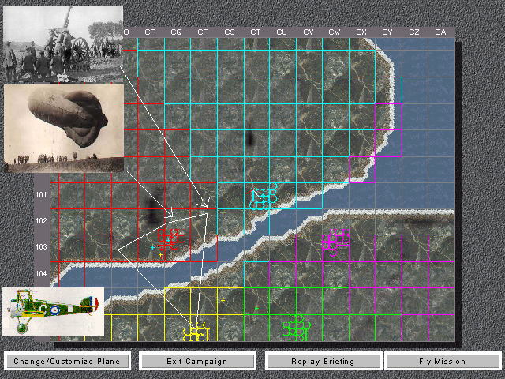
PICTURE IS PLACEHOLDER

Each mission is preceded by a briefing that takes the form of 2D and/or 3D images (maps, photographs, stock film etc) accompanied by audio. The purposes of these briefing screens are to lay out the mission objectives. The player’s commanding officer conducts the briefing. Pressing any button will end the briefing and bring the player into the Mission. This screen contains the following buttons:
- Plane Stats – Gives statistics of the default plane, as well as info about enemy planes the player can expect to encounter.
- Fly Mission – Takes the player into the game.
- Replay Briefing – will restart the Briefing (incl. Audio and animation)
- Options – brings the player to the Options Screen.
- Back – Will take the player back to the Pilot Profile Screen

Pause Menu (within the Game)
While playing the game, the player can press the Start button to bring up the Pause Menu. This screen has the following buttons:
- Resume – brings the player back into the game/mission.
- Restart mission – brings the player back to the Briefing Screen.
- Mission Overview – brings up the Mission Overview screen.
- Game Map – brings up the Game Map screen.
- Options – brings up the Options Menu.
- Quit – Will take the player back to the Pilot Profile Screen.

Game Maps
The game map, found on the in-flight pause menu flight, can tell you a lot about the status of friendly and enemy installations and radar coverage.
On the map are icons to show the location of various installations in the game world. Following are the various icons and what they represent:
Tank Group
Factory
Village
Railway station
Enemy Airfield
Allied Airfield
Ships (enemy and allied)
A small colored “X “symbol with two colored” tails represents your plane. The white line indicates your plane’s heading, while the colored line indicates the direction of the nearest enemy.

Enemy planes show up on the map as colored “+” signs. Allied planes show up on the map as white “+” signs.

Options Menu
This screen contains the following buttons:
- Controller configuration – brings the player to the Configure Controller Screen.
- Sound Options – brings the player to the Sound Options screen.
- Back – brings the player back to the Pause Menu.

Configure Controller Screen
Players can configure the controls to their liking and whatever they save will become the new default controls for that Player Profile. On top of allowing players to customize the controls to their liking this screen contains the following buttons:
- Back – brings the player back to the Options Menu.
- Cancel – cancels any changes to the controller the player may have made and brings the player back to the Options Menu.

The major functions used on the controller include:
Flight controls x-y (ailerons and elevators)
Throttle (up/down)
Rudders (left/right)
Fire guns
Fire rockets
Look around
Look around & up
Inside/outside view toggle

Following is a description of the types of functions that can be assigned to each controller button or stick type:

Triggers: guns/rockets, rudder
Sticks and D-pad: flight controls, look around/look around & up, throttle/rudder
Buttons: guns/rockets, view toggle, throttle

The default configuration will be:

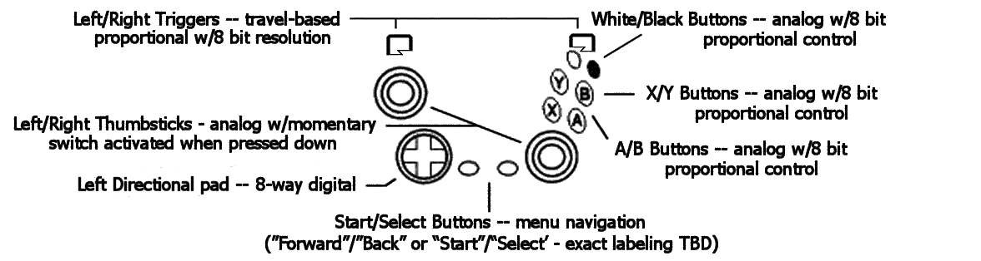



- Left trigger = fire rockets/bomb
- Right trigger = fire guns
- Left stick = flight control
- Right stick = throttle and rudder
- D-pad = look around
- D-pad (depressed) = look around & up

The controller configuration screen should include 4 assignment selections. The first is the default assignment, which cannot be altered. The other three are blank user configurations. Players will be able to customize one of the three configurations and then select that as their default controller. The last controller configuration used by a pilot is automatically saved for use with that pilot.

Sound Options Screen
This screen allows the player to adjust the current sound settings in the game. This screen has the following buttons:
- A slider allows the player to adjust music volume (high to low), sound volume (high to low), audio briefings (toggle on/off)
- Back – brings the player back to the Options Menu.
- Cancel – cancels any changes to the controller the player may have made and brings the player back to the Options Menu.

End Of Mission Screen
After the mission, the player will see a results screen whose text will depend upon how well the mission’s objectives were achieved. If the player set ‘high scores’ those mission stats will be saved in place of the previous high scores. This screen has the following buttons:
- Replay mission – restarts the Mission without going to the Briefing Screen first.
- Quit – Will take the player back to the Pilot Profile Screen.

Training Missions
Selecting Training Missions from the Main Menu allows the player to select one of the five Training Missions.

Training Mode Flowchart
Main Menu
Training Mission Screen
Briefing Screen
Game/Mission
Pause Screen

Options Screen
Configure Controller Screen
Sounds Options Screen

Once Training Missions is selected from the Main Menu, the player is brought to the Training Mission Screen.

Training Missions

Chesterfield will feature several training missions designed to give the player an opportunity to practice various combat techniques. Additionally, the training missions will also serve as “mini-games” that the player can adjust to provide additional gameplay.

The training missions presented will include:

Learning to Fly
Fighter vs. Fighter combat
Bomber Intercept combat
Dive Bombing
Torpedo Bombing
Rocket and Strafing attacks

For each mission we need to fill in:
Script:
Mission Briefing: (text)
Voice Actors:
Audio Script:

Mission 1: Fighter vs Fighter Combat

Synopsis:
Default Player Plane:
Default Enemy Planes:
Setup Options:
Map:

Mission 1: Fighter vs Fighter Combat

This mission allows the player to dogfight against enemy fighters. In its default condition, the player is dogfighting with a Spitfire I against a pair of 109Es. The enemy planes are at the minimum level of ability, which means they fire but never hit the player. When all planes in a group are shot down, a new set of enemy planes will spawn just outside of visual range and will fly toward the player.

Default Player Plane: Supermarine Spitfire Mk.Ia
Default Enemy Planes: 2x Messerschmitt Bf-109E-4

Setup Options:
Choose Player Plane (all Fighters in game)
Choose Enemy Plane (all Fighters in game)
Set Number Of Enemy Planes per spawn (1-10)
Set Enemy AI Level (??)
Set End Conditions (No end conditions, end after X time, end after X planes shot down)

Map: Water

Mission 2: Bomber Intercept Combat

This mission allows the player to practice bomber intercepts against a formation of bombers. In it’s default condition, the player is flying a Grumman F4F-4 Wildcat against a formation of three Betty bombers. The default AI is set so that the planes will shoot back at the player but will not hit. When all planes have been shot down out of a formation a new formation will spawn behind the former enemy group, just outside of visual range, and will follow the previous group’s heading.

Default Player Plane: Grumman F4F-4 Wildcat
Default Enemy Plane: 3x Mitsubishi G4M2 Betty

Setup Options:
Choose Player Plane (all fighters)
Choose Enemy Plane (all Bombers)
Set Number of Enemy Planes per formation (1-24)
Set Enemy AI level (??)
Set End Conditions (No end conditions, end after X minutes, end after X planes shot down)

Map: Water

Mission 3: Dive Bombing

This mission allows the player to practice dive-bombing attacks against ships and ground targets. In its default condition, the player is in a single SBD-2 Dauntless Dive Bomber with unlimited bombs. The map will include both land and sea area so that the player can practice against ships and ground targets. Ground targets include tanks and “villages”. At default level, the AA defenses will shoot but not hit the player. Tanks and ships will not be moving. Tanks and ships will spawn at random locations on the map. Buildings will repair themselves after 5 minutes.

Default Player Plane: Douglas SBD-2 Dauntless

Setup Options:
Choose Player Plane (all Fighter-Bombers, Stuka, SBD-2, Val, IL-2)
Set AA AI Level (??)
Set End Conditions (No end conditions, end after X time, end after X bomb drops)

Map: North Africa

Mission 4: Torpedo Bombing

This mission allows the player to practice torpedo-bombing attacks. In its default condition, the player is in an Avenger with an unlimited supply of torpedoes. Default AA AI level will shoot at the player but not hit. There will be about a half-dozen ships scattered about. New ships will spawn just out of visual range whenever a ship is sunk. Ships will be stationary.

Default Player Plane: Grumman TBF-1C Avenger

Setup Options:
Choose Player Plane (TBF-1C, Kate, Betty)
Set AA AI Level (??)
Set End Conditions (No end conditions, end after X minutes, end after X ships sunk)

Map: Water

Mission 5: Rocket & Strafing Attacks

This mission allows the player to practice strafing and rocket attacks against tanks and buildings. As a default, the player is in an IL-2 with unlimited rockets and ammo. The map will be populated with stationary tank columns and villages. When all tanks in a column are destroyed, a new column spawns at a random location on the map. Buildings regenerate after 5 minutes

Default Player Plane: Ilyushin IL-2m3 Stormovik

Setup Options:
Choose Player Plane (IL-2, Ju-87G, Me-262, FW-190A-8, TBF-1, P-38L)
Set AA AI level (??)
Set End Conditions (No end conditions, end after X minutes)

Map: Kursk

Training Mission Screen
This screen will list the five available Training Missions. The player uses the D-pad to select the desired mission. Once they have selected the mission they wish to play (and a confirmation dialog box is shown):
- If the player chooses ‘Yes’ from the confirmation box they are brought to the Briefing Screen.
- If the player chooses ‘No’ from the confirmation box they remain on the Training Mission Screen.

Training Mission Briefing Screen
Each mission is preceded by a briefing that takes the form of 2D and/or 3D images (maps, photographs, stock film etc) accompanied by audio. The purposes of these briefing screens are to lay out the mission objectives. The player’s commanding officer conducts the briefing. Pressing any button will end the briefing and bring the player into the Mission. This screen contains the following buttons:
- Plane Stats – Gives statistics of the default plane, as well as info about enemy planes the player can expect to encounter.
- Fly Mission – Takes the player into the game.
- Replay Briefing – will restart the Briefing (incl. Audio and animation)
- Options – brings the player to the Options Screen.
- Back – Will take the player back to the Training Mission Screen.

After the player has completed the Training Mission, they will be returned to the Training Mission Screen (where they can either play another Training Mission or return to the Main Menu).

Multiplayer Mode
To Be Designed.

Gameplay
Despite the fact that the single player game allows for bombing and other attacks against ground and sea targets, the multiplayer game will consist only of dogfighting arenas, which are designed to simulate each of the theaters represented in the single player game.

Arenas
We will provide five basic arenas pre-configured to the plane-set and map, each of which is based on the theaters in the single-player game.

Aircraft
The aircraft allowed in each arena will consist of the basic Allied and Axis aircraft presented in each of the single-player game arenas. Additional aircraft will be available, which players can “unlock” through a combination of single –player and multi-player gameplay.

Player Progression
The multiplayer game is linked with the single-player game in that players will be given limited access to online arenas and planes until they complete campaigns in the single-player game.

For example, when a player first gets the game, they will only be able to access the Battle Of Britain online arenas. Once they complete the Battle Of Britain campaign in the single player game, they will be allowed access to the Western Desert arenas.

New planes will be available to the player in each of the theaters based on how well they perform in the missions in the related single-player campaign. This same access to new planes applies to the Training Missions.

Rank
Players will receive points based on their accomplishments in each of the online theaters. These points will cross with a table of ranks for that theater, which will translate to a progression of enlisted and officer ranks in the related service.

This rank progression will be relatively easy in that a couple of weeks of play in each theater will enough to get to the maximum rank, considering a player of average ability.

Plane Tags
The online game will include text “tags” displayed near each aircraft, which show each player’s “name” and rank.

Chat
If the Xbox has a fully functioning and bug-free voice communications system complete by September 1, 2002, and we can get the programming resources to do it, we will be able to include voice chat in the arena. Otherwise, lacking a keyboard in the basic Xbox configuration, there will be no “chat” in the online game.

Online Mode Flowchart

Game views

There are three views supported in the game. By using the ‘view toggle’ button, the player will switch between the views. The default view for this game will be the Nose view. Subsequent presses of the view toggle button will take the player to Cockpit view, then to external view and then back to Nose view.

All forward game views will have a crosshair placed in the middle of the screen, for use in targeting enemy planes.

Nose

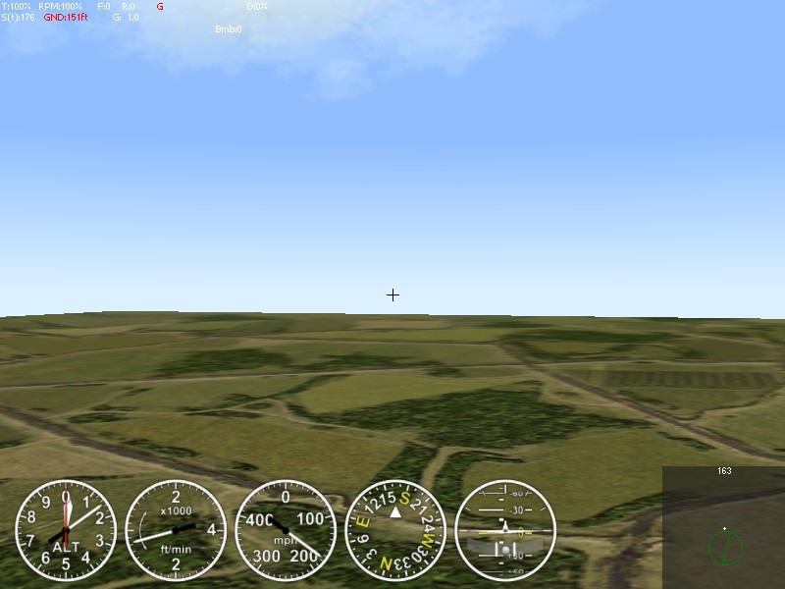

This fixed view is made from the nose of the aircraft and shows no part of the aircraft. For a description of what cockpit instrumentation is shown in Nose view, go to Cockpit Instrumentation/Information.

Cockpit

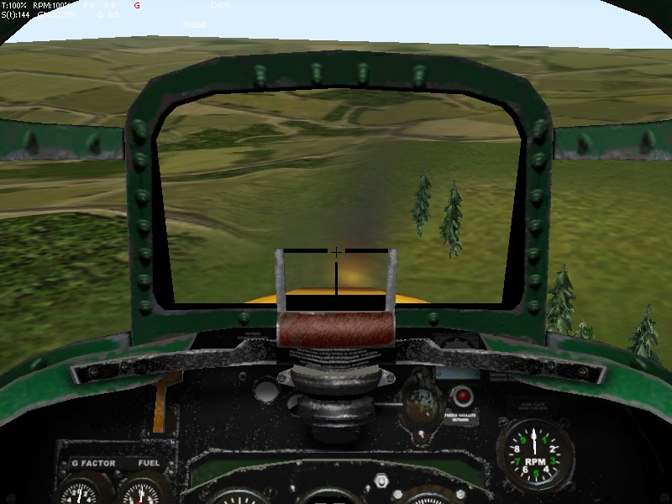

This view is from inside the cockpit and shows the cockpit controls. We will
make a standard cockpit view (by default) without cockpit and as options some
kinds of cockpit (pre-rendered or 3d without working indicators).

This fixed view is made from the nose of the aircraft and shows no part of the aircraft. For a description of what cockpit instrumentation is shown in Cockpit view, go to Cockpit Instrumentation/Information.

External

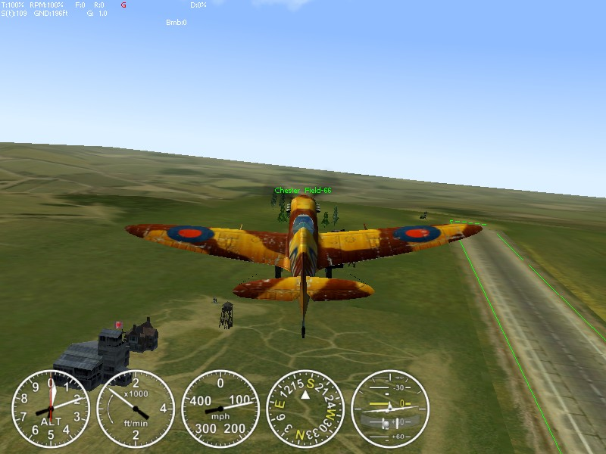

This view is from behind and slightly above the plane’s tail. This fixed view is made from the nose of the aircraft and shows no part of the aircraft. For a description of what cockpit instrumentation is shown in Cockpit view, go to Cockpit Instrumentation/Information.

Cockpit Instrumentation/Information
Regardless of the view the player chooses to play in, the Cockpit Instrumentation and Information remains the same; the difference is how it’s presented. The major difference is between the Cockpit view and the other three views.
The five major cockpit instruments/information are:
Airspeed: A measure of how much ground you are covering. Indicates the current airspeed and the type of airspeed indicator being used. In the long form, the scale is displayed after the airspeed value (mph or kph). The letter in parenthesis indicates the type of airspeed indicator being used, showing “t” for “true” and “i” for “indicated.”
Altimeter: The Altimeter that measures your height above the ground. This is very useful during combat because you want to know how much room you have to maneuver.
Compass: Displays the direction the player is flying.
Turn & Bank Indicator: Displays the angle/levelness that player is flying.
Climb Rate: Displays the rate that the player is climbing in altitude.
In Cockpit Views, the above information is displayed as part of the planes’ unique cockpits. In the other views, the above information is displayed as circular dials.
The following information will also be displayed, regardless of the view the player is using. Unlike FA, it would be best if this information can be conveyed graphically, as opposed to just using numbers and letter abbreviations.
Throttle / T⎯The current throttle setting, displayed as a percentage of maximum. When you use WEP (War Emergency Power), “WEP” is displayed instead of a percentage. On multi-engine aircraft, the throttle and rpm settings are displayed together in the form 100/100, where the number before the slash is the throttle and the number after is the slash the rpm setting. When the engine if off, this display is grayed, but turns white when the engine is started.
Damage: / D⎯Indicates the amount of damage done to your plane, expressed as a percentage of maximum damage. When damage is at 0, the indicator is white, but turns red as soon as any damage is applied.
Ammunition / Ammo⎯Displays the remaining ammunition as a percentage, as well as displaying the exact number of rounds of each type remaining. Rounds remaining are displayed as primary gun rounds followed by secondary gun rounds.
Bomb⎯Displays the number of bombs remaining (when flying a plane capable of dropping bombs.)
Rockets / Rckt⎯Displays the number of rockets remaining (when flying a plane capable of firing rockets.)

Torpedoes / Torp⎯Displays the number of torpedoes remaining (when flying a plane capable of firing torpedoes.)

Weather
The game will feature several different weather patterns. To add variations to the game, a ‘randomize weather’ generator will be implemented which will assign a specific weather condition to a specific mission. It is important to note that the different missions have been to work with specific weather patterns. For example, a mission in the Western Desert would never take place in a snowy environment.

- Sunny/Clear skies: clear blue sky, almost no clouds

- Cloudy: clear sky, lots of fluffy clouds

- Foggy: low lying clouds obscure the ground, sunny above

- Overcast: grey sky, completely covered by cloud layer, some rain

- Stormy: heavy cloud layer covering sky, rain squalls, lightning

- Sunset: clear sky with some clouds, sun at horizon or below so that clouds and sky light up in brilliant colors

- Snowy: special variant of Stormy weather. Snow in the ground and snow in the sky. Note: Snowy would only apply to the Battle of Germany Campaign.

Sun Glare
Sun glare will be used to provide an additional gameplay element. Players will not be able to see aircraft that are “in the sun”, which will enable real-world tactics to be successfully employed.

Clouds
3D clouds will be used. When an aircraft enters a cloud, others see it gradually go transparent. The pilot of the plane will see his world gradually obscured by a gray “fogging” effect.

Weapons
Following are descriptions of the weapons that are to be used in this game.

Since this game is meant to be arcadey, we will not limit the players to historically accurate loadouts. The amount of ammo given to a player will depend not only on the type of plane they are flying but also the difficulty level, which they are playing.

 | Easy | Medium | Hard
Guns | Unlimited | 4 x historically accurate figure | Historically Accurate figure.
Rockets | 4 x historically accurate figure | 2 x historically accurate figure | Historically Accurate figure.
Bombs | 4 x historically accurate figure | 2 x historically accurate figure | Historically Accurate figure.
Torpedoes | 4 x historically accurate figure | 2 x historically accurate figure | Historically Accurate figure.

Bombs
TBD.

Rockets
The following parameters that affect rockets within the game are needed:

- The name of the rocket (if known) and its country of usage.

- The “type” of rocket, which is its approximate size. Possible types are:

1 ~ 45 mm
2 ~ 82 mm
3 ~ 120 mm
4 ~ 210 mm

- The “sub-type”. This is an integer from 0 to 15 that serves as an identifier when combined with the type.

- The physical mass of the rocket, measured in kilograms, which is added to the overall aircraft weight. Possible values are integers between 1 and 500.

- The caliber of the rocket, measured in millimeters. This is used to calculate the amount of drag the rocket will contribute. Possible values are integers between 40 and 750.

- The length of the rocket, measured in centimeters. This is used when calculating the “flight” trajectory of a rocket as it travels to its target, and does not need to be 100% precise. Possible values are integers between 30 and 1500.

- The “power” of the rocket, which is the amount of damage it will inflict. This is an arbitrary value that is balanced with the armor value of the objects in the game. Possible values are integers between 10 and 10,000.

- The seventh field is the “life” of the rocket, which is a measure of its maximum flight time, measured in “ticks”. The rocket life is its burn time, after which it will either disappear or explode. A “tick” is 1/50 of second. Possible values are integers between 100 and 500.

- The terminal behavior of the rocket. (i.e. A value of 0 indicates that the rocket disappears after its life is over and a value of 1 indicates that it explodes instead. A value of 0 therefore represents an impact only rocket, while a value of 1 indicates an impact and timed fuse rocket.)

Guns
The following parameters that affect guns within the game are needed:

- The name of the gun with the country of usage in parenthesis.

- The “type”. The type groups the gun according to caliber. Possible gun types are:

0 = Rifle Caliber Machine Guns (RCMG): caliber is less than or equal 10mm
1 = Heavy Machine Guns (HMG): caliber is greater than 10mm and less than or equal to 19mm
2 = Light Cannon: caliber is greater than 19mm and less than or equal to 23mm
3 = Cannon: caliber is greater than 23mm and less than or equal to 36mm
4 = Heavy Cannon: caliber is greater than 36mm

- The physical mass of the gun, measured in kilograms. This used in calculating the total aircraft weight. Possible values are real numbers between 1 and 1000.

- The caliber of the gun, measured in millimeters. Possible values are real numbers between 5 and 57 (inclusive).

- The gun’s rate of fire, measured in rounds per minute. Possible values are integers between 30 and 4800 (inclusive).

- The amount of time of continuous fire that will cause the gun to overheat, measured in seconds. After overheating, the gun must go unfired for half of same period before it can be fired again. Possible values are real numbers between 0.8 and 240 (inclusive).

- The muzzle velocity of the round as it comes out of the gun, measured in meters per second. Possible values are real numbers between 200 and 1275 (inclusive).

- The “life” of the bullet, measured in “ticks”. The bullet life is the amount of time it will exist in the world. When the life is expired, the bullet object is removed from the game. The amount of distance the bullet will travel before it is eliminated is based on its initial velocity (muzzle velocity plus aircraft speed), round weight, and drag. A “tick” is 1/50 of second. Possible values are integers between 5 and 150 (inclusive).

- The mass of the bullet, in kilograms. Note that since different types of rounds (tracer, API, HE, etc.) all have minor weight differences, the average weight should be used. This affects bullet drop and terminal energy, when combined with velocity. Possible values are real numbers between 0.001 and 100.

- The amount of damage that is done by solid (armor-piercing) rounds. The damage is an arbitrary value and is balanced with the armor value of the various objects within the game. Possible values are real numbers between 0.5 and 1000.

- The amount of damage that is done by high explosive rounds. The damage is an arbitrary value and is balanced with the armor value of the various objects within the game. Possible values are real numbers between 0.5 and 1000 (inclusive).

- The “dispersion” value of the gun, which is an arbitrary measure designed to simulate the instability of a moving aircraft as a gun platform. As dispersion is increased, the more the bullet path can diverge from a straight-line. Possible values are real numbers between 0.0001 and 0.05, with a resolution of four decimal places. The default values are 0.012 for cannon and 0.008 for machine guns. The value is the sine of maximum angle of bullet path inclination from gun direction.

- The total number of rounds in a “chain”, which is a pre-defined pattern of different types of rounds “chained” throughout the belt or drum of ammunition. Possible values are integers between 4 and 10. For example, a chain might be 1 tracer round followed by 1 armor-piercing round followed by 1 high explosive round. This pattern would be repeated throughout the ammunition source. The specified “type” of gun determines the basic makeup of the chain and the “chain” value determines how many normal rounds are used in combination with the predefined number of other rounds. The makeups of the chains are as follows:

For AI gunners:

Types 0,1 = tracers only

Types 2,3,4 = tracers, then single HE shell at the end of chain

For pilot-controlled weapons:

Type 0 =1 tracer and 1 incendiary within first 4 rounds, mixed with and followed by N-2 armor-piercing shells, where N is chain length

Type 1 = 1 tracer and 2 armor piercing within first 4 rounds, mixed with and followed by N-3 incendiary/explosive shells

Types 2,3,4 = 1 tracer within first 4 rounds, mixed with and followed by N-1 high-explosive shells

Note that the damage and mass of tracer and incendiary rounds differs from that of armor-piercing rounds, using the following table:

Type 0: tracers and incendiary = HE damage (11th field, should be lower than AP damage - 10th field), mass * 0.8

Type 1: tracers = AP damage * 0.8, mass * 0.8;
incendiary/explosive = HE damage (value may be slightly higher or lower than AP damage), mass*0.9

Type 2: tracers = AP damage * 0.7, mass * 0.75
explosive = HE damage (value should be higher than AP damage, especially for GE guns), mass*0.9

Type 3: tracers = AP damage * 0.7, mass * 0.8
explosive = HE damage (value should be higher than AP damage, especially for GE guns), mass*0.9

Type 4: tracers = AP damage * 0.7, mass * 0.85
explosive = HE damage (value should be significantly higher than AP damage), mass*0.9

Torpedoes
The following parameters that affect torpedos within the game are needed:

- The “type” of torpedo, which defines whether the torpedo is an early war or late-war torpedo. Possible types are: early-war and late-war

- The name of the torpedo (if known) and its country of usage.

- The “sub-type” of torpedo - serves as an identifier when combined with the type and usually corresponds to the country of origin id. Note that each individual torpedo within the same “type” classification must have a unique sub-type identifier.

- The physical mass of the torpedo, measured in kilograms. This is applied to the overall aircraft weight. Possible values are integers between 300 and 1600.

- The caliber of the torpedo, measured in millimeters. This is used to calculate the amount of drag the torpedo will contribute when carried externally. Possible values are integers between 300 and 800.

- The length of the torpedo, measured in centimeters. This is used when calculating the “flight” trajectory of the torpedo as it travels falls from the plane, and does not need to be 100% precise. Possible values are integers between 200 and 800.

- The “power” of the torpedo, which is the amount of damage it will inflict. This is an arbitrary value that is balanced with the armor value of the objects in the game. Possible values are integers between 5,000 and 50,000.

- The “life” of the torpedo, which is a measure of its maximum travel time in the water, measured in seconds. After the life has expired, the torpedo disappears from the game. Possible values are integers between 50 and 250.

- The speed of the torpedo in the water, as it travels to its target, measured in centimeters per second. Possible values are integers between 500 and 3,000.

Damage System

Aircraft Damage

1. Each aircraft is composed of a series of invisible "hit boxes", which detect impact with bullet and shrapnel objects. These boxes are defined below. If the aircraft does not have one of the specified component types, that box is not present in the aircraft model. Note that some objects have multiple collision detection boxes.

0 - overall surrounding box
1..4 - boxes of fuselage single or first
5..7 - second fuselage (e.g. P38), but in case we have single fuselage, these may be boxes of this single fuselage
8..10 - third fuselage (e.g. P38)
11..20 - pilots' cabin
21..26 - left wing
27..30 - left wing lower (for biplane), but in case monoplane - still this single left console
31..36 - right wing
37..46 - right wing lower (biplane)
41..44 - rudder single or central or left (in case 2 rudders - then left, in case 3 - then central)
45..48 - second rudder - right
49..50 - third rudder (left)
51..54 - elevator left
55..58 - elevator right
59..60 - central or lower elevator
61..65 - engine (single or left inner)
66..70 - engine 2 (right)
71..75 - engine 3 (leftmost)
76..80 - engine 4 (rightmost)
81..82 - gunner's cabin 1st
83..84 - gunner's cabin 2nd
85..86 - gunner's cabin 3rd
87..88 - gunner's cabin 4th
89..90 - gunner's cabin 5th
91..92 - gunner's cabin 6th
93..94 - gunner's cabin 7th
95..96 - gunner's cabin 8th
97..98 - gunner's cabin 9th

2. An "aircraft_C.txt" file exists for each plane in the game. This file contains information about the location, dimensions, and capacities of all parent and child objects on the plane, except:

engine(s)
cockpit
gunner's compartments
internal and external ordnance

For damage purposes, the only data that matters in these files is:

iResist - the component's "resistance" to accepting damage, this value acts as a divider on the damage done to the component
iDmgPossib - the chance that each sub-child will be the object that gets damaged by the hit. The iDmgPossib value for main child components is obsolete and is thus ignored.
iDmgWeight - the percentage of damage that is applied to the overall aircraft damage state.

3. Engines are both parent and child objects. As parents, they have their own hit box and can be damaged directly. As children they can be damaged by random distribution from the relevant parent object (fuselage or wing). All engines have

iDmgPossib = 5

when viewed as child objects (iDmgPossib is meaningless for parent objects). The iResist value for each engine can be found in the "aircraft_E.txt" file.

The DmgWeight for each engine is hard-coded based on the number of engines on the plane:

1 engine = 40
2 engines = 25
3 engines = 20
4 engines = 20

4. Internal and external stores (bombs, rockets, drop tanks, and torpedoes) have the following hard-coded values:

iDmgPossib = 5
iResist (internal stores) = 50
iResist (external stores) = 25
iDmgWeight = 5

5. When a hit is detected on the hit box, the damage distribution and calculation is done using the following steps:

a. Cross reference the hit box with the child object (fuselage, wing, etc.).

b. Check to see if a sub-child was hit or not. To do this, take the individual iDmgPossib values for each sub-child and enumerate them into a table of chances, 1-100. For example, the A-20 left wing has 4 children:

Aileron (iDmg = 10)
Flap (iDmg = 20)
Fuel Tank (iDmg = 30)
Gear (iDmg = 10)

This creates a "distribution table" as follows:

Aileron 1-10
Flap 11-30
Fuel Tank 31-60
Gear 61-70
Wing 71-100

A random number between 1 and 100 is generated and the result is crossed with the distribution channel to determine which object was hit.

c. If a sub-child is hit, determine how much of the damage it will receive, with the rest going to the main child object. The formula used to determine how much of the original damage is applied to the sub-child object is:

Damage to sub-child = DmgPower * iDmgPossib * 0.02

For example, assuming a .30 cal bullet does 3 points of damage and the aileron from the above table was hit, the amount of damage done to the aileron would be:

Damage = 3 * 10 * 0.02 = 0.6 pts

The remainder of the 3 points (2.4 pts) would be applied to the main wing structure itself.

d. Determine the percentage of damage done to each child and sub-child using the following formula:

( DmgPower * ( 100 - PlnType * 5 )) / iResist )

Note that PlnType is a value intended to reduce damage done to larger planes like heavy bombers. A 0 plane type is a small, vulnerable fighter, while a 4 is a large, heavy bomber. Each aircraft's PlnType can be found in the relevant "aircraft_P.txt" file and is as follows:

0 = all fighters
1 = attack planes (A-20, Mosq FB VI, Mosq XVIII, IL-2, IL-10, Ju-87G)
2 = dive/torpedo bombers (SBD-2, TBF-1, Mosq B IV, Mosq B IX, Pe-2, Tu-2, Ju-87D, Ju-88A4, D3A, B5N)
3 = medium bombers (B-25, Do-217, G4M2, Ki-67)
4 = heavy bombers (B-17, Lancaster)
5 = reserved for future use

Note also that the minimum amount of damage that can be applied is 0.1% of the total.

Assuming a PlnType of 0 in the above example (to simplify the basic math), we calculate the damage done to each component. Continuing our example from above, the aileron would receive:

( 0.6 * ( 100 - 0 * 5 )) / 10 ) = ( 0.6 * 100 / 10 ) = 6%

and the main wing structure itself would receive:

( 2.4 * ( 100 - 0 * 5 )) / 675 ) = ( 2.4 * 100 / 675 ) = 0.35% round to 0.4%

6. In addition to being destroyed by receiving 100% damage, engines can be destroyed with either a single hit or through random chance meant to simulate production faults. Note that random failures can be enabled or disabled in the arena configuration file.

7. If the damage done to a main child component reaches a "critical" level or if a single hit is strong enough, the main component will fail. What are the critical levels???? Where can I find them? How much is "strong enough" of a hit? Is it different for each component? where do I find it??

Otherwise, once a component receives 100% damage it will fail. In the case of a structural component like the wing or fuselage, the failure will result in the component breaking.

Building Damage
Building damage will use the typical building damage calculations from FA3.0.

Vehicle Damage
Vehicle damage will use the typical vehicle damage calculations from FA3.0.

Ship Damage
1. All ships will have their hull divided into 4 identically sized "damage boxes", a forward port box, aft port, forward starboard, and aft starboard box.

2. Carriers will have an additional box to represent the flight deck.

3. Hits and near misses will damage the boxes in the same way that they damage buildings, tanks, and aircraft components.

4. In addition to normal damage, each hit (not a near miss) has a random chance of causing "critical damage". The chance modifiers should allow for a 0-100% chance of doing critical damage.

5. Critical damage will multiply the amount of damage done to the box. The size of the multiplier should be randomly selectable within a value range. I want to be able to set the minimum and maximum multipliers for critical damage to any value from 0 to 50, inclusive.

6. Damage effects at different percentages of damage will be as follows:

10% damage attained = thin white smoke
25% damage attained = thin plume of black smoke
50% damage attained = fire and thick black smoke
75% damage attained = list the ship in the direction of the affected box
100% damage = sink the ship in the direction of the affected box

7. The flight deck will behave differently than the hull damage boxes. The flight deck itself does not actually take damage that has any effect on sinking. Instead of applying damage to the flight deck, we use the flight deck damage box merely for the purpose of checking for critical hits.

8. The flight deck should be able to be able to be set to accept craters or not. If it does accept craters it would act in the same way as craters on an airfield. We need an arena config entry to allow carrier decks to be cratered or not.

It is hard to make craters on carrier. Current craters management system can't handle moving craters. I offer to prohibit craters on carrier deck.

9. A hit to the flight deck that does not generate a critical hit would still do "cratering" damage (if enabled) and blast damage to nearby planes and AA guns (if they can be damaged).

10. A hit to the flight deck, which results in a critical hit causes the calculated amount of damage to be applied to the nearest hull damage box. This simulates an internal explosion of fuel or ordnance.

11. When a hull box of a carrier receives "list" type damage, the carrier should be removed from the list of usable airfields and all related game bookkeeping will take place.

12. When a hull box receives "sink" type damage, the ship is considered destroyed at that point. This will cause points and sinking credit to be given to the player who did the final damage, as well as all team scoring and other bookkeeping.

13. Alexander's water weight sinking model is applied whenever "list" or "sink" damage is done to a hull box. In the case of list damage, an amount of water should be put into the section to cause the ship to visibly list and show that that quarter of the hull is damaged badly. You can put this water in at any point within the bounds of the box. The necessary amount of water should be put into the box within 30 seconds of the damage being applied to the box. This can be done instantly if it will look good or can be spread over the 30 seconds if that will look better.

When sinking damage is applied to a box, put the necessary amount of water into that box within 30 seconds of the damage being applied. As with list damage, it can be done instantly or spread out over the period of time, as you see fit.

It is important that users be able to see the fruits of their labor. The pilot that drops the torpedo that sinks the carrier should be able to see the carrier sink within a reasonable amount of time. If you all think 30 seconds is not right, we can adjust up or down, but it should be fairly quickly.

14. All damage boxes are repaired simultaneously in the same way that buildings at a scene are repaired. We will need some control over the amount of damage repaired during each time slice. We will need to know the length of the time slice, but will not need direct control over it.

15. When a list damaged ship repairs itself to lose the list, it should pump the water out of the section fairly quickly, though it doesn't have to be as quick as we listed it (30 seconds), it should be quick enough that players will be able to resume air operations from the non-listed ship within 2 minutes of the damage being repaired. Do not make the carrier a selectable airfield until it is no longer physically listed.

16. Each hull damage box will have initial values of fDmgState = 100 and iResist = 950. These are the maximum values for these factors. If this isn't enough, we'll need to look at the arbitrary limitations of the damage system for resolution. We can let all ships have the same damage levels for now and adjust it during testing.

17. Smoke and fire effects should emerge from the side of the hull, about halfway from the water line to the deck. Since there will never be more than 4 boxes on a ship, smoke effects should be capable of lasting at least as long as they do from buildings on airfields. If smoke is not persistent, then it should be triggered with each hit as long as the damage level is above the required level for that type of smoke/fire.

Game Statistics

Game Statistics are those used by the game engine to define a plane’s performance;
Researched Statistics are real-world performance statistics from historical sources;
Derived Statistics are game statistics whose value is set by calculations from researched statistics.

Game Statistics
The following statistics are used to define aircraft performance in the game. Game statistics are subject to change during testing, in order to optimize gameplay. Game statistics can be edited using the PlaneEditor.exe program.

Guns
The number of machine guns on the plane: min: 1, max: 2

Stall
Minimal take-off speed: min: 40 mph, max: 70 mph

Speed
Top speed: min: 120 mph, max: 200 mph

Acceleration
Current max acceleration is about 5 m/s² (~1/2 g). The limits for acceleration should be 3-6 m/s²

Pull-Out
The ability to pull out of dives (or put another way - altitude adjustment time): min: 1, max: 5

Armor
The ability to take damage (or, 'armor points'): min: 100, max: 200

Maneuverability
The ability to quickly change direction in turns: min: 1, max: 5

Researched Statistics
The following statistics were available from historical sources. Where values vary, the value giving the best plane performance was chosen, except in cases where this was so far different from the majority of historical sources as to suggest a typo or other error.

Guns
Both sides used calibers between 7.69 and 8mm; for the purposes of the game all machine guns are to be regarded as identical.

Speed
Top speed at any altitude, in km/h.

HP
Engine horsepower.

Wing Area
Total wing area in square meters.

Weight
Maximum loaded weight in kg.

Wingspan
Wingspan in meters.

Length
Fuselage length in meters.

Derived Statistics
NOTE: The calculation of all derived statistics is subject to change. These calculations are used in FA3.0 and are therefore more realistic than we want for use in Project: Chesterfield. One of the main goals of FA3.5 is to improve their arcade physics. Therefore, the Project: Chesterfield team will work closely with the FA3.5 team in developing ‘arcade’ calculations for use with both titles.

Stall
Using (5-maneuverability)*(5/8)*33 to convert from km/h to mph and give a value from 30-70 mph.

Acceleration
Using 20*(engine horsepower)/(max weight kg) to give a value from 2-6 m/s²

Pull-Out and Maneuverability
Using 100*(wing area m²)/(max weight kg) to give a value from 1-5. Same value for both statistics.

Scoring
Throughout the game, the player will be earning scores based on their performance. The scores will be numerically calculated with these numbers being used to determine what medals (if any) the player has earned.

For example, a score of 5000 may earn the player a Pacific Star. The points given have been designed to make it impossible to earn the highest medals while playing on Easy Level, and therefore hopefully increasing the replayability level.

Scoring Appendix

The following chart lists the activities and the points the players earn during a mission. For exact damage capacity numbers go to that object’s description using the hyperlink.

 | End of Mission Bonuses | + | + | +
All | All targets destroyed  Missions 1-4  Missions 5-8  Missions 9-12  Missions 13-16  Missions 17-20 | 1000  2000  3000  4000  5000 | 2000  3000  4000  5000  6000 | 3000  4000  5000  7500  10000
All except when player flies alone. | All allied planes survival bonus  Missions 1-4  Missions 5-8  Missions 9-12  Missions 13-16  Missions 17-20 | 2000  3000  4000  5000  6000 | 3000  4000  5000  6000  7000 | 4000  5000  6000  7500  10000
All except when player flies alone. | Per Allied plane survival bonus.  Missions 1-4 (per plane)  Missions 5-8 (per plane)  Missions 9-12 (per plane)  Missions 13-16 (per plane)  Missions 17-20 (per plane) | 100  250  500  750  1000 | 250  500  750  1000  1500 | 500  750  1000  1500  2000
1 4 8 9 14 | All targets defended - survival bonus.  Missions 1 & 4  Missions 8 & 9  Missions 14 | 5000  7500  1000 | 7500  10000  12500 | 10000  15000  20000
 | Task |  | hit/kill
Mission # | Hitting/Destroying Enemy Plane | + Easy | + Med | + Hard
1, 2 | Ju-87D-3 Stuka | 10/50 | 20/75 | 30/100
2, 3, 4 | Messerschmitt Bf-109E-4 | 10/50 | 20/75 | 30/100
5,6,7,8 | Messerschmitt Bf-109F-4 | 15/75 | 30/100 | 45/125
18, 19 | Messerschmitt Bf-109G-6 | 75/175 | 100/200 | 125/250
19, 20 | Messerschmitt Me-262 Schwalbe | 100/200 | 175/250 | 200/300
4 | Junkers Ju-88A-4 | 10/50 | 20/75 | 30/100
7,14 | Junkers Ju-87G-1 Stuka | 45/150 | 60/175 | 85/225
14 | Junkers Ju-87D Stuka | 45/150 | 60/175 | 85/225
13, 14, 15, 16 | Focke-Wulf FW-190A-4 | 45/150 | 60/175 | 85/225
17,18 | Focke-Wulf FW-190A-8 | 75/175 | 100/200 | 125/250
19, 20 | Focke-Wulf FW-190D-9 | 100/200 | 175/250 | 200/300
9 | Aichi D3A1 Val | 25/100 | 40/125 | 50/150
9 | Mitsubishi B5N2 Kate | 25/100 | 40/125 | 50/150
10, 11, 12 | Mitsubishi A6M2 Zero | 30/125 | 50/150 | 75/200
11 | Mitsubishi G4M2 Betty | 30/125 | 50/150 | 75/200
Mission # | Hitting/Destroying Enemy Object | + Easy | + Med | + Hard
6, 8, 15, 16 | Tiger Tank - German  Missions 6 & 8  Missions 15 & 16 | 25/100  50/200 | 40/125  80/250 | 50/150  100/300
15, 16 | Panther Tank - German | 50/200 | 80/250 | 100/300
10 | Japanese Cruiser # 1 | 150/300 | 250/500 | 400/1000
12 | Japanese Cruiser # 2 | 150/300 | 250/500 | 400/1000
10 | Japanese Battleship | 200/400 | 300/600 | 500/1500
12 | Japanese Carrier | 150/300 | 250/500 | 400/1000
9 | Japanese Submarine | 200/350 | 300/600 | 450/1250
10 | Japanese Torpedo Boat | 200/350 | 300/600 | 450/1250
1 | German Torpedo Boat | 25/100 | 40/125 | 50/150
17 | German Train | 150/250 | 400/1000 | 500/1500
6, 13, 20 | German AA Guns  Missions 6  Missions 13  Mission 20 | 10/50  20/75  30/100 | 20/75  30/100  45/125 | 45/125  55/150  75/175
11 | Japanese Airfield AA Guns | 20/75 | 30/100 | 55/150
10 | Japanese Observation Post | 250/350 | 750/1500 | 1000/3000
13 | German Airfield Strip | 30/100 | 45/125 | 75/175
20 | German Jet Base | 250/500 | 500/1000 | 750/2500
6 | German Supply Depot | 45/150 | 60/175 | 85/225
6, 13 | German Enemy Building #1  Missions 6  Missions 13 | 25/100  50/150 | 40/125  80/200 | 50/150  100/300
6, 13 | German Enemy Building #2  Missions 6  Missions 13 | 25/100  50/150 | 40/125  80/200 | 50/150  100/300
6 | Destroy German Artillery Site | 50/125 | 75/200 | 150/300
17 | German Train Tunnel | 250/350 | 750/1500 | 1000/3000
17 | German Train Station | 350/700 | 1500/3000 | 2000/4000
 | Mission Specific Bonuses | + | + | +
1 | Points remaining to British cargo ship. (points/point remaining) | 25 | 50 | 75
2 | Points remaining to British airfield strip. | 25 | 50 | 75
2 3 | Wingman survives. | 50 | 100 | 150
4 | London Bridge Survival Bonus | 200 | 500 | 1000
4 | Westminster Survival Bonus. | 300 | 750 | 1500
4 | St. James’ Cathedral, Survival Bonus. | 250 | 600 | 1250
4 | TDB-London Building Survival Bonus. | 200 | 500 | 1000
5 | Destroying Messerschmitt Bf-109F-4 before it makes second strafing run. | 500 | 1000 | 2000
7 | Destroy Junkers Ju-87G-1 Stuka before it strafes | 750 | 1500 | 3000
7 | Destroy Junkers Ju-87G-1 Stuka before it drops its bombs. | 750 | 1500 | 3000
7 | Cromwell tanks (per surviving tank). | 500 | 750 | 1000
8 | Player’s distance from airfield when last tank is killed or disabled (point/mile) | 100 | 200 | 300
9 | Destroy Aichi D3A1 Val / Mitsubishi B5N2 Kate before it attacks (per plane). | 1000 | 2500 | 3500
9 | Destroy Aichi D3A1 Val before it drops its bombs. | 1500 | 3000 | 4000
9 | US carrier survival. | 2000 | 3500 | 5000
9 | US cruiser survival. | 2000 | 3500 | 5000
11 | Destroy Mitsubishi G4M2 Betty before it drops bombs | 1750 | 3250 | 4500
11 | Points remaining British airfield strip. | 100 | 200 | 300
14 | Destroy Junkers Ju-87D Stuka / Junkers Ju-87G Stuka / Focke-Wulf FW-190A-4 plane before it drops its bombs. | 2000 | 4000 | 6000
14 | T34 tank survival bonus (Per tank remaining). | 1500 | 3500 | 5000
18 | Destroy Messerschmitt Bf-109G-6 before it exhausts its cannon load. | 2500 | 5000 | 7000
19 | Bridge survival bonus (Per points remaining/Bonus if bridge is at perfect health). | 250 | 500 | 1000
20 | All Messerschmitt Me-262 Schwalbe destroyed. | 5000 | 10000 | 15000
 | Points Lost
 | Allied Target Hit/Destroyed | - | - | -
All | Damage taken to player’s plane (per damage point taken). | 30 | 50 | 75
Almost all. Not 1. | Allied plane destroyed. | 100 | 200 | 500
1 | British cargo ship | 25/100 | 50/150 | 75/200
2 | British airfield strip | 25/125 | 50/175 | 75/225
5 | British Airfield Building #1 | 35/175 | 70/200 | 100/300
5 | British Airfield Building #2 | 35/175 | 70/200 | 100/300
4 | London Bridge | 50/200 | 100/500 | 250/2000
4 | Westminster | 75/300 | 150/750 | 300/3000
4 | TDB-London Building | 50/200 | 100/500 | 250/2000
4 | St. James’ Cathedral | 75/300 | 150/750 | 300/3000
7 | Cromwell - British Tank | 50/200 | 80/250 | 100/300
14 | T-34 - British Tank | 50/200 | 80/250 | 100/300
9 | American Carrier | 150/300 | 250/500 | 400/1000
9 | American Cruiser | 150/300 | 250/500 | 400/1000
2, 5 | British Airfield AA Guns | 20/75 | 30/100 | 55/150
19 | American Airfield AA Guns | 30/100 | 45/125 | 75/175
4 | London AA Guns | 20/75 | 30/100 | 55/150
19 | Bridge | 50/500 | 100/2000 | 250/5000
5 | Gas tanks and Ammo | 35/175 | 70/200 | 100/300
 | Time Remaining | + | + | +

*Wherever applicable
Graphics
Wherever possible, the graphics will be taken from Fighter Ace III. All of the planes already exist although some new textures may be needed for some. (Such as Messerschmitt Bf-109F-4 which requires a pink cammo scheme used in FA3 beta.)

Game Objects

British Planes

Hawker Hurricane Mk.Ia

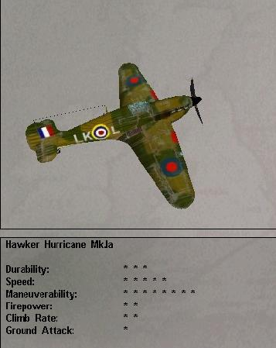

Found in Mission: 1, 2, 4
Damage Capacity:
Loadout:
- Mission 1, 2, 4 – full ammunition load
AI scripts:
- Mission 2 – TBD
- Mission 4 - those engaged by 109s will try to defend themselves and keep the 109s occupied, while the other fighters go for the bombers

Hurricane Mk.IIc

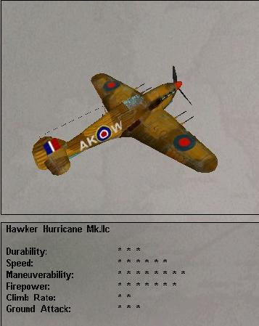

Found in Mission: 6, 8
Damage Capacity:
Loadout:
- Mission 6 –2x 500 lb bombs and full ammo load each full ammunition load
- Mission 8 - 2x 500 lb bombs and full ammo load
AI scripts:
- Mission 6 - will dive and drop bombs on targets in the supply dump, will then strafe the dump until the 109s arrive, after which they will fight their way back to friendly lines
- Mission 8 - drop bombs on tanks, then strafe after bombs are gone. They evade the 109s and will home in their attacks on the tanks

Supermarine Spitfire Mk.Ia

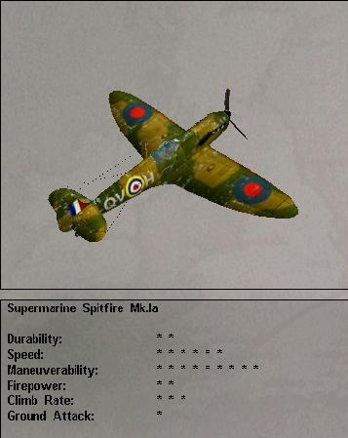

Found in Mission: 3, 4
Damage Capacity:
Loadout:
- Mission 3 – full ammo load
- Mission 4 - full ammo load
AI scripts:
- Mission 3 - will try to shoot down 109s with help of player. will try to do teamwork with player, calling out several basic moves. will chase the 109s as far as the middle of the channel, unless the player turns back
- Mission 4 - those engaged by 109s will try to defend themselves and keep the 109s occupied, while the other fighters go for the bombers

Supermarine Spitfire MkVb (Trop)

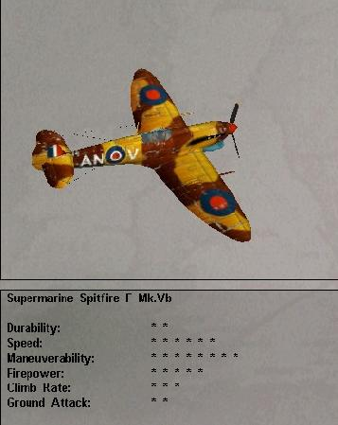

Found in Mission: 5, 7
Damage Capacity:
Loadout:
- Mission 5 – full ammo load
- Mission 7 - full ammo load
AI scripts:
- Mission 5 - The second Spit will try to shoot down 109s and will turn back for home when the player does.
- Mission 7 - will try to shoot down Stukas above all, but if forced to fight a 109 will do so. Will chase the GE planes back to the front lines, and then turn for home

British Mosquito Bomber
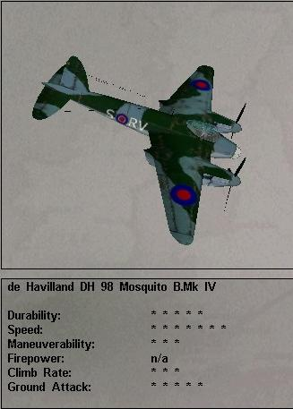

Found in Mission: 7
Damage Capacity:
Loadout:
- Mission 7 – no ammo, no gunners
AI scripts:
- Mission 7 - Head for home base at full speed.

Supermarine Seafire Mk.IIIb
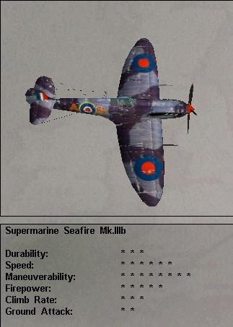

Found in Mission: Online Play (Online Play Guadalcanal (1942) arena)
Damage Capacity:
Loadout:

Hawker Typhoon Mk.Ib
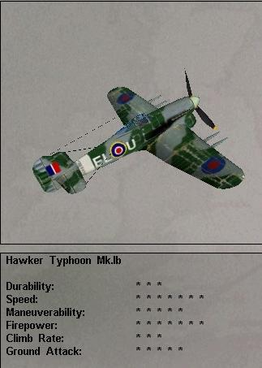

Found in Mission: Online Play (Online Play Kursk (1943) arena)
Damage Capacity:
Loadout:

Supermarine Spitfire Mk.IXc
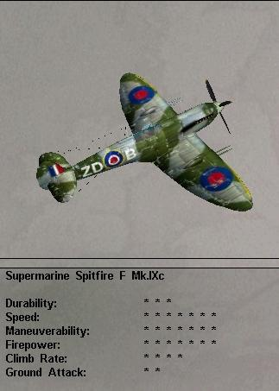
Found in Mission: Online Play (Online Play Kursk (1943) arena)
Damage Capacity:
Loadout:

Hawker Tempest Mk.V
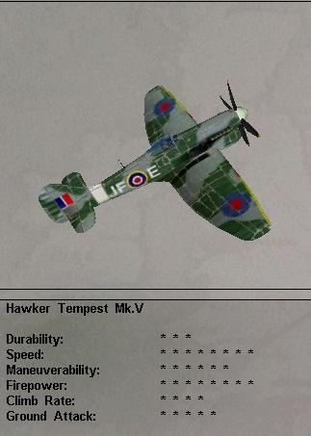
Found in Mission: Online Play (Online Play Germany (1944) arena)
Damage Capacity:
Loadout:

Supermarine Spitfire Mk.XIVe
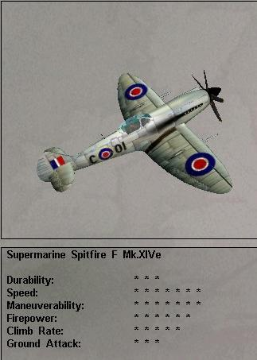
Found in Mission: Online Play (Online Play Germany (1944) arena)
Damage Capacity:
Loadout:

German Planes

Messerschmitt Bf-109E-4

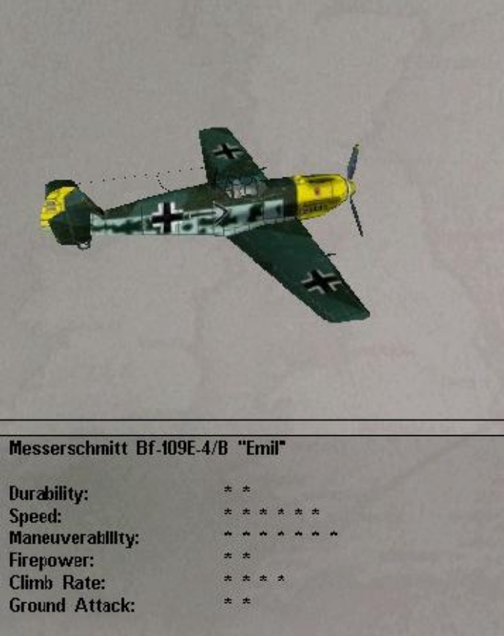

Found in Mission: 2, 3, 4, Training Mission 1
Damage Capacity:
Score:
Loadout:
- Mission 1 – 1x 550 lb bomb and 4x 110 lb bombs each, full offensive and defensive ammo load
- Mission 2 - full ammo loads, on Easy level 109s will get low on fuel in about 10-15 minutes after the start of the fight and will try to run for home, (Med: 14, Hard: 18)
- Mission 3 - 109s – full ammo load
- Mission 3 - 109s with bombs – 1x 550 lb bomb each, full ammo loads
AI scripts:
- Mission 2 - if the player reaches the coast, the 109s will be triggered, 109s dive and engage the player, trying to continue edging south to keep within protection range of the Stukas, if the player turns for home and there are Stukas around, the 109s will gain altitude and head south to protect the Stukas, if the Stukas are all dead, the 109s will engage and will chase the player as far as half-way back to the player’s airfield
- Mission 2 - Damaged 109s – they are out of ammo, have damaged engines and will use evasion techniques if engaged, working their way steadily south
- Mission 3 - will first shoot down the leader, extend, then turn to come back at the Spitfires. 109 pilots will work together to kill the Spits, with a slight preference to killing the AI Spitfire first. After about 10 minutes of combat, the 109s will run low on fuel and will work their way south. As such they will not chase the player north if he runs after this time. 109s run as soon as they get a good chance.
- Mission 4 – The 109s will work in pairs to take out GB fighters, with a priority being given to those fighters that are engaging bombers. As the bombers egress, the 109s will try to keep the GB fighters from pursuing the bombers until the bombers are at least 10 km away. If the bombers are all shot down, the fighters will start working their way home.
- Mission 4 - will drop bombs on airfield, then will join the battle for the bombers.
- Training Mission 1 - The enemy planes are at the minimum level of ability, which means they fire but never hit the player. When all planes in a group are shot down, a new set of enemy planes will spawn just outside of visual range and will fly toward the player.

Messerschmitt Bf-109K-4

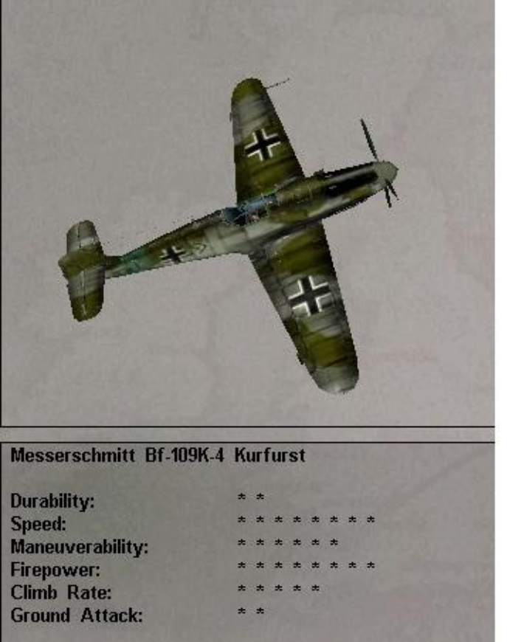

Found in Mission: 17, 18, 19
Damage Capacity:
Score:
Loadout:
- Mission 18 - full ammo load
- Mission 19 - 1x 550 lb bomb, full ammo load
AI scripts:
  - Mission 18 - 109s will try to keep the P-51s away from the 190s.
  - Mission 19 - All GE planes will make glide bomb attack from angle from 1- 179 degrees. 109s will stick around to engage Mustangs after their bomb attack; others will run in an easterly direction after the drop.

Messerschmitt Bf-109F-4

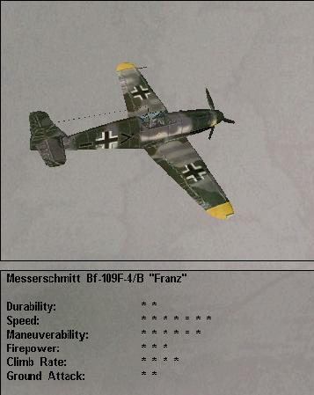

Found in Mission: 5 (*Note: need older pink paint job that was in earlier FA3 beta), 6, 7, 8 (with old pink cammo scheme)
Damage Capacity:
Score:
Loadout:
- Mission 5 - full ammo load
Mission 6 – full ammo load
- Mission 7 - full ammo load
- Mission 7 - full ammo load
AI scripts:
- Mission 5 - Strafe runway twice, then run for home into the setting sun. The 109s will fight if forced to do so, but will prefer to run
- Mission 6 – will try to destroy Hurricanes, working as two groups of two
- Mission 7 - will try to keep the Spitfires engaged so the Stukas can do their thing, after the Stukas start to run, the 109s will do a fighting withdrawal to cover them
- Mission 8 - try to shoot down the Hurricanes. Will do a fighting withdrawal if all tanks are destroyed

Messerschmitt Bf-109G-6

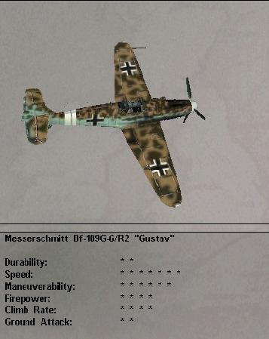

Found in Mission: 13, 14, 15, 16, 17
Damage Capacity:
Score:
Loadout:
- Mission 13 – full ammo load
- Mission 14 - 1x 550 lb bombs, full ammo load
- Mission 15 – full ammo load
  - Mission 15 - Escorting 109s – half ammo load
- Mission 16 – full ammo load
- Mission 17 - full ammo load
AI scripts:
- Mission 13 - will try to take off then will concentrate on downing the ILs. Will chase the group about half way back to the front lines before disengaging.
- Mission 14 - make dive bombing attack on T-34s, then try to mix it up with the La-5s. 190s will stay in the area and provide fighting withdrawal for the bombers that precede them
- Mission 14 - 109s harassing Tu-2s – try to shoot down the Tu-2s, if engaged, will make a fighting withdrawal
- Mission 15 - try to down Ils
- Mission 15 - Escorting 109s – defend the 217s from attacks. If no attacks are made on 217s after several minutes, the 109s will engage the player’s flight
- Mission 16 - try to down Ils
- Mission 16 - Escorting 109s – will stay with their bombers, will defend the bombers from attack as necessary
- Mission 17 - will try to shoot down the Lightnings.

Messerschmitt Me-262 Schwalbe

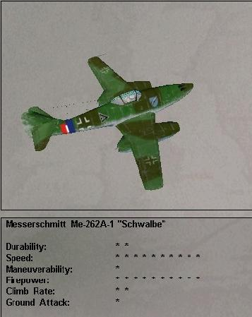

Found in Mission: 19, 20
Damage Capacity:
Score:
Loadout:
- Mission 19 – 2x 550 lb bombs, full ammo load
- Mission 20 - none
AI scripts:
- Mission 19 - planes will make glide bomb attack from angle from 1- 179 degrees. 109s will stick around to engage Mustangs after their bomb attack, others will run in an easterly direction after the drop
- Mission 20 - are out of ammo, so will either try to evade shots or will try to use speed to run away and make another approach

Junkers Ju-88A-4

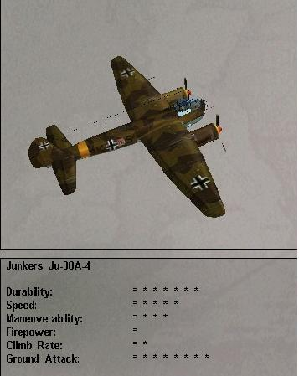

Found in Mission:1, 2, 3, 4, 5, 7
Damage Capacity:
Score:
Loadout:
- Mission 1 - normal defensive gunners with 50% load for gunners that aren’t dead
- Mission 2 - Full defensive load, gunner level 1
- Mission 3 - 88s – 10x 110 lb bombs in bomb bay, full defensive ammo load, gunner level 1
- Mission 4 - 10x 110 lb bombs in bomb bay, full defensive ammo load
- Mission 7 - full defensive ammo load, gunner level 2
AI scripts:
- Mission 2 - Ju-88 Recon – flies north at normal cruise speed at 25,000 feet
- Mission 4 - the German bombers will fly in formation and will close formation whenever a plane drops out of formation. when the bombers get to the target, they will split into two groups, 2:1 in ratio, if the number of planes is more than 12. The larger group will target Westminster Abbey and the smaller group will target the London Bridge. If the number of bombers left when they get to the target is 7-12 or less, all bombers will attack Westminster, and if it is 1-6 left, they will attack the Bridge. After dropping their loads, the 88s will swing to the east and then southeast to egress out over the Thames estuary
- Mission 7 - head for Cairo on recon mission

Junkers Ju-87G-1 Stuka

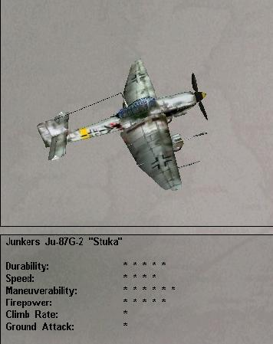

Found in Mission: 7, 14, 16
Damage Capacity:
Score:
Loadout:
- Mission 7 - 1x 500 lb bomb, full ammo load, gunner level 2
- Mission 14 - 1x 1100 lb bomb, full ammo load, gunner level 2
- Mission 16 - 1x 550 lb bomb and full ammo load, gunner level 3
AI scripts:
- Mission 7 - drop pick a tank and drop a bomb on it, then turn and strafe tanks with 37mm cannon. After ammo is gone, turn west and run for the front lines on the deck
- Mission 14 - – make glide attacks against tank group with bombs, then come in strafing with 37mm cannon. After cannon ammo is gone, they egress west at treetop height
- Mission 16 - will head over lines and attack some T-34s behind Russian lines

Ju-87D-3 Stuka

- 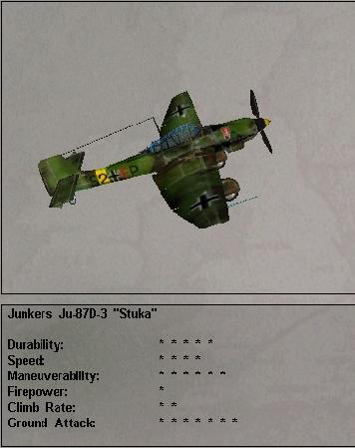

Found in Mission: 1, 2, 3 14
Damage Capacity:
Score:
Loadout:
- Mission 1 – 1x 550 lb bomb and 4x 110 lb bombs each, full offensive and defensive ammo load
- Mission 2 - 1x 550 lb and 4x 110 lb bombs each, full defensive and offensive ammo load
- Mission 3 - 1x 500 lb and 4x 110 lb bombs, full defensive ammo load, gunner level 1
- Mission 13 - 3x 1100 lb bombs, full ammo load, gunner level 2
- Mission 14 - 3x 1100 lb bombs, full ammo load
AI scripts:
- Mission 1 - take turns making attack on ship, make dive bomb attack on ship with egress to the north, make 180 degree turn, make strafing run on ship, scatter and run for home at 100 ft, weave and dodge to throw player’s aim off if the player chases
- Mission 2: pair of Stukas take turns diving on the airfield, after the bomb drop, they turn around and strafe the field, then head for home at about 100-200 ft agl:
- Mission 3 - head for the nearest airfield, dive and drop their bombs, then form up and head for home on the deck
- Mission 14 – tip over and dive on tank group, dropping all bombs at once, pulling out of their dive and heading home at treetop level

Focke-Wulf FW-190A-4

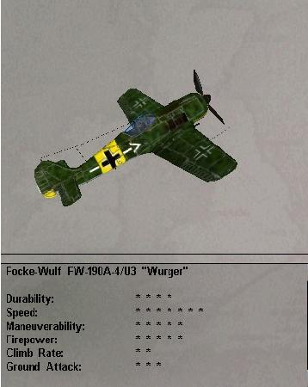

Found in Mission: Online Play (Online Play Guadalcanal (1942) arena)
Damage Capacity:
Loadout:

Focke-Wulf FW-190A-8

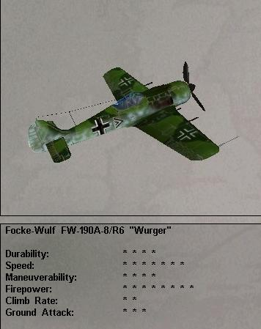

Found in Mission: 17, 18,
Damage Capacity:
Score:
Loadout:
- Mission 17 – full ammo load
- Mission 18 – full ammo load
AI scripts:
- Mission 17 - 190s will try to shoot down the Lightnings
- Mission 18 - will concentrate on attacking bombers. They attack by diving from 12 o’clock high, then split-S’ing and getting in position for another attack. They will keep attacking until all cannon ammo has been expended

Focke-Wulf FW-190D-9

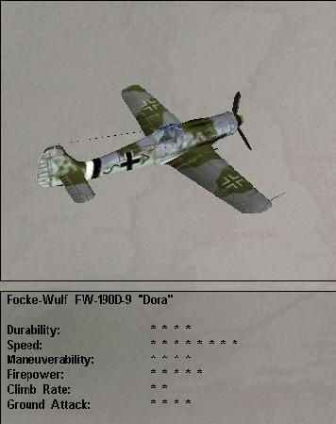

Found in Mission: 19, 20
Damage Capacity:
Score:
Loadout:
- Mission 19 – 1x 1100 lb bomb, full ammo load
- Mission 20 – full ammo
AI scripts:
- Mission 19 - planes will make glide bomb attack from angle from 1- 179 degrees. 109s will stick around to engage Mustangs after their bomb attack, others will run in an easterly direction after the drop
- Mission 20 - try to protect 262s

Dornier Do-217e

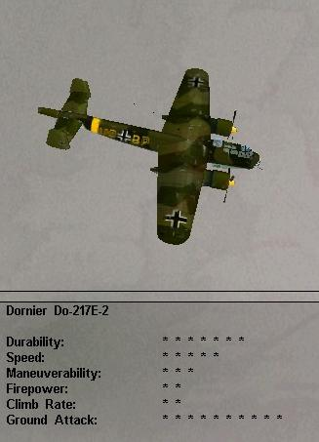

Found in Mission: 13, 14, 15, 16, 19
Damage Capacity:
Score:
Loadout:
- Mission 13 –TBA
- Mission 14 –full defensive ammo load, gunner level 3
- Mission 15 - half ammo load, gunner level 3
- Mission 16 - full bomb and defensive ammo load, gunner level 3
- Mission 19 - full defensive ammo load, gunner level 3
AI scripts:
    - Mission 13 –can be seen headed west on their way home from a night bombing mission. One of them has a smoking engine.
    - Mission 14 - flies at high altitude to the east
    - Mission 15 - head for home in close formation
    - Mission 16 - will fly towards the edge of the map on bombing mission in tight formation
    - Mission 19 - will head to edge of map on recon mission.

Japanese Planes

Aichi D3A1 Val

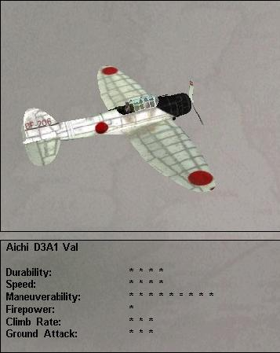

Found in Mission: 9
Damage Capacity:
Score:
Loadout:
- Mission 9 - full bomb load (1x550, 2x 132)
AI scripts:
- Mission 9 – Vals will pick out a target (60% chance of carrier, 10% chance for each other ship), then line up for a dive bomb attack. After dropping bombs, the enemy planes will egress on the deck to the west.

Mitsubishi B5N2 Kate

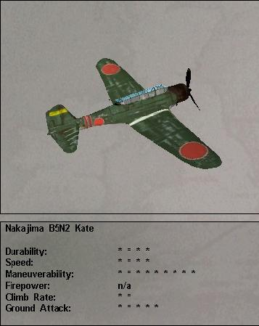

Found in Mission: 9, 12
Damage Capacity:
Score:
Loadout:
- Mission 9 – 1x torpedo
- Mission 12 - 1x torpedo, full defensive ammo load, gunner level 2
AI scripts:
- Mission 9 – Kates will pick out a target (60% chance of carrier, 10% chance for each other ship), then will line up and make a torpedo attack on their selected target. After dropping bombs, the enemy planes will egress on the deck to the west.
- Mission 12 - will fly towards the US fleet in close formation, gunners will try to shoot down any US planes that attack

Mitsubishi A6M2 Zero

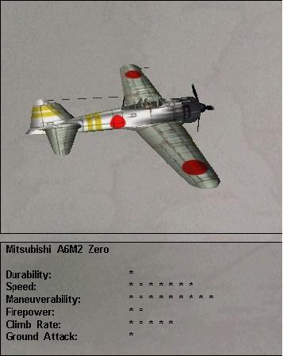

Found in Mission: 10, 11, 12, Online Play (Found in: Western Desert (1941) arena)
Damage Capacity:
Loadout:
Damage Capacity:
Score:
Loadout:
- Mission 10 – full ammo load
- Mission 11 – full ammo load
- Mission 11 - Zeros attacking Marines – 2x 110 lb bombs, full ammo load
- Mission 12 – full ammo load
AI scripts:
- Mission 10 - Zeros will try to disrupt Avengers, to spoil their attacks
- Mission 11 - Zeros will try to shoot down Wildcats to protect bombers. After bombers have dropped will try to keep Wildcats off bombers and will work their way back up the slot in a fighting withdrawal.
- Mission 11 - Zeros attacking Marines – will drop their bombs and strafe the tank to try to destroy it until engaged by Corsairs, then will try to shoot it out and escape to the northwest.
- Mission 12 - try to get at Dauntlesses and shoot them down

Mitsubishi G4M2 Betty

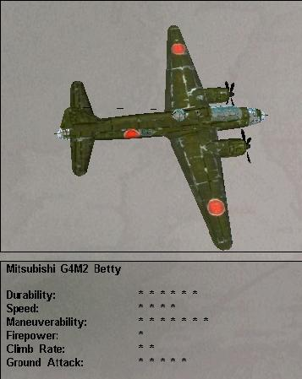

Found in Mission: 9, 11, Training Mission 2,
Damage Capacity:
Score:
Loadout:
- Mission 9 - 1x torpedo, full defensive ammo, gunner level 2
- Mission 11 – 12x 110 lb bombs, full defensive ammo load, gunner level 2
AI scripts:
- Mission 9 - Betty – tries to sneak in at low-level to deliver a torpedo into the side of the carrier. After dropping, will egress to the west.
- Mission 11 - Betty’s will fly in close formation, closing formation to make up for losses. When they get to the airfield, they will drop their bombs, and then turn in formation to the left and fly back up the slot.
- Training Mission 2 - In it’s default condition, the player is flying a Grumman F4F-4 Wildcat against a formation of three Betty bombers. The default AI is set so that the planes will shoot back at the player but will not hit. When all planes have been shot down out of a formation a new formation will spawn behind the former enemy group, just outside of visual range, and will follow the previous group’s heading.

Nakajima Ki-43-II Oscar
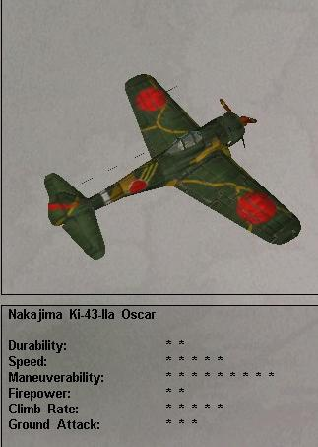
Found in: Online Play (Battle Of Britain (1940) arena)
Damage Capacity:
Loadout:

Kawasaki Ki-61-II Tony
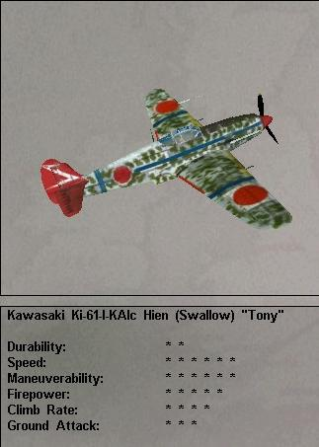
Found in Mission: Online Play (Online Play Guadalcanal (1942) arena)
Damage Capacity:
Loadout:

Kawasaki Ki-100 Tony
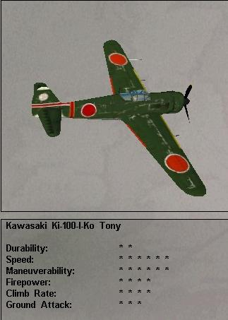
Found in Mission: Online Play (Online Play Kursk (1943) arena)
Damage Capacity:
Loadout:

Mitsubishi J2M3 Jack
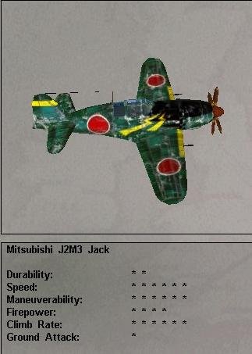
Found in Mission: Online Play (Online Play Kursk (1943) arena)
Damage Capacity:
Loadout:

Kawanishi N1K2 George
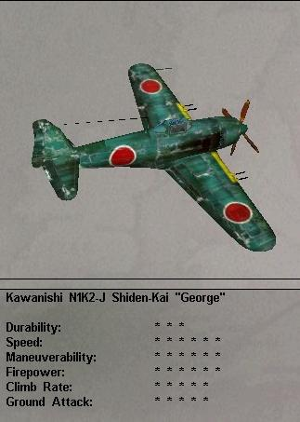
Found in Mission: Online Play (Online Play Germany (1944) arena)
Damage Capacity:
Loadout:

Russian Planes

Ilyushin IL-2 Stormovik

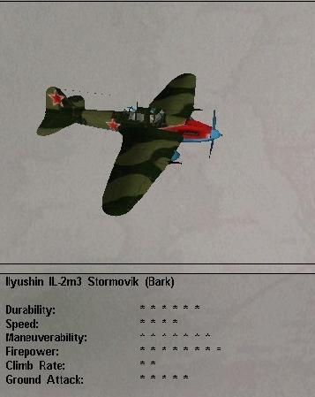

Found in Mission: 13, 15, 16
Damage Capacity:
Loadout:
- Mission 13 – 8x RS-132 rockets, full ammo load, gunner level 2
- Mission 15 – 8x RS-132 rockets, full ammo load, gunner level 2
- Mission 16 – 8x RS-132 rockets, full ammo load, gunner level 2
AI scripts:
- Mission 13 - will pick out quarters of the field to work on and will swap sides with the plane opposite them. Will first attempt to take out AA and flak with their guns, then will use rockets and guns on buildings. Will leave when all objects on field have been destroyed or when ammo and rockets are at least half gone for all Ils.
- Mission 15 - Attack tanks with rocket barrages, then strafe tanks with guns until at least all ILs have spent half their ammo
- Mission 16 - Attack tanks with rocket barrages, then strafe tanks with guns until at least all ILs have spent half their ammo

Lavochkin La-5FN

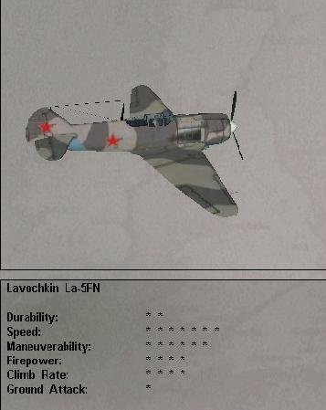

Found in Mission: 13, 14, 15, 16
Damage Capacity:
Loadout:
- Mission 13 – full ammo load
- Mission 14 – full ammo load
- Mission 15 – full ammo load
- Mission 16 - full ammo load
AI scripts:
- Mission 13 - will try to destroy any FWs before they have a chance to take off, then will engage FWs in the air. Will work to keep the FWs away from the ILs so that the ILs can do their job. When the ILs leave, the La’s will conduct a fighting withdrawal to protect the ILs from any remaining fighters.
- Mission 14 – TBD.
- Mission 15 - Try to keep 190s off ILs. Will make fighting withdrawal when Storms leave
- Mission 16 - Try to keep 190s off ILs. Will make fighting withdrawal when Storms leave

Tupolev Tu-2
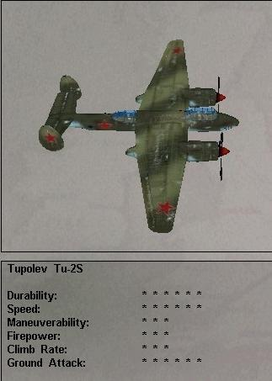

Found in Mission: 14
Damage Capacity:
Loadout:
- Mission 14 – one quarter defensive ammo , gunner level 2
AI scripts:
- Mission 14 - heading for home at 10,000 feet in close formation

Hawker Hurricane Mk.IIb
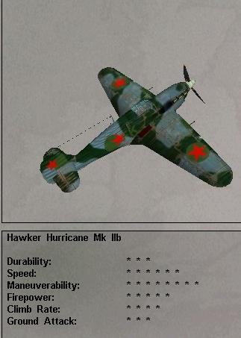
Found in: Online Play (Western Desert (1941) arena)
Damage Capacity:
Loadout:

Lavochkin LaGG-3
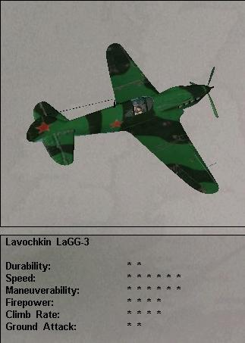
Found in: Online Play (Battle Of Britain (1940) arena)
Damage Capacity:
Loadout:

Polikarpov I-16 Ratta
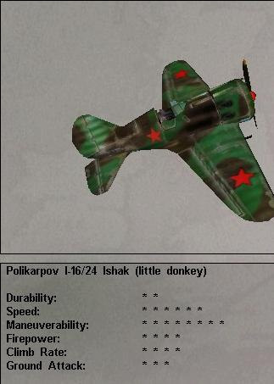
Found in: Online Play (Battle Of Britain (1940) arena)
Damage Capacity:
Loadout:

Yakovlev Yak-1b
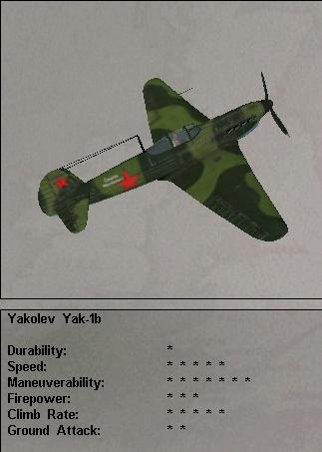
Found in: Online Play (Western Desert (1941) arena)
Damage Capacity:
Loadout:

Yakovlev Yak-3
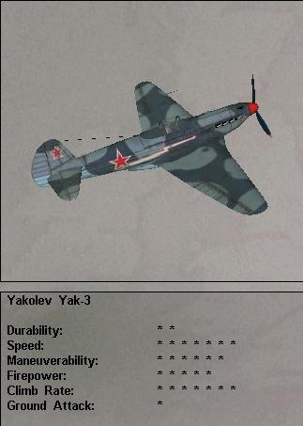
Found in Mission: Online Play (Online Play Guadalcanal (1942) arena)
Damage Capacity:
Loadout:

Bell P-39Q Airacobra
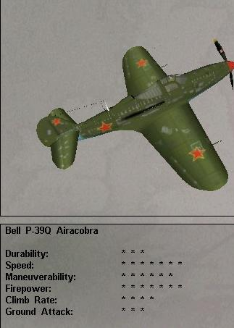
Found in Mission: Online Play (Online Play Guadalcanal (1942) arena)
Damage Capacity:
Loadout:

Lavochkin La-7
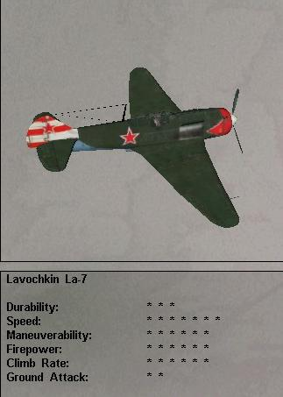
Found in Mission: Online Play (Online Play Germany (1944) arena)
Damage Capacity:
Loadout:

American Planes

Chance-Vought F4U-1a Corsair

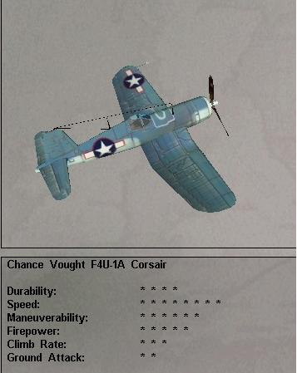

Found in Mission: 9, 10, 11, 12
Damage Capacity:
Loadout:
- Mission 9 – full ammo load
- Mission 10 – full ammo load
- Mission 11 – full ammo load
- Mission 12 – full ammo load
AI scripts:
- Mission 9 - Corsairs – will try to shoot down all enemy planes before their attacks.
- Mission 10 - Will try to keep Zeros off the Avengers
- Mission 11 - Will try to shoot down the bombers before they drop their bombs, then will concentrate on the fighters after the bombers have dropped.
- Mission 12 - Will try to keep the Zeros off the Dauntlesses. Will engage in a fighting withdrawal as bombers escape

Grumman TBF-1C Avenger

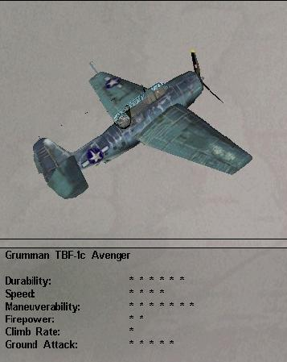

Found in Mission: 10
Damage Capacity:
Loadout:
- Mission 10 – 1x torpedo, full defensive ammo, gunner level 2
AI scripts:
- Mission 10 - Avengers will make torpedo run on Battleship

Douglas SBD-2 Dauntless

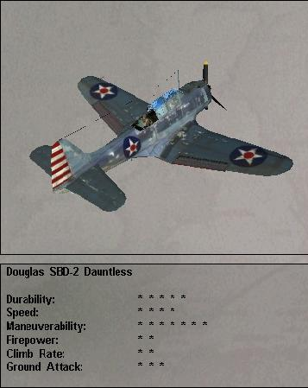

Found in Mission: 12
Damage Capacity:
Loadout:
- Mission 12 – 1x 1000 lb and 2x 500 lb bombs, full defensive and offensive ammo load, gunner level 2
- AI scripts:
- Mission 12 – dive bomb attack on ships, egress to the east.

Lockheed P-38L Lightning

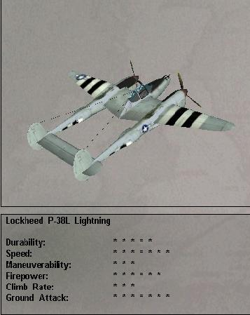

Found in Mission: 17
Damage Capacity:
Loadout:
- Mission 17 – 10x 5” rockets, full ammo load
AI scripts:
- Mission 17 - Lightnings will attack trains with rockets until all are exhausted, then will attack with guns. Emphasis is on disabling the engine first. When attacked by the FWs, the Lightnings will defend themselves as best they can

P-51D Mustang

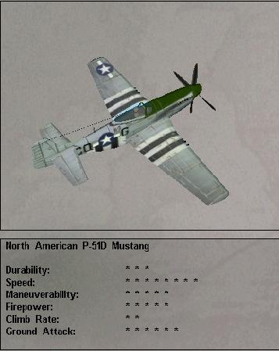

Found in Mission: 18, 19, 20
Damage Capacity:
Loadout:
- Mission 18 – full ammo load, drop tanks
- Mission 19 - full ammo load
- Mission 20 - full ammo load
AI scripts:
- Mission 18 - will try to shoot down the 190s primarily and defend against the 109s
- Mission 19 - P-51 wingman will stick with player, help shoot at enemy, watch player’s back, engage 109s while player goes after next plane
- Mission 20 - try to shoot down 262s or 190s (priority to 262s)

Boeing B-17G Flying Fortress

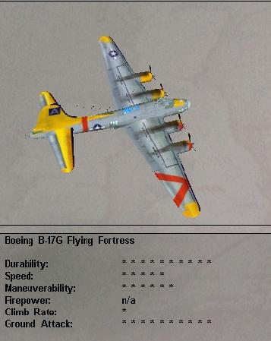

Found in Mission: 18
Damage Capacity: normal B-17 damage capacity from FA3
Loadout:
- Mission 18 – full bomb and ammo load, gunner level 2
AI scripts:
- Mission 18 - will stay in formation and will close formation as planes drop out. AI gunners will fire at enemy planes, with low to medium quality.

Curtiss P-40C Tomahawk
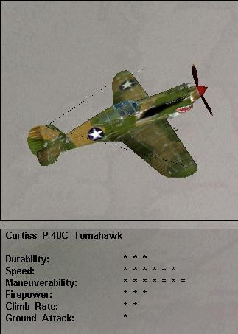
Found in: Online Play (Battle Of Britain (1940) arena)
Damage Capacity:
Loadout:

Grumman F4F-3 Wildcat
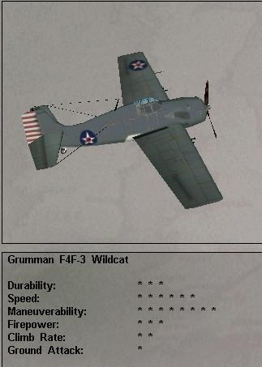
Found in: Online Play (Battle Of Britain (1940) arena)
Damage Capacity:
Loadout:

Curtiss P-40E-1 Warhawk
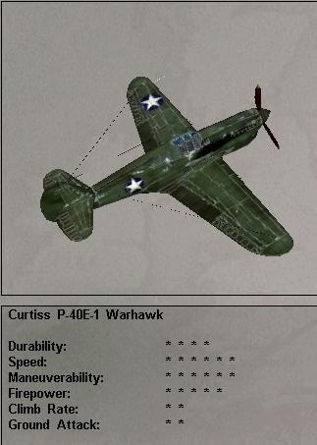
Found in: Online Play (Western Desert (1941) arena)
Damage Capacity:
Loadout:

Grumman F4F-4 Wildcat
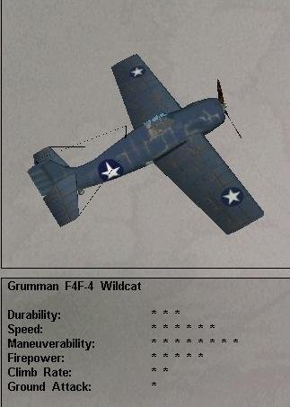
Found in: Online Play (Western Desert (1941) arena)
Damage Capacity:
Loadout:

Lockheed P-38G Lightning
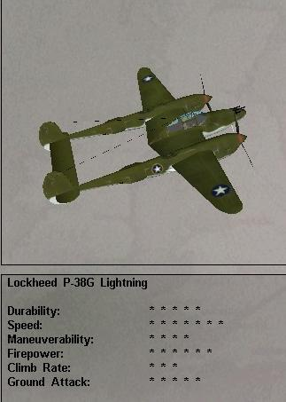
Found in Mission: Online Play (Online Play Guadalcanal (1942) arena)
Damage Capacity:
Loadout:

Grumman F6F-3 Hellcat
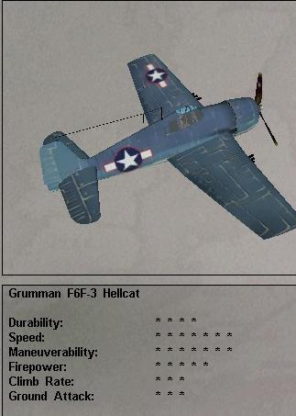
Found in Mission: Online Play (Online Play Kursk (1943) arena)
Damage Capacity:
Loadout:

Republic P-47D Thunderbolt
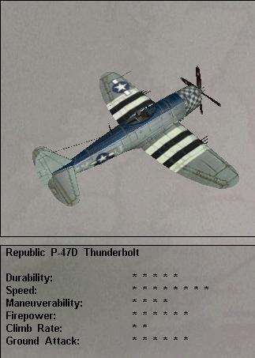
Found in Mission: Online Play (Online Play Kursk (1943) arena)
Damage Capacity:
Loadout:

Game Objects

Tanks

Tiger Tank - German
Found in Mission: 6 (2 in courtyard), 8, 13, 15, 16,17
Damage Capacity: each tank can be destroyed with a single 500 lb bomb or will be disabled with 25 hits from 20mm fire from the Hurricanes, standard FA damage capacities. A hit or close miss on a tank with a bomb will destroy it. 3-5 hits with the Stuka’s cannon will destroy a tank as well.
Score:
Loadout:
- Mission 6 – a total of about 8x .30 cal AA, gunner level 1
- Mission 7 - 1x .30 cal AA gun each, gunner level
- Mission 8 - 1x .30 cal AA each, gunner level 1
- Mission 13 –
- Mission 14 -
- Mission 15 - 1x .30 cal AA each, gunner level 3
- Mission 16 - 1x .30 cal AA, gunner level 3
- Mission 17 - 1x .30 cal AA each, gunner level 3
AI scripts:
- Mission 6 – TBD
- Mission 7 - will try to shoot down enemy planes, low quality gunner
- Mission 8 - drive for airfield, have AA to shoot at Hurcs, medium quality gunner
- Mission 8 - Tanks in battle – will try to destroy other side’s tanks/guns.
- Mission 13 – will head for front lines, will try to shoot down any marauding aircraft
- Mission 14 -
- Mission 15 - shoots at all enemy planes, emphasis on ILs, medium quality gunner
- Mission 16 - shoots at all enemy planes, emphasis on ILs, medium quality gunner
- Mission 17 - will shoot at Lightnings

Panther Tank - German
Found in Mission – 6, 8, 13, 15, 16 (spread out in groups of three), 17
Damage Capacity: normal tank damage capacity from FA3
Score:
Loadout:
- Mission 13 –
- Mission 14 –
- Mission 15 - 1x .30 cal AA each, gunner level 3
- Mission 16 - 1x .30 cal AA, gunner level 3
- Mission 17 - 1x .30 cal AA each, gunner level 3
AI scripts:
- Mission 13 –
- Mission 14 –
- Mission 15 - shoots at all enemy planes, emphasis on ILs, medium quality gunner
- Mission 16 - shoots at all enemy planes, emphasis on ILs, medium quality gunner
- Mission 17 - will shoot at Lightnings

Cromwell - British Tank
Found in Mission – 7, 8
Damage Capacity: standard FA damage capacities. A hit or close miss on a tank with a bomb will destroy it. 3-5 hits with the Stuka’s cannon will destroy a tank as well TBD
Score:
Loadout:
- Mission 7 – Taken from FA3.0, low quality gunner
- Mission 8 - 1x .30 cal AA each, gunner level 1
AI scripts:
- Mission 7 - will try to shoot down enemy planes, low quality gunner TBD
- Mission 8 - Tanks in battle – will try to destroy other side’s tanks/guns.

T-34 - British Tank
Found in Mission – 14 (note that T-34 tanks are dispersed in groups of three around the map)
Damage Capacity: normal tank damage resistance from FA3
Score:
Loadout:
- Mission 14 – 1x .30 cal AA, gunner level 1
AI scripts:
- Mission 14 - AA fire against incoming planes, low quality gunner

US Marine Tank
Found in Mission – 11
Damage Capacity: normal tank damage resistance from FA3
Loadout:
- Mission 11: 1x .30 cal AA, gunner level 2
AI Scripts:
- Mission 11: will try to shoot down zeros

Ships

British Cargo Ship
Found in Mission: 1
Damage capacity:
- Mission 1: The ship will sink it is hit by a total of at least 1650 lbs of bombs
Score:
Loadout:
- Mission 1 – 2x .30 caliber AA gun with 0 level gunners (just for visual effect)
AI scripts:
- Mission 1 Ship AA – will try to shoot down Stukas, low quality gunner

American Carrier
Found in Mission – 9
Damage Capacity: The carrier will sink with a combination of 5000 lbs of ordnance
Score:
Loadout:
- Mission 9 – low quality gunner
AI scripts:
- Mission 9 - Ship AA will try to shoot down enemy planes, low quality gunner, Ship AA – will try to shoot down enemy planes, will target sub periscope if player shoots at it with big guns and destroys the sub.

American Cruiser
Found in Mission – 9
Damage Capacity: the cruisers will sink with a total of 2000 lbs of ordnance (torpedoes = 2000 lbs)
Score:
Loadout:
- Mission 9 – low quality gunner
AI scripts:
- Mission 9 - Ship AA will try to shoot down enemy planes, low quality gunner, Ship AA – will try to shoot down enemy planes, will target sub periscope if player shoots at it with big guns and destroys the sub.

Japanese Cruiser # 1
Found in Mission – 10, 12
Damage Capacity: the cruisers will sink with a total of 2000 lbs of ordnance (torpedoes = 2000 lbs)
Score:
Loadout:
- Mission 10 – lots of flak and AA, gunner level 1
- Mission 12 – numerous flak and .30 cal AA, gunner level 1
AI scripts:
- Mission 10 - Ship AA will try to shoot down US planes
- Mission 12 - will try to shoot down US planes, medium quality gunner

Japanese Battleship
Found in Mission – 10
Damage Capacity: Battleships will sink with a total of 6000 lbs of ordnance (1 torpedoes = 2000 lbs)
Score:
Loadout:
- Mission 10 – lots of flak and AA, gunner level 1
AI scripts:
- Mission 10 - Ship AA will try to shoot down US planes

Japanese Carrier
Found in Mission – 12
Damage Capacity: carrier will sink if hit by a total of 3000 lbs of bombs
Score:
Loadout:
- Mission 12 – numerous flak and .30 cal AA, gunner level 1
AI scripts:
- Mission 12 - will try to shoot down US planes, medium quality gunner

Japanese Submarine
Found in Mission: 9, 12
Damage Capacity:
Score:
Loadout:
- Mission 9 – TBA
- Mission 12: 1x .30 cal AA, gunner level 2
AI Scripts:
- Mission 9 - will try to get into position for a torpedo shot on the carrier, if not spotted will let loose a salvo of four torpedoes at the carrier
- Mission 12 - will surface briefly, then will dive if the player gets to within 1000 feet of it (vertically and/or horizontally)

Japanese Torpedo Boat
Found in Mission – 10
Damage Capacity:
Score:
Loadout:
- Mission 10 - 1x 20mm and 1x .30 cal AA, gunner level 2
AI scripts:
- Mission 10 - will try to shoot down player’s plane while putting emphasis on evading the player’s attack

German Torpedo Boat
Found in Mission – 1
Damage Capacity: carrier will sink if hit by a total of 3000 lbs of bombs
Score:
Loadout:
- Mission 1 – 2x 1000 lb torpedoes, 1x 20mm and 1x .30 caliber AA guns with 0 level gunners
AI scripts:
- Mission 1 - will attack cargo ship from the south with two torpedoes each, then will turn to the south and make off at top speed

Other Vehicles

German Train
Found in Mission – 17, 18
Damage Capacity: normal train damage capacity from FA3
Score:
Loadout:
- Mission 17 – 3x .30 cal AA, gunner level 3
- Mission 18 - 3x .30 cal AA, gunner level 3
AI scripts:
- Mission 17 - Train AA will shoot at Lightnings, medium gunner quality

German Scout Car
Found in Mission – 5
Damage Capacity:
Score:
Loadout:
Mission 5 - Scout car – 1x .30 cal defensive AA, gunner level 2
AI scripts: German scout car headed west for German lines

German Truck (column)
Found in Mission: 20
Damage Capacity:
Score:
Loadout:
- Mission 20: 2x .30 cal AA, gunner level 4
AI Scripts:

Guns

British Airfield AA Guns
Found in Mission: 2, 4, 5
Damage Capacity:
Score:
Loadout:
- Mission 2/5 - Airfield – 4x .30 cal defensive AA, gunner level 1
- Mission 4 - gunner level 1
AI scripts:
- Mission 2 - will try to shoot down enemy planes, low quality gunner
- Mission 4 - will shoot flak at the bombers to make lots of puffy flak bursts, gunner level 1
- Mission 5 - will try to shoot down enemy planes, low quality gunner

American Airfield AA Guns
Found in Mission: 11, 19
Damage Capacity:
Score:
Loadout:
- Mission 11 - 4x .30 cal AA, 4x 40mm flak, gunner level 1
- Mission 19 – TBD medium gunner quality
AI scripts:
- Mission 11 - will shoot flak bursts at bombers, low quality gunner.
- Mission 19 - will shoot at GE planes, with medium gunner quality

German AA Guns
Found in Mission: 6, 13, 20
Damage Capacity: TBD
Score:
Loadout:
- Mission 6 - 2x .30 cal AA, 2x 40mm flak, gunner level 2
- Mission 13 – 4x .30 cal AA, gunner level 3
- Mission 20 – Airfield AA – 8x .30 cal AA, 4x 40mm flak, gunner level 4
AI scripts:
- Mission 6 - will try to shoot down GB planes, medium quality gunner
- Mission 13 - will try to shoot down RU planes, medium quality gunner
- Mission 20 - – shoots at Mustangs, high gunner quality

London AA Guns
Found in Mission: 4
Damage Capacity: TBD
Score:
Loadout:
- Airfield – 4x .30 cal machine guns, gunner level 1
AI scripts:
- Mission 4 - will shoot flak at the bombers to make lots of puffy flak bursts, low quality gunner

Japanese Airfield AA Guns
Found in Mission: 10, 11
Damage Capacity: TBD
Score:
Loadout:
  - Mission 10 - 2x .30 AA, gunner level 2
- Mission 11 – 4x .30 cal machine guns, gunner level 1
AI scripts:
- Mission 10 - If the player goes after the torpedo boat, he will be able to see a small observation post on the shore, which can be destroyed by strafing.
- Mission 11 - Airfield AA will shoot flak bursts at bombers, low quality gunner, will try to shoot down US planes

Buildings

British Airfield Strip
Found in Mission: 2, 5
Damage Capacity:

American Airfield Strip
Found in Mission: 11,
Damage Capacity:
AI: Airfield AA – will shoot flak bursts at bombers, low quality gunner.

Russian Airfield Strip
Found in Mission: 11, 13
Damage Capacity:

German Airfield Strip
Found in Mission: 13
Damage Capacity: normal airfield damage from FA3

German Artillery Site
Found in Mission: 6, 19
Damage Capacity:
Loadout:
- Mission 6: 2x .30 cal AA, 2x 40mm flak, gunner level 2
- Mission 7: 4x .30 cal AA, gunner level 3

German Jet Base
Found in Mission: 20
Damage Capacity: TBD.

German Rocket Site
Found in Mission: 18
Damage Capacity:
Loadout: 4x .30 cal AA and 2x 40mm flak, gunner level 4

Westminster
Damage Capacity: Westminster will be destroyed by hits from a total weight of 8000 lbs of bombs
Found in Mission: 4

London Bridge
Found in Mission: 4
Damage Capacity: London Bridge will be destroyed by hits from a total weight of 4000 lbs of bombs

St. James Cathedral
Found in Mission: 4
Damage Capacity: St. James Cathedral will be destroyed by hits from a total weight of 8000 lbs of bombs

British House of Parliament
Found in Mission: 4
Damage Capacity: TBD

British Airfield Building #1
Found in Mission: 5
Damage Capacity: TBD
Visual Description: Taken from FA3.0 – Gray camouflaged hangar?

British Airfield Building #2
Found in Mission: 5
Damage Capacity: TBD
Visual Description: Taken from FA3.0 – Brown camouflaged hangar?

German Supply Depot
Found in Mission: 6, 20
Damage Capacity: Some targets will need the 500 lb bomb to take out while others can be taken out with guns
Loadout:
- Mission 6 - Depot AA –4x .30 cal AA, 2x 40mm flak, gunner level 2
- Mission 20 - Supply Dump AA – 4x .30 cal AA, 2x 40mm flak, gunner level 4
Visual Description: Taken from FA3.0 – Brown camouflaged hangar?

Japanese Supply Dump
Found in Mission: 11
Loadout:
- Mission 11 - 2x .30 cal AA, 2x 40mm flak, gunner level 2
AI:
- Mission 11 - Supply Depot AA – will try to shoot down US planes

German Enemy Building #1
Found in Mission: 6, 13
Damage Capacity: TBD
- Visual Description: Taken from FA3.0 – Wooden armaments factory? Unknown factory type (aircraft?)

German Enemy Building #2
Damage Capacity: TBD
Found in Mission: 6, 13
Visual Description: Taken from FA3.0 – Visual Description: Taken from FA3.0 – Wooden armaments factory? Unknown factory type (aircraft?)?

German Train Tunnel
Damage Capacity: TBD
Found in Mission: 17
Visual Description: Taken from FA3.0? Tunnel can be destroyed, destroying any trains inside the tunnel as well as causing other trains to smash into the tunnel entrance and be destroyed.

German Train Station
Damage Capacity: TBD
Found in Mission 17
Visual Description: Taken from FA3.0? Station can be damaged and destroyed.

Allied Bridge
Found in Mission: 19
- Loadout:
- Mission 19: 8x .30 cal AA, 4x 40mm flak, gunner level 1, will shoot at GE planes, with medium gunner quality
Damage Capacity: Bridge can withstand hits by a total of 3000 lbs of bombs.

Enemy Bridge
Found in Mission 17
Loadout: Bridge – 2x .30 cal AA, gunner level 3
Damage Capacity: Bridge can withstand hits by a total of 3000 lbs of bombs.
AI:
Mission 17 - will shoot at Lightnings

Japanese Observation Post
Found in Mission: 10
Loadout:
- Mission 10 - 2x .30 AA, gunner level 2
Damage Capacity:
- Mission 10 - AA - will try to shoot down player’s plane

Other Objects

Gas tanks and Ammo
Found in Mission: 5
Damage Capacity: TBD
Behavior: The 109s will blow up some gas tanks and ammo
Visual Description: Taken from FA3.0 – Single Fuel tanks 1 and 2?

Other Available FA3.0 Objects
- Heavy AA on X-mount
- Heavy AA on V-mount
- Medium “Bofors” AA gun
- Machine-gun “flak” tower

- Radar type 1
- Radar type 2

- Single fuel tank type 1
- Single fuel tank type 2

- Fuel factory
- Four tank fueling station
- Train station

- Grey camouflaged hanger
- Brown camouflaged hanger
- Concrete bunker

- British headquarters building
- German headquarters building
- Japanese headquarters building
- Russian headquarters building
- US headquarters building

- Tank factory
- Brick armaments factory
- Wooden armaments factory
- Factory of unknown type (aircraft?)
- Building of unknown type (Manufactory)

- Wooden lean-to
- Barracks
- Four-corner tent
- Standard two-point tent
- Low quality tree type 1
- High quality tree type 1
- High quality tree type 2
- Low quality tree type 3

- Church
- House 1
- House 2
- House 3
- House 4

Medals

RAF (British)

http://home.swipnet.se/~w-11578/medals.htm

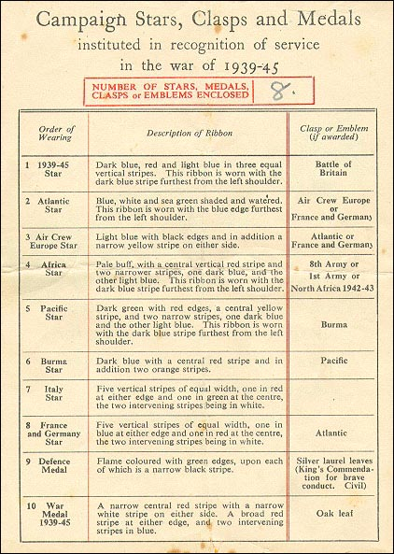

RAF

1) V.C.

2) D.C.M / C.G.M (up to 1993 when D.C.M was abolished)

3) M.C./ D.F.C/ D.F.M/ A.FC / A.F.M ( D.F.M and A.F.M abolished in 1993).

4) MiD ( Mention in despatches)

http://medalsreasource.homestead.com/index2.html

Africa Star

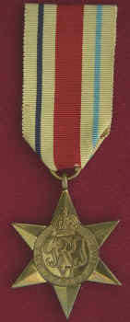

This medal was awarded for 1 or more day’s service in North Africa between 10 June 1940 and 12 May 1943 (inclusive). There were 3 clasps for this medal: 8th Army, 1st Army and North Africa 1942-43. Only one bar could be worn on the medal. If a recipient was entitled to more than one clasp, they wore the first clasp gained.
Army personnel had to enter North Africa on the establishment of an operational unit. Service in Abyssinia, Sudan, Somaliland and Eritrea also qualified. Service in West Africa did not qualify for this medal.
RAF personnel had to land in, or flown over, any of the areas previously mentioned.
No one person could receive more than 5 stars and the two medals. Also no one person was awarded more than one clasp to any one campaign star. This maximum entitlement is 1939-45 Star, Atlantic Star (or Aircrew Europe or France and Germany), Africa Star, Pacific Star (or Burma Star), Italy Star, Defence Medal and War Medal. For example, a RAF pilot who qualified first for the Atlantic Star and then the France & Germany star, would wear the Atlantic Star with France and Germany clasp. A soldier who won the Pacific Star, and then gained the Burma Star, would wear the Pacific Star with Burma clasp.

Atlantic Star

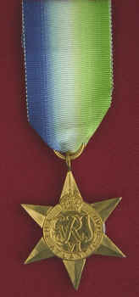

This star was awarded to commemorate the Battle of the Atlantic within the period 3 September 1939 to 8 May 1945. The 1939-45 Star must have been earned by 6, or 2 for aircrew, months service before commencing qualifying service for the Atlantic Star.
The recipient was awarded this star if their service period was terminated by their death or disability due to service. Also the award of a gallantry medal or MID also produced the award of this medal, regardless of their service duration.

Royal Navy and Merchant Navy personnel, together with Army and RAF personnel serving with either Naval service, had to complete 6 months service in the Atlantic, home waters, North Russia Convoys or South Atlantic waters west of longitude 20 degrees East.

RAF members of aircrews who had completed 2 months service in active operations within the specified area, providing that service for the 1939-45 Star had been completed.

Air Crew Europe Star

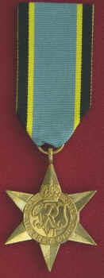

This medal was awarded for operational flying from the UK over Europe, between the period 3 September 1939 to 5 June 1944 (outbreak of war until the start of the D-Day Normandy Invasion).

The recipient was awarded this star if their service period was terminated by their death or disability due to service. Also the award of a gallantry medal or MID also produced the award of this medal, regardless of their service duration.

RAF air crew had to complete 2 months service for this medal. However, these 2 months had to come after the service, which entitled the person to the 1939-45 Star.

Army personnel qualified for this star if they served on air crew duties for 4 months, and that 2 months of this minimum 4 month period had been operational flying over Europe, with at least one operational sortie.

Pacific Star

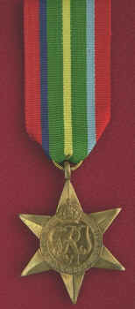

This medal was awarded for service in the Pacific theatre of operations in the period 8 December 1941 to 2 September 1945, both dates inclusive.

Royal and Merchant Navy service in the Pacific Ocean, South China Sea and the Indian Ocean east of a line running approximately south of Singapore qualified for this medal, providing that the 6 months service for the 1939-45 had already been earned.

Army personnel had to serve in those territories, which had been subjected to enemy or allied invasions. Service in Burma was excluded, as this area had its own star: The Burma Star. Service in China and Malaya between 8 December 1941 and 15 February 1942 was included. The Army had no prior time qualification.

RAF crews had to complete at least 1 operational sortie over the appropriate sea or land area.

France and Germany Star

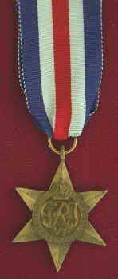

This medal was awarded for service in France, Belgium, Holland or Germany in the period 6 June 1944 and 8 May 1945.

Royal and Merchant Navy qualification had no prior time qualification. The qualifying service area was the direct support of land operations in France, Belgium, Holland and Germany, in the North sea south of a line from the Firth of Forth to Kristiansand in the English Channel or the Bay of Biscay east of longitude 6 degrees W. Service off the coast of South France qualified for the Italy Star. Shore based Naval personnel were subject to the same qualification as the Army.

RAF aircrew had to take part in an operation sortie over Europe between 6 June 1944 and 8 May 1945. RAF aircrew who flew operations over Europe, starting from Mediterranean bases, did not qualify for the France & Germany star but the Italy Star.

Personnel who had already qualified for the Aircrew Europe Star received the France and Germany clasp. Those who had qualified for the France and Germany Star, and went on to qualify for the Atlantic Star, gained the Atlantic clasp for their France and Germany Star. Those who qualified for the Atlantic, Aircrew Europe and France & Germany Stars would be awarded the first star qualified for and a 2nd medal clasp to this 1st star.
Due to the different date ranges, you can't have a Aircrew Europe clasp to a France and Germany Star.

RAAF (Australian)

General Wearing of Medals

War medals are not freely available for wear by all. Medals are only to be worn by those to whom the medal has been conferred. The only exception to this ruling occurs on Remembrance Day and Anzac Day. On these two occasions, descendants may wear the medals of deceased recipients but only on the right breast.

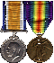 War Medals are generally dressed to the left, horizontally pinned and suspended from a non-visible single bar or stitched to the garment if preferred. If worn on a jacket or coat, the garment should be buttoned. Ribbon lengths vary but they should not exceed 2.5 cm in length [1"]. An extension of the ribbon is permissible to accommodate multiple clasps. The top clasp should be approximately 2.5cm [1"] below the top of the ribbon. If more than two medals are worn, the base line should be horizontally aligned.
Medals are worn according to the Campaign period [left of centre, across to the left shoulder] with the first conferred being closest to the left of centre.
In instances such as the granting of both the Australian Service Medal 1945-1975, and the current ASM, the latter would fall second as the first recognizes prior service.

Australian Order of Precedence of Honours and Awards Update

Victoria Cross
George Cross
Cross of Valour
Knight/Lady of the Garter
Knight/Lady of the Thistle
Knight/Dame Grand Cross of the Order of the Bath
Order of Merit
Knight/Dame of the Order of Australia
Knight/Dame Grand Cross of the Order of St. Michael and King George
Knight/Dame Grand Cross of the Royal Victorian Order
Knight/Dame Grand Cross of the Order of the British Empire
Companion of the Order of Australia
Companion of Honour
Knight/Dame Commander of the Order of the Bath
Knight/Dame Commander of the order of St Michael and St George
Knight/Dame Commander of the Royal Victorian Order
Knight/Dame Commander of the Order of the British Empire
Knight Bachelor
Officer of the Order of Australia
Companion of the Order of the Bath
Companion of the Order of St Michael and St George
Commander of the Royal Victorian Order
Commander of the Order of the British Empire
Star of Gallantry
Star of Courage
Companion of the Distinguished Service Order
Distinguished Service Cross
Member of the Order of Australia
Lieutenant of the Royal Victorian Order
Officer of the Order of the British Empire
Companion of the Imperial Service Order
Member of the Royal Victorian Order
Member of the Order of the British Empire
Conspicuous Service Cross
Nursing Service Cross
Royal Red Cross [1st class]
Distinguished Service Cross
Military Cross
Distinguished Flying Cross
Air Force Cross
Royal Red Cross [2nd class]
Medal for Gallantry
Bravery Medal
Distinguished Service Medal
Public Service Medal
Australian Police Medal
Australian Fire Service Medal
Medal of the Order of Australia
Order of St John
Distinguished Conduct Medal
Conspicuous Gallantry Medal
George Medal
Conspicuous Service Medal
Antarctic Medal
Queen's Police Medal for Gallantry
Queen's Fire Service Medal for Gallantry
Distinguished Service Medal
Military Medal
Distinguished Flying Medal
Air Force Medal
Queen's Gallantry Medal
Royal Victorian Medal
British Empire Medal
Queen's Police Medal for Distinguished Service
Queen's Fire Service Medal for Distinguished Service
Commendation for Gallantry
Commendation for Brave Conduct
Queen's Commendation for Brave Conduct
Commendation for Distinguished Service
War Medals/Australian Active Service Medal [in order of date of qualifying service]
Police Overseas Service Medal
Civilian Service Medal 1939-1945
Polar Medal
Imperial Service Medal
Coronation and Jubilee Medals [in order of date of receipt]
Defence Force Service Medal
Reserve Force Decoration
National Medal
Champion Shots Medal
Long Service Medals
Independence and Anniversary Medals [in order of date of receipt]
Foreign Awards [in order of date of authorization of their acceptance and wearing]

1939-45 Star
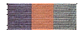

Awarded for 180 days operational service between 3 September 1939 to 2 September 1945, the 1939-45 Star is a six pointed gold star suspended from a dark blue, red and pale blue equal striped ribbon [said to represent the Royal Navy, Army and Royal Air Force]. 'The 1939-45 Star' is inscribed and the medal was in some circumstances issued in lieu of injury, death or capture. In some instances the Battle of Britain clasp was awarded.

Atlantic Star
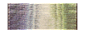


The Atlantic Star was awarded to Australians in commemoration of the Battle of the Atlantic between 3 September 1939 and 8 May 1945. A six pointed star, the medal hangs from a green, white and blue [watered] ribbon said to represent the sea. It is inscribed with 'The Atlantic Star' and was issued with bars for Air Crew Europe, France and Germany. In some instances a silver rose emblem [worn on ribbon bar] was awarded.

Air Crew Europe Star
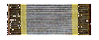

This 6 pointed star was awarded to air crews who flew missions over Europe from the United Kingdom air bases between 3 September 1939 and 4 June 1945. 3,150 Australians qualified for the award and bars were issued for the Atlantic, Germany, and France. The star is suspended from a black, yellow & light blue ribbon which is said to represent night flying, spotlights, and the sky. The star is inscribed with the words 'The Air Crew Europe Star'. In some instance a silver rose emblem [on ribbon bar] was awarded.

Africa Star


Awarded to those who served in North Africa 1940 to 1943, the six pointed Africa Star hangs from a pale buff ribbon with a thick central red stripe and outer but not edging thin stripes of dark and light blue. 5,250 members of the Royal Australian Navy and 32,506 members of the Australian Army [AIF] received the Africa Star. Clasps included North Africa and 8th Army or 1st Army. While 4,701 members of the Royal Australian Air Force received the same star.

Pacific Star


The Pacific Star was awarded to approximately 205,000 Australians for service in the Pacific from December 1941 to August 1945. The ribbon is red [Army], dark blue [Navy], dark green [jungle], yellow [beaches], and light blue [Royal Air Force]. The Star is inscribed with 'The Pacific Star'. In some instances this star was issued for operational activities in China, Hong Kong and Malaya. Clasps are limited to the Burma.

Burma Star

The Burma Star was awarded for service in Burma, China, Malaya and Sumatra between December 1941 and 1945. The ribbon is dark blue said to represent the British Forces, orange [the sun], with a thick central red stripe [Commonwealth Forces]. The six pointed star is inscribed with the words 'The Burma Star' and may be dressed with a Pacific clasp. 3,700 members of the Royal Australian Navy, 1,311 members of the Royal Australian Air Force and only 36 members of the Australian Army [AIF] were awarded the Burma Star.

Italy Star
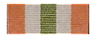

1,300 members of the Royal Australian Navy, 3,245 members of the Royal Australian Air Force and 95 members of the Australian Army [AIF] were awarded the Italy Star for service in Italy and Sicily between 1943 and 1945. Some operational activities in Greece, Sardinia and Corsica also attracted this medal.

France And Germany Star
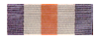

Awarded to those who served in France, Belgium, Holland and/or Germany This medal was awarded to 4,800 Australians who served between June 1944 and May 1945. The red centre stripe of the ribbon is flanked by equal width white stripes, which in turn are edged by stripes of blue. An Atlantic bar was also awarded.

Defence Medal


The Defence Medal was awarded for six months non-operational service in the armed forces, civil defence and non defence services that experienced war-like activity and/or for twelve months service outside Australia. 5,500 named Defence Medals were awarded to members of the Royal Australian Navy. 65,690 Defence Medals were awarded to those from the Australian Army [AIF] and 11,202 were awarded to members of the Royal Australian Air Force.

War Medal 1939-45
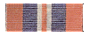
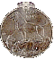
Approximately 250,000 Australians were granted the War Medal 1939-45 for 28 days service in the Armed Forces and Merchant Navy between September 1939 and September 1945. No bars were issued with this medal, however an oak leaf was awarded in some instances for dispatch recognition.

Australian Service Medal 1939-45

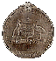
Awarded to more than 211,500 members of the Australian Armed Forces and Merchant Navy during WWII, the ASM 1939-45 [instituted in 1949] hangs from a ribbon with a central khaki stripe flanked by thin red stripes. The outer stripes are dark light blue. This medal was also awarded to non-defence personnel who served in operational areas. In certain instances, those eligible for the ASM 1939-45 were also granted the British Campaign Stars, War Medal and Defence Medal.

RUSSIAN

Bravery Medal (Medal "Za otvagu")
Conferred to officers and soldiers of the Russian Armed Forces for acts of bravery and valor in the battlefield.
- Established: 1938; renewed March 2, 1994, by decree of president Yeltsyn
- Classes: single
- Badge: a circular medal of silver, 35 mm of diameter.
- Obverse: the two line inscription ZA / OTVAGU (for bravery) in red enameled letters. Above three flying planes are depicted, and a tank below.
- Reverse: plain except for a number.
- Ribbon: light gray with narrow blue edges (2 mm).

Ushakov Medal (Medal Ushakova)
Instituted 1944 as an extension to the Soviet Order of Ushakhov; renewed by decree of president Yeltsyn of March 2, 1994. Conferred to officers and seamen of the Russian Navy and Naval Aviation for war merit. Named after an 18th Russian admiral.
- Established: 1944 as an extension to the Soviet Order of Ushakhov; renewed March 2, 1994, by decree of president Yeltsyn
- Classes: single
- Badge: a circular medal of oxidized silver, 35 mm of diameter. The medal is superimposed on an oxidized anchor whose chain stretches to the top of the ribbon.
- Obverse: the head of the admiral, with the semicircular inscription ADMIRAL USHAKOV above and two laurel sprays below.
- Reverse: plain.
- Ribbon: sea green with white (2 mm) and blue (1.5 mm) edges.

Nyestyerov Medal (Medal Nyestyerova)
Conferred to soldiers of the Russian Air Forces, air force of other services, workers of civil aviation and aviation industry for acts of valor in defense of the Federation, further for outstanding military service and maintaining military preparedness. The medal is named in honor of Peter Nyestyerov (1887-1914), a pioneer of Russian aviation.
- Established: March 2, 1994, by decree of president Yeltsyn
- Classes: single
- Badge: a circular silver medal, 32 mm of diameter.
- Obverse: the head of Nyestyerov en face, with the semicircular inscription PETR NYESTYEROV above and two laurel sprays below.
- Reverse: he emblem of the Russian Air Forces -- a double headed eagle with a propeller, sword and burning grenade, and a number.
- Ribbon: light blue with yellow edges (3 mm).

USAF

Presidential Unit Citation (Air Force and Army)

Presidential Unit Citation (Air Force and Army) was created by Executive Order 9075 on Feb. 26, 1942, and was superseded by Executive Order 9396 on Dec. 2, 1943, which authorized the Distinguished Unit Citation, and this executive order was superseded by Executive Order 10694, on Jan. 10, 1957, which redesignated the Distinguished Unit Citation as the Presidential Unit Citation.
Award: The Citation is conferred on units of the armed forces of the United States and of cobelligerent nations, for extraordinary heroism in action against an armed enemy on or after Dec. 7, 1941. The unit must display such gallantry, determination, and esprit de corps in accomplishing its mission as to set it apart from and above other units participating in the same campaign. The degree of heroism required is the same that which would warrant award of the Distinguished Service Cross to an individual.
For subsequent awards of the Presidential Unit Citation, the individual is authorized to wear a bronze oak-leaf cluster on the ribbon. The same oak-leaf cluster in silver is worn in lieu of five bronze oak-leaf clusters.
An individual assigned or permanently attached to, and also present for duty with, a unit in the action for which the Presidential Unit Citation is awarded may wear the emblem as a permanent part of their uniform.
Design: The Army and Air Force Presidential Unit Citation is a dark blue ribbon, 1 3/8 inches wide and 3/8 of an ich high, set in a decorative gold metal frame sumulating a laurel wreath.
The Air Force Presidential Unit Citation is slightly smaller than that of the Army, being the regulation size, so that it can be worn in alignment with other Air Force ribbons.
http://www.vspa.com/usaf-medals.htm

The Silver Star
Silver Star was established by Congress on 9 JUL 18.
Awarded for each Citation received by US Air Force personnel for gallantry in action not sufficient to warrant the Medal of Honor or the Distinguished Service Cross. The Silver Star is currently awarded by all branches of the armed forces to any person who, while serving in any capacity, is cited for gallantry in action against an enemy of the United States while engaged in military operations involving conflict with an opposing foreign force, or while serving with friendly forces against an opposing armed force in which the United States is not a belligerent party. Designed by the firm of Bailey, Banks and Biddle. On August 8, 1932, the Silver Star was re-designed as a medal by an Act of Congress. This medal, is a gilt-toned star of five points. On the obverse side in the center, is a small silver star (the same size as the original citation star), centered within a wreath of laurel. Eighteen rays radiate from the star to the wreath. The reverse of the star has the inscription, “For Gallantry in Action” in raised letters, below which is a blank area suitable for engraving the recipient's name.
Ribbon: The Ribbon, one of the most striking of all American awards has a wide center stripe of red flanked on either side by a wide stripe of dark blue, a wide stripe of white, a thin stripe of white and a narrow stripe of dark blue at the edges.
History: The Silver Star Medal had its beginning during World War I. An Act of Congress of July 9, 1918, authorized the wearing by Army personnel of a small silver star, 3/16 of an inch in diameter, upon the service ribbon of a campaign medal, to indicate citation for gallantry in action, published in orders issued from headquarters of a general officer, not warranting the award of a Medal of Honor or Distinguished Service Cross. Known in the Army as the citation star the award was made retroactive, so that all those cited for gallantry in action in previous campaigns, even as far back as the Spanish-American War, were eligible to wear it. It is estimated that more than 20,000 members of the Army received such citations before 1918. A similar device was authorized for Navy and Marine Corps personnel in 1920 which authorized a special letter of commendation; to be awarded on the recommendation of the Board of Naval Award. Receipt of this special letter of commendation authorized its recipient to wear a small silver star on the ribbon of the Victory Medal.
Army announced that anyone who had previously earned a Citation Star could apply for the Silver Star Medal. Navy and Marine Corps personnel could only apply, if the Army awarded them a citations star. The status of the Silver Star was further clarified, when on August 7, 1942, Congress authorized the award of the Silver Star to any person who, while serving in any capacity with the Navy since December 6, 1941, distinguished himself by gallantry and intrepidity in action, but not of a nature to justify the award of the Navy Cross. Four months later, on December 15, 1942, the decoration was extended to Army personnel for gallantry in action, but not of a degree to justify an award of the Distinguished Service Cross.

Distinguished Flying Cross
Distinguished Flying Cross was established by an Act of Congress of July 2, 1926 (amended by Executive Order 7786 on January 8, 1938), for award to any person who, serving any branch of the service including the National Guard and the Organized Reserves after 6 APR 17: For Heroism or Extraordinary Achievement while Participating in Aerial Flight.
Award: This medal is awarded to any officer or enlisted man of the armed forces of the United States who shall have distinguished himself by heroism or extraordinary achievement while participating in an aerial flight, subsequent to November 11, 1918.&quot; The decoration may also be given for an act performed prior to November 11, 1918, when the individual has been recommended for, but has not received the Medal of Honor, Distinguished Service Cross, Navy Cross, or Distinguished Service Medal.
Oak-leaf clusters indicate subsequent awards of the Distinguished Flying Cross for Army and Air Force personnel and by additional award stars for members of the Naval services. During wartime, members of the armed forces of friendly foreign nations serving with the United States are eligible for the D.F.C. It is also given to those who display heroism while working as instructors or students at flying schools.
Design: Designed by Elizabeth Will and Arthur E. DuBois. It is a bronze cross pattern, with rays between the arms of the cross. On the obverse is a propeller of four blades, with one blade in each arm of the cross and in the re-entrant angles of the cross are rays, which form a square. The cross is suspended by a rectangular-shaped bar and centered on this is a plain shield. The reverse is blank and suitable for engraving the recipients name and rank.
When this decoration was originally created there was a movement to have this awarded in different classes, and though this idea was never approved, some copies of the higher class were made, they are the same design as the approved Distinguished Flying Cross, slightly larger, and with a pin attached to the reverse, so that it would be worn as a breast decoration. This class was never approved and was never officially awarded.
Distinguished Flying Cross Ribbon: The Ribbon has a narrow red center stripe, flanked on either side by a thin white stripe, a wide stripe of dark blue, a narrow white stripe and narrow dark blue at the edge of the ribbon. Bronze V device worn to denote Valor/Heroism.
The Distinguished Flying Cross was awarded first to Captain Charles A. Lindbergh, of the U.S. Army Corps Reserve, for his solo flight of 3600 miles across the Atlantic in 1927, a feat which electrified the world and made one of America's most popular heroes. The first D.F.C. to be awarded to a Navy man was to Commander Richard E. Byrd, of the U.S. Navy Air Corps, on May 9, 1926, for his exciting flight to and from the North Pole. Both these famous aviators also received the Medal of Honor with the Distinguished Flying Cross. The Aviatrix Amelia Earhart also received the Distinguished Flying Cross. Hers was the only such award, as an executive order on March 1, 1927, ruled that D.F.C. should not be conferred on civilians
An example of the gallantry for which the Distinguished Flying Cross is awarded took place on the morning of August 31, 1969 in. Captain Francis J. Cuddy, USMC a Helicopter pilot, was assigned the mission of assisting in the extraction of an Army Special Forces reconnaissance team heavily engaged in combat with a large North Vietnamese Army deep in an mountainous area under the enemy's complete control. Captain Cuddy, undaunted by the heavy volume of hostile fire directed at his aircraft, directed other helicopters into the area, moved his aircraft into treetop level and delivered repeated rocket and strafing runs on the enemy positions. As a result of his devastating attacks, the hostile fire was suppressed and sufficiently to enable the transport helicopters to safely extract the reconnaissance team. The citation for his award went on the say “Captain Cuddy's courage, superior airmanship, and unwavering devotion to duty in the face of personal danger were instrumental in accomplishing this hazardous mission and were in keeping with the highest traditions of the Marine Corps and of the United States Naval Service. Captain Cuddy was also awarded the Silver Star, three Distinguished Flying Crosses, Commendation Medal with Combat the Purple Heart and forty eight Air Medals During his tour of duty in Vietnam.

Air Medal
Air Medal was established on May 11, 1942, by Executive Order 9158 and amended by Executive Order 9242-A, on Sept. 11, 1942, is given to any person who, while serving with the armed forces of the United States in any capacity subsequent to Sept. 8, 1939, shall have distinguished themselves by meritorious achievement while participating in aerial flight.

The Award is given for combat or non-combat action, and conferred in recognition of single acts of heroism or merit for operational activities against an armed enemy, or for meritorious services, or for sustained distinction in performance of duties involving regular and frequent participation in aerial flight. This decoration is the same for all branches of the Armed Forces of the United States. Bronze V device worn to denote Valor/Heroism. Subsequent awards denoted by bronze arabic numerals.

Designed by Walker K. Hancock, after an open competition. The medal is a bronze
compass rose of sixteen points that is surrounded by a fleur-de-lis design in the top point. On the obverse, in the center, is an American Eagle, swooping downward (attacking) and clutching a lightning bolt in each talon. The reverse has a raised disk on the compass rose, left blank for the recipient's name and rank.

‘Air Medal Ribbon: The ribbon has a broad stripe of ultramarine blue in the center flanked on either side by a wide stripe of golden orange, and with a narrow stripe of ultramarine blue at the edge. The original colors of the Army Air Corps Presidential Unit
Citation (Air Force and Army)

Presidential Unit Citation

Presidential Unit Citation: Presidential Unit Citation (Air Force and Army) was created by Executive Order 9075 on Feb. 26, 1942, and was superseded by Executive Order 9396 on Dec. 2, 1943, which authorized the Distinguished Unit Citation, and this executive order was superseded by Executive Order 10694, on Jan. 10, 1957 which redesignated the Distinguished Unit Citation as the Presidential Unit Citation.
The Citation is conferred on units of the armed forces of the United States and of cobelligerent nations, for extraordinary heroism in action against an armed enemy on or after Dec. 7, 1941. The unit must display such gallantry, determination, and esprit de corps in accomplishing its mission as to set it apart from and above other units participating in the same campaign. The degree of heroism required is the same that which would warrant award of the Distinguished Service Cross to an individual. For subsequent awards of the Presidential Unit Citation, the individual is authorized to wear a bronze oak-leaf cluster on the ribbon. The same oak-leaf cluster in silver is worn in lieu of five bronze oak-leaf clusters.

An individual assigned or permanently attached to, and also present for duty with, a unit in the action for which the Presidential Unit Citation is awarded may wear the emblem as a permanent part of their uniform.

Design: The Army and Air Force Presidential Unit Citation is a dark blue ribbon, 1 3/8 inches wide and 3/8 of an ich high, set in a decorative gold metal frame simulating a laurel wreath. The Air Force Presidential Unit Citation is slightly smaller than that of the Army, being the regulation size, so that it can be worn in alignment with other Air Force ribbons.

US NAVY AIR FORCE

http://www.dposs.com/usaf-medals.htm#cmoh
http://www.angelfire.com/co3/usaf/medals.html

Sounds

Audio Strategy

The quality of the game audio is extremely important in the creation of an immersive experience. To this end, Project: Chesterfield will make full use of the advanced features of the Xbox. The audio engine is responsible for sound effects and music. All sound effects in the game will be implemented as 3D positional sound source. The player should be able hear the strain of their engine, the spatter of enemy gunner fire, the sound of the enemy plane as it screams in for the kill. These effects will add to the feeling of being there in the middle of the action.

As a sort of hybrid between FA3 - and Storm of Aces (for PC), this project has the luxury of looking at existing sounds for each of these two projects. By evaluating what already exists – and what works and doesn’t work well – we can come up an audio strategy that balances the grittiness of FA3.0 and the arcade feel of SOA.

The Xbox has 64 3-D voices, which will allow Project: Chesterfield to exhibit up to 64 distinct spatial audio sources at any one time. Such remarkable technology will work well in a game where multiple audio sources (the planes) will be moving around in 3-D space.
Thanks to the Xbox hard drive the audio engine will be able to load and unload audio content on the fly during actual gameplay. This decreases level load times and allows the game’s entire library of sound to be available for Playback at anytime.
8 MB of RAM will be set aside for Sound Effect and Music playback

The audio in Storm of Aces will consist of the following separate areas:
- Music
- Game UI audio.
- In-flight 3D audio
- Briefing Screens.

Music
Using the new features of direct music, dynamic music creation and blending will be used to set the mood and ambiance. While there will be music during the intro and menu screens, the game will not feature music of any kind during gameplay. This is due to several reasons. First, music is generally regarded as being obtrusive in combat flight games. Secondly, there is no need to invoke any “mood” with music. Players will be fully engaged by the white-knuckled action and the 3-D environmental sound effects of the plane combat.

Music for this game will all be in the Microsoft proprietary WMA format and streamed off of the Hard Drive. Decompression of the WMA format is done in software and will take 2 to 3% of the CPU time. All sound effects will be played back in 3D utilizing Microsoft’s DirectSound. Environmental effects
will also be applied at run-time.

GUI audio
The music on the GUI screens will be appropriate to the title. Do we want unique ‘campaign’ music or the same music for each campaign? As well, audio will be used to give feedback to the player’s selections/actions on these screens, such as a ‘click’ when the player chooses to go to a different screen.

In-flight 3D audio
The player will also hear other plane engines around them as they are engaged in dogfights. These engine sounds will be Doppler shifted and placed 3-dimensionally in the audio spectrum. This will give the player clues as to the location and direction of movement of the other planes.

The weaponry sounds are engineered to represent the armaments used during the period. The player will also hear the guns of other planes in his immediate vicinity. As with the engine sounds, these will be Doppler shifted and placed 3-dimensionally in the audio spectrum to represent location and direction of movement of the other aircraft.

Below is a list of sounds from FA3.0. If these sounds are needed for the Project: Chesterfield there is an X in the column.

Sound | Comment | Needed
Start of plane engine. | There will be unique sound for the engine starting. This sound is initiated by the transition from a non-running engine state, with zero-throttle setting, to a non-zero throttle position. This sound will play as the engine gets up to idle speed, at which point the sound of the normal “Running Engine” will take over. | X
Stop of plane engine | When the throttle position is set to zero (or below the engine Idle position), the engine will first “wind down” or fall in pitch using the Running Engine sound, until idle speed is reached. At this point the Engine Shutdown sound will take over. | X
Normal work of plane engine sound | The aircraft engine(s) will make a steady sound, at all times while the engine is running. This sound will vary in pitch and tone, as needed, in direct proportion the throttle setting | X
Diving Ju-87 | NOTE: Do we want different diving sounds for different planes? | X
Gears |  | X
Flaps |  | X
Pre stall (short buzzer) | This will be a “rattling” sound, and will persist as long as the airframe is in or near the stall condition. This Stall sound will vary in proportion, growing louder and more violent, until the actual Stall occurs. | X
Stall (shake of plane) | When the aircraft is approaching a Stall condition, the sound of air separating from the wing will be heard. Once the Stall occurs, the Stall sound “rattle” will continue, until the Stall condition has been alleviated. | X
Stress Crack of plane (dangerous overload of plane)
Taking off from ship. |  | X
Plane taking off down airfield. |  | X
Touch down of plane's wheels on ground | When the aircraft lands, the wheels need to make a “screech” as the tires touch the runway, and are then accelerated up to the aircraft speed. This sound should be of very short duration. | X
Brakes of wheels on ground |  | X
Fire (launch) of rocket |  | X
Fire by gun | Anti-Aircraft Guns: AA guns will use the standard machine-gun sound when firing. This sound will be the same, regardless where the AAA is based. | X
Fire by cannon |  | X
Fire by heavy cannon |  | X
4-6 sounds of various hits of bullets |  | X
Crash landing of plane on ground |  | X
Water splash when plane falls to the water |  | X
Crash of plane with explosion |  | X
Explosion of rocket on ground |  | X
Explosion of rocket in air |  | X
Explosion of ground objects (buildings, trains, tanks) |  | X
Explosion of Flak's bullets |  | X
Tank's moving |  | X
Tank's firing |  | X
Airfield Defence Siren Start |  | X
Airfield Defence Siren |  | X
Hits to various plane's parts: | To elevator by gun/cannon  To fuselage by gun/ cannon  To wings by gun/by cannon  To tails by gun/by cannon  To tails | X
Ship |  | X

Below is a list of sounds from SOA. If these sounds are needed for the Project: Chesterfield there is an X in the column.

Filename | Notes | Sample Type | Needed
Anti-Aircraft - fire loop - high altitude.wav | This AA Gunfire sample was designed be heard as though it is an anti-aircraft gun being fired from the ground and being heard at 400-600 foot altitude. | LOOP | X
bullet impacting ground 1.wav | This sound was designed to be triggered whenever a bullet hits the ground | One-Shot | X
Explosion - Secondary.wav | This explosion is intended primarily for explosions happening nearby the player as a result of AA fire or other planes exploding or even could be used as a midair rocket hit plane explosion sound. | One-Shot | X
External Aircraft - fly-by loop 1.wav | This is the External Aircraft Fly-By Loop. | LOOP | X
External Aircraft - fly-by loop 2 (higher pitch).wav | This is a secondary External Aircraft Fly-By Loop | LOOP | X
Player Aircraft - crash explosion - fireball 1 -- support sound.wav | This is a support sound for one of the fireballs that the player aircraft emits after a crash. This sound is designed to be triggered to play back a 5th of a second after the "fireball 1" or any of the other main fireball samples are played. This will help make the randomness of the fireball seem a bit more even. | One-Shot | X
Player Aircraft - crash explosion - fireball 1.wav | This is a fireball sound, meant to be played when a fireball is emitted from the player aircraft after the plane has crashed. | One-Shot | X
Player Aircraft - crash explosion - fireball 2 -- support sound.wav | This is a support sound for one of the fireballs that the player aircraft emits after a crash. This sound is designed to be triggered to play back a 5th to a 10th of a second after the "fireball 2" or any of the other main fireball samples are played. This will help make the randomness of the fireball seem a bit more even. | One-Shot | X
Player Aircraft - crash explosion - fireball 2.wav | this is an alternate fireball sound. | One-Shot | X
Player Aircraft - crash explosion - fireball 2a.wav | this is an alternate fireball sound. | One-Shot | X
Player Aircraft - crash explosion - fireball 3.wav | this is an alternate fireball sound. | One-Shot | X
Player Aircraft - crash explosion - support.wav | This is an incidental Player Aircraft crash explosion sound meant to be an in-air explosion caused by a rocket. | One-Shot | X
Player Aircraft - crash explosion 1.wav | This is the Player Aircraft Crash Explosion sound. This sound is intended primarily for use as a "crash into ground" sample. | One-Shot | X
Player Aircraft - crash explosion 2.wav | This is an alternate Player Crash Explosion sound, which could be used either for an explosion in-air or into the ground. | One-Shot | X
Player Aircraft - Damage Hit - Metal 1.wav | This is the sound of a bullet hitting a metal part of an player's aircraft. This sound can alternately be used for an enemy aircraft too, provided that it's got directional effects applied to it, as well as volume lowered on it. | One-Shot | X
Player Aircraft - Damage Hit - Metal 2.wav | This is an alternate sound of a bullet hitting a metal part of the player's aircraft. This sound can alternately be used for an enemy aircraft too, provided that it's got directional effects applied to it, as well as volume lowered on it. | One-Shot | X
Player Aircraft - Damage Hit - Wood.wav | This is the sound of an enemy bullet hitting a wooden part of the player's aircraft. This sound can alternately be used for an enemy aircraft too, provided that it's got directional effects applied to it, as well as volume lowered on it. | One-Shot
Player Aircraft - engine shutdown.wav | This is the player Aircraft Engine Shutdown one-shot sample. It will sound fine played directly after the idle loop no matter where the idle pitch is at. | One-Shot | X
Player Aircraft - idle loop 1.wav | This is the Player Aircraft Engine Idle loop. This sound was designed to be played at 0 pitch directly after the "Player Aircraft - Start" sound, and is designed to be the default idle sound. If it is played at any other pitch directly after the start sound, it will not sound right, and will not match up correctly to the Engine Start sound. When implementing this sound, please make sure that when it is played directly after start of engine that the file is played at it's standard default pitch and not altered by the game until the player increases the throttle position. This sound, looped, can also be used as the engine sound for the Sound Effects Volume Adjustment section of the configuration options inside the UI. | LOOP | X
Player Aircraft - idle loop 2 (slightly deeper bass).wav | This file is almost exactly the same as the standard idle loop except for that it has more bass eq'd in. | LOOP | X
Player Aircraft - In-flight Stall Shake (loop).wav | This is the Player aircraft stall shake sample. | LOOP | X
Player Aircraft - In-flight Stress Crack 1 (one shot).wav | This is the Player Aircraft in-flight Stress Crack sample. | One-Shot | X
Player Aircraft - In-flight Stress Crack 2 (one shot).wav | This is an alternate Player Aircraft in-flight Stress Crack sample. | One-Shot | X
Player Aircraft - In-flight Stress Crack 3 (one shot).wav | This is an alternate Player Aircraft in-flight Stress Crack sample. | One-Shot | X
Player Aircraft - landing gear screech 1.wav | This is the sound of a landing gear tire screeching. I have made 5 other alternate sounds to choose from. These sounds are so tiny that I would advise choosing 2 or 3 that you like, and then implementing them so that they play randomly, which will add a nice feel to the game. | One-Shot | X
Player Aircraft - landing gear screech 2.wav | see description for "Player Aircraft - Landing Gear Screech 1.wav" | One-Shot | X
Player Aircraft - landing gear screech 3.wav | see description for "Player Aircraft - Landing Gear Screech 1.wav" | One-Shot | X
Player Aircraft - landing gear screech 4.wav | see description for "Player Aircraft - Landing Gear Screech 1.wav" | One-Shot | X
Player Aircraft - landing gear screech 4a.wav | see description for "Player Aircraft - Landing Gear Screech 1.wav" | One-Shot | X
Player Aircraft - landing gear screech 5.wav | see description for "Player Aircraft - Landing Gear Screech 1.wav" | One-Shot | X
Player Aircraft - Machine Gun loop 1.wav | This is the Standard Machine Gun loop for the player's aircraft. I have provided 2 other alternate samples in case this one doesn't fit the bill. In the current build of Storm of Aces, the Machine Gun sound abruptly stops playing whenever the player releases the fire button. This sample (and the other 2 alternates) are designed to be played looped as long as the player is holding down the fire button, but needs to be played as a one shot sample when the fire button is released. This sample (and the other samples) can be used for either the player aircraft or enemy aircraft as well. | LOOP | X
Player Aircraft - Machine Gun loop 2.wav | This is the Standard Machine Gun Loop, alternate #2. Please see Machine Gun Loop #1's description for intended usage. | LOOP | X
Player Aircraft - Machine Gun loop 3.wav | This is the Standard Machine Gun Loop, alternate #3. Please see Machine Gun Loop #1's description for intended usage. | LOOP | X
Player Aircraft - Rain on Canopy 1 (loop).wav | This is a Rain on Canopy Loop intended to be heard from inside the plane while flying or sitting on the ground. | LOOP
Player Aircraft - Rain on Canopy 2 (muffled) (loop).wav | This is a Rain on Canopy Loop intended to be heard externally. | LOOP
Player Aircraft - start 1 (slightly deeper bass).wav | This sample is the same as the standard start sound except it has more bass eq'd in. | One-Shot
Player Aircraft - start 1.wav | This is the sound of the Player Aircraft being started up. This sound is designed to have the Engine Idle sound played after it with no gaps in between, and is also designed with the idea that the pitch of the engine idle loop sound won't be altered for the first 10th of a second of playback. If the pitch of the engine idle is altered in any way from the beginning of the idle sample, the two won't match, and will not sound proper. | One-Shot | X
Power-Up - Invulnerability (stereo).wav | This is the Invulnerability Power-Up sound, which was designed to be played when the player acquires it. This version of the sound is in Stereo. | One-Shot
Power-Up - Invulnerability (mono).wav | This is the Invulnerability Power-Up sound, which was designed to be played when the player acquires it. This version of the sound is in Mono. | One-Shot
Power-Up - Repair - 1 (mono).wav | This is the Instant Repair Power-Up sound, version 1, which includes a music/tonal cue and a standard Socket Wrench laid over the tonal cue. This version is in Mono. | One-Shot
Power-Up - Repair - 1 (stereo).wav | This is the Instant Repair Power-Up sound, version 1, which includes a music/tonal cue and a standard Socket Wrench sound layed over the tonal cue. This version is in Stereo. | One-Shot
Power-Up - Repair - 2 (mono).wav | This is the Instant Repair Power-Up sound, version 2, which includes a music/tonal cue and a Compressed-Air style Power Wrench laid over the tonal cue instead of a standard old-fashioned socket wrench. This version is in Mono. | One-Shot
Power-Up - Repair - 2 (stereo).wav | This is the Instant Repair Power-Up sound, version 2, which includes a music/tonal cue and a Compressed-Air style Power Wrench laid over the tonal cue instead of a standard old-fashioned socket wrench. This version is in Stereo. | One-Shot
Power-Up - Rockets (mono).wav | This is the Rockets Power-Up sound, which includes a tonal cue and the sound of an exaggerated rocket flying by. The tonal cue used in this sound was also used on the Super Machine Gun Power-Up, to denote weapon familiarity in an arcade style. That is to say, after playing for a while, the player should notice that when they fly over either a Rocket or Super Machine Gun Power-Up, they will instantly know that they received a weapon based on the tonal cue. This version is in Mono. | One-Shot
Power-Up - Rockets (stereo).wav | This is the Rockets Power-Up sound, which includes a tonal cue and the sound of an exaggerated rocket flying by. The tonal cue used in this sound was also used on the Super Machine Gun Power-Up, to denote weapon familiarity in an arcade style. That is to say, after playing for a while, the player should notice that when they fly over either a Rocket or Super Machine Gun Power-Up, they will instantly know that they received a weapon based on the tonal cue. This version is in Stereo. | One-Shot
Power-Up - Speed Up (mono).wav | This is the Speed-Up Power Up (or the Supercharger, as I've come to call it) sound. This denotes that the player has received the speed-up power up and that their plane has had it's speed boosted. This sound contains a tonal cue. This version is in Mono. | One-Shot
Power-Up - Speed Up (stereo).wav | This is the Speed-Up Power Up (or the Supercharger, as I've come to call it) sound. This denotes that the player has received the speed-up power up and that their plane has had it's speed boosted. This sound contains a tonal cue. This version is in Stereo. | One-Shot
Power-Up - Super Machine Guns (mono).wav | This is the sound that denotes that the player has picked up a Super Machine Guns Power-Up. As mentioned in the description for the Rocket Power-Up sound, this sound has the same tonal cue as the rocket sound, designed to invoke familarity to the player after he/she has played the game awhile. This version of the sound is in Mono. | One-Shot
Power-Up - Super Machine Guns (stereo).wav | This is the sound that denotes that the player has picked up a Super Machine Guns Power-Up. As mentioned in the description for the Rocket Power-Up sound, this sound has the same tonal cue as the rocket sound, designed to invoke familarity to the player after he/she has played the game awhile. This version of the sound is in Stereo. | One-Shot
Rocket - Explosion - Air (missed target).wav | This is the sound of a rocket exploding when it's missed it's target. It can either be used as an internally or externally heard sound, as long as it's used directionally. Alternately, this can be used as a direct hit sound as well if desired. | One-Shot | X
Rocket - Launch.wav | This is the sound of a Rocket being launched. This sound is designed to work with the Rocket Thrust loop only if the first 10th of a second of the Rocket Thrust Loop sample is played at pitch for the first 10th of a second of the Rocket Thrust sample. If the pitch is varied on the Rocket Thrust sample at all during the first 10th of a second, the sounds will not match up with the launch sound and the sample will sound improper. After the Rocket Thrust sound has played past it's first 10th of a second, it can then be altered by the doppler effect and/or flanging effects if desired. | One-Shot | X
Rocket - Thrust (loop).wav | This is the Rocket Thrust Loop. This sound is meant to be played directly after the "Rocket - Launch" sample with no gap in between. This loop must not be altered by the doppler effect or any other effect until after the first 10th of a second of the sample, and then any effect desired can be applied. If the thrust sound is altered in any way (ie the pitch is changed, doppler effect is started immediately upon playback, etc) at or during the beginning of the sample, up to the 10th of a second mark, the sample will not sound proper when placed with it's launch sound. Alternately, if a flanger effects, a doppler effect and directional effects are all applied, this can be used as a "rocket whizzing by the player" sound. | LOOP | X
SplashScreen Battle.wav | This is the splash screen sound. It is essentially the sounds of a battle going on. There is no music in this sample, just sound effects of a battle. This sample can be looped. | LOOP | X
Super Machine Gun - Fire (loop).wav | This sound is the Super Machine Gun firing sound. In the current build of Storm of Aces, the Machine Gun sound abruptly stops playing whenever the player releases the fire button. This sound is designed to be played looped, but once the player releases the fire button, the sound should play through as a one shot and stop instead of stopping abruptly. It would sound peculiar if playback is abruptly halted as soon as the player let go of the fire button. If this doesn't make sense, please call me and I will explain. | LOOP | X
UI - Menu Select 01.wav | This is a UI sound, and it is a sample of a sort of throw-switch. | One-Shot | X
UI - Menu Select 02.wav | This is a UI sound, and it is a sample of a rotary switch. | One-Shot | X
UI - Menu Select 03.wav | This is a UI sound, and it is a sample of a rotary switch, played slightly faster. | One-Shot | X
UI - Menu Select 04.wav | This is a UI sound. It is a sample of another simpler type of switch. | One-Shot | X
UI - Negative Audio Feedback Buzzer (loop).wav | This is a UI Sound, and can also alternately be used as a low-altitude indicator sound if played as a one-shot with a quarter of a second of delay in between each playback. Also, this sound should probably be played at a medium volume instead of full volume. If alteration of volume is necessary from my end, or if you would like me to the quarter second of silence to the end of the file, please advise and I will modify this sample to accommodate. | LOOP | X
UI - Negative Audio Feedback Buzzer (one shot).wav | This is a loop of the above buzzer sound. This loop's intended use is for if a player holds a button down while in the UI that they're not supposed to hold down. Medium volume is advised for playback. | One-Shot | X
weather - lightning strike 1.wav | This is a lightning strike sample. I have made quite a few alternates for you to choose from as well. This sample (and/or any of the alternates) should be triggered whenever a visual lightning strike occurs on-screen. | One-Shot | X
weather - lightning strike 2.wav | This is an alternate lightning strike sound. Please see description of Lightning Strike 1 for details. | One-Shot | X
weather - lightning strike 3.wav | This is an alternate lightning strike sound. Please see description of Lightning Strike 1 for details. | One-Shot | X
weather - lightning strike 4a.wav | This is an alternate lightning strike sound. Please see description of Lightning Strike 1 for details. | One-Shot | X
weather - lightning strike 4b.wav | This is an alternate lightning strike sound. Please see description of Lightning Strike 1 for details. | One-Shot | X
weather - lightning strike 5.wav | This is an alternate lightning strike sound. Please see description of Lightning Strike 1 for details. | One-Shot | X
weather - lightning strike 6a.wav | This is an alternate lightning strike sound. Please see description of Lightning Strike 1 for details. | One-Shot | X
weather - lightning strike 6b.wav | This is an alternate lightning strike sound. Please see description of Lightning Strike 1 for details. | One-Shot | X
weather - lightning strike 7 with light rain.wav | This lightning strike sample has a bit of light rain in the background. | One-Shot | X
weather - thunder - foreground with lightning crack.wav | This thunder sample was designed to simulate thunder as heard from close range, and contains a bonus lightning strike sound. It can be used as either an extremely close thunder boom, or a distant thunder crack, but is recommended to be used in close range for a dramatic effect. Realtime doppler effects applied to this sample are highly recommended. | One-Shot | X
weather - thunder 1a.wav | This thunder sample was designed to simulate thunder as heard from close range. It can be used as either an extremely close thunder boom, or a distant thunder crack, but is recommended to be used in close range for a dramatic effect. Realtime doppler effects applied to this sample are highly recommended. | One-Shot | X
weather - thunder 1b.wav | This thunder sample was designed to simulate thunder as heard from close range. It can be used as either an extremely close thunder boom, or a distant thunder crack, but is recommended to be used in close range for a dramatic effect. Realtime doppler effects applied to this sample are highly recommended. | One-Shot | X
weather - thunder 2a.wav | This thunder sample was designed to simulate thunder as heard from close range. It can be used as either an extremely close thunder boom, or a distant thunder crack, but is recommended to be used in close range for a dramatic effect. Realtime doppler effects applied to this sample are highly recommended. | One-Shot | X
weather - thunder 2b (rolling).wav | This thunder sample was designed to simulate thunder as heard from a distance. It can be played at any loudness the programmers/producers desire, but was designed to be played slightly lower in volume and directionally far away from the player. Doppler effects are highly recommended for use on this sample. | One-Shot | X
weather - thunder 3.wav | This thunder sample was designed to simulate thunder as heard from close range. It can be used as either an extremely close thunder boom, or a distant thunder crack, but is recommended to be used in close range for a dramatic effect. Realtime doppler effects applied to this sample are highly recommended. | One-Shot | X
weather - thunder 4.wav | This thunder sample was designed to simulate thunder as heard from close range. It can be used as either an extremely close thunder boom, or a distant thunder crack, but is recommended to be used in close range for a dramatic effect. Realtime doppler effects applied to this sample are highly recommended. | One-Shot | X
weather - thunder 5a.wav | This thunder sample was designed to simulate thunder as heard from close range. It can be used as either an extremely close thunder boom, or a distant thunder crack, but is recommended to be used in close range for a dramatic effect. Realtime doppler effects applied to this sample are highly recommended. | One-Shot | X
weather - thunder 5b.wav | This thunder sample was designed to simulate thunder as heard from close range. It can be used as either an extremely close thunder boom, or a distant thunder crack, but is recommended to be used in close range for a dramatic effect. Realtime doppler effects applied to this sample are highly recommended. | One-Shot | X
weather - thunder 5c.wav | This thunder sample was designed to simulate thunder as heard from close range. It can be used as either an extremely close thunder boom, or a distant thunder crack, but is recommended to be used in close range for a dramatic effect. Realtime doppler effects applied to this sample are highly recommended. | One-Shot | X
weather - thunder 6a.wav | This thunder sample was designed to simulate thunder as heard from close range. It can be used as either an extremely close thunder boom, or a distant thunder crack, but is recommended to be used in close range for a dramatic effect. Realtime doppler effects applied to this sample are highly recommended. | One-Shot | X
weather - thunder 6b.wav | This thunder sample was designed to simulate thunder as heard from close range. It can be used as either an extremely close thunder boom, or a distant thunder crack, but is recommended to be used in close range for a dramatic effect. Realtime doppler effects applied to this sample are highly recommended. | One-Shot | X
weather - thunder roll 1.wav | This thunder sample was designed to simulate thunder as heard from a distance. It can be played at any loudness the programmers/producers desire, but was designed to be played slightly lower in volume and directionally far away from the player. Doppler effects are highly recommended for use on this sample. | One-Shot | X
weather - thunder roll 2.wav | This thunder sample was designed to simulate thunder as heard from a distance. It can be played at any loudness the programmers/producers desire, but was designed to be played slightly lower in volume and directionally far away from the player. Doppler effects are highly recommended for use on this sample. | One-Shot | X
weather - thunder roll 3.wav | This thunder sample was designed to simulate thunder as heard from a distance. It can be played at any loudness the programmers/producers desire, but was designed to be played slightly lower in volume and directionally far away from the player. Doppler effects are highly recommended for use on this sample. | One-Shot | X
Wind - Outside Plane (loop).wav | This Wind Loop is meant to be used as an external wind loop, as heard from outside the plane while flying. | LOOP | X
Wind - short canopy wind (loop).wav | This Wind Loop is meant to be used as an internal wind loop, as heard from inside the plane while flying. | LOOP

Environment Sounds
These are sounds that are external to the aircraft, yet can be heard by the pilot.

Other planes
When the player’s plane is within 20 meters of another plane, that other plane’s sounds can be heard. At 20 meters, the sound will be very faint. At 0 meters the sound is about 95% of maximum volume.

This sound level will increase linearly within the sound range. All sounds will be directional so that if a plane is behind the player, they will hear the sound from behind them (assuming they have the audio hardware to support 3d sound directions.

If possible, the sound should be Doppler shifted to give the impression of moving sound sources and to increase the immersion factor
.

Ground Objects
When the player’s plane is within 20 meters of a ground object, that ground object’s sound will be heard by the player using the same rules as stated above for other plane sounds.

Campaign/Mission Briefing Screens audio
There will be a significant amount of voice over material required for this project. Many FMV sequences will be used to advance the game.

Each of the five campaigns will be introduced through the voice of a Newsreader, which will be accompanied by appropriate imagery.

Each of the 20 missions will be introduced with a briefing screen, with the audio done by the player’s flight squadron leader.

Within the game, audio triggers will be used to advance the mission.

The required audio is listed under each mission description.

Technology Detail

Xbox Optimizations

- Graphics: Motion Blur / Anti aliasing
- Full Scene Anti aliasing is another option that may be enabled depending on the final performance of the game. We're attempting to be as transform limited as possible.
- Advanced per-pixel lighting
- We plan on using advanced per-pixel lighting for all 3D characters & geometry
- Bump mapping
- Bump mapping is planned on being used as often as possible. Many of the objects that will appear close to the player will have bump mapping applied to them so they won't appear completely flat.
- Point Sprites
- Point Sprites will primarily be used for particle systems to create weather-related effects, smoke from planes, Sparks and other electrical effects
- Projected Textures
- Bullet marks on both the terrain as well as the planes will be projected when either bullets or rockets have hit them.
- Volumetric Textures
- Volume textures can be used to help simulate clouds, snow or rain.
- Matrix Indexing via Vertex shaders
- Allows high-speed rendering of complicated planes with many moving parts.
- Audio: VR1 has developed a powerful engine that is compatible with DirectMusic for the Xbox. The audio in Storm of Aces will take full advantage of the Xbox hardware and DirectMusic. All sound effects will be 3D, Dolby 5.1 and music will be interactive, taking advantage of all that the Xbox DirectMusic has to offer.

Xbox Hard Drive
- Load times will be significantly reduced by caching game data.
- Provides the speed necessary for the demanding requirements of our audio engine.
- Other: With the exceptional horsepower of the Xbox CPU, it will be much easier to model arcade like physics for the planes. The additional power will also allow for higher numbers of particles and other special effects to be processed. Additional memory also allows much more detailed models (poly count and texture detail) to be used, unlike other consoles.
- We are taking into consideration scene optimization for the rendering engine.

Xbox Audio Specs Optimizations
- 256 Voices total. 64 of which can be 3D
- Compression:
- Xbox supports WMA which is similar to the MP3 format
- Xbox supports the MS ADPCM codec (approximately 3.5 to 1 ratio)
- Xbox supports ADPCM decompression in hardware that will let Project: Chesterfield Attack deliver roughly three times more audio content without requiring additional RAM.
- WMA is not decompressed in hardware. It takes 2 to 3% CPU time to stream off
the DVD
- Playback rate is at 48kHz
- Audio Streaming off the DVD
- Dolby Digital 5.1 support

The Competition

Platform Title
Dreamcast Iron Aces
Xbox Air Force: Delta Storm
Dreamcast Aero Wings 2: Air Strike
PS2 Ace Combat 04: Shattered Skies
PS2 Iron Aces II
PS2 Aerodancing 4
PS2 The Captain

